**Egyptian E-Learning University**

Faculty of Computers & Information Technology

**Craft Management System**  
**Using Deep Learning**

**[Mobile Application]**

# By

|  |  |
| --- | --- |
| **Nada Saad Redwan Tawfik** | **2101339** |
| **Hagar Hassan Gaber** | **2100749** |
| **Alaa Sayed Hassan** | **2100450** |
| **Ahmed Abd Elhakeem Abd Elrahman** | **2100379** |
| **Tarek Abdellah Ali** | **2101661** |
| **Mostafa Atia Ahmed** | **2101313** |
| **Abd Elrahman Mohamed Saber** | **2100286** |

# Supervised by

**Dr. Ahmed Hamza**

Doctor, Department of

Information Technology at

Egyptian E-Learning University

(EELU)

**Eng. Mohamed Hasan**

Teaching Assistant, Department of

Information Technology at

Egyptian E-Learning University

(EELU)

**A Graduation Project Report Submitted for the Partial Fulfillment of the Requirements of the B.SC. Degree**

**Assuit 2024-2025**

Abstract

This project proposes the development of a mobile application specifically designed to support artisans by creating a secure, accessible, and cost-effective platform for selling handmade products. The objective is to enhance local economic activity and reduce unemployment by empowering artisans—particularly those in rural or underserved communities—with the digital tools they need to showcase their work and connect directly with customers.

The methodology involves designing a mobile application that incorporates deep learning algorithms to verify product authenticity by distinguishing handmade items from mass-produced ones. This feature builds trust and transparency between sellers and buyers. The app will also offer much lower transaction fees compared to traditional platforms and ensure full security in payment and delivery processes.

In addition to being user-friendly and inclusive, the platform will support a wide range of crafts across different artisan sectors. It will include built-in analytics tools to help users track sales, monitor business growth, and improve performance based on real-time data insights.

Focusing on the Egyptian local market, the application aims to preserve and promote the culture of handmade craftsmanship while providing economic opportunities to artisans. The key results expected include increased visibility for handmade products, improved income generation for artisans, and strengthened customer trust in local crafts.

**Acknowledgments**

First and foremost, we thank God Almighty for the blessing of reaching this advanced stage in our education to achieve this result of success.

We put effort into this project. However, this would not have been possible without the support and assistance of many individuals and organizations. I would like to express my sincere thanks to all of them.

Thank you to the Egyptian University for E-Learning and especially the Asyut Center for helping us reach this level of awareness.

We would like to express our gratitude to our Project Supervisor Dr. Ahmed Hamza for giving us the opportunity to lead us and provide invaluable guidance during this project. It was a great honor and privilege for us to work under his supervision.

We are especially indebted to express our heartfelt thanks to Eng. Mohamed Hasan Omar for the guidance, constant supervision, patience, friendship and great sense of humor for all his efforts with us.

Finally, we would like to express our gratitude to everyone who helped us during the graduation project.

Contents

[By 0](#_Toc200506858)

[Supervised by 0](#_Toc200506859)

[Abstract 1](#_Toc200506860)

[Chapter 1 9](#_Toc200506861)

[1.1.Introduction 10](#_Toc200506862)

[1.2 Background and motivation for the project: 11](#_Toc200506863)

[1.3.Importance of the problem being addressed: 12](#_Toc200506864)

[1.4.Problem Statement 14](#_Toc200506865)

[1.5.Objectives 15](#_Toc200506866)

[1.6 Brief overview of the proposed solution. 16](#_Toc200506867)

[Chapter 2 17](#_Toc200506868)

[2.1.Summary of existing research and technologies related to your project. 18](#_Toc200506869)

[2.1.1.Related Work: 18](#_Toc200506870)

[2.1.1.1.Etsy 18](#_Toc200506871)

[2.1.1.2.Handmade at Amazon: 21](#_Toc200506872)

[2.1.1.3.AyadiMisr 23](#_Toc200506873)

[2.1.1.4.Herafy 26](#_Toc200506874)

[2.1.1.5.Oriental 27](#_Toc200506875)

[2.1.1.6.Creative Egypt 29](#_Toc200506876)

[2.2. Gaps in current solutions that your project aims to fill: 30](#_Toc200506877)

[2.3.Summary: 35](#_Toc200506878)

[Chapter 3 36](#_Toc200506879)

[3.1.Approach used to solve the problem 37](#_Toc200506880)

[3.2. architecture (diagrams preferred: UML, flowcharts, ER diagrams, etc.). 43](#_Toc200506881)

[3.2.1 ERD Diagram 45](#_Toc200506882)

[3.2.2.Database Schema 46](#_Toc200506883)

[3.2.3. UML Use Case Diagram 47](#_Toc200506884)

[3.2.4.Data Flow 50](#_Toc200506885)

[3.2.5. System Summary 53](#_Toc200506886)

[3.3.Algorithms or frameworks used. 56](#_Toc200506887)

[3.3.1.Deep Learning 56](#_Toc200506888)

[3.3.2.Flutter (Frontend Algorithm) 84](#_Toc200506889)

[3.3.3.C# .NET (Backend Logic / Algorithms) 84](#_Toc200506890)

[Chapter 4 85](#_Toc200506891)

[4.1 Technologies, tools, and programming languages used. 86](#_Toc200506892)

[4.1.1. Mobile Application 86](#_Toc200506893)

[4.1.2. Flutter 86](#_Toc200506894)

[4.1.2.1.Introduction 86](#_Toc200506895)

[4.1.2.2. Advantages of Flutter 87](#_Toc200506896)

[4.1.2.3. Packages in Flutter 89](#_Toc200506897)

[4.1.2.4. Flutter runs the code on Android 91](#_Toc200506898)

[4.1.2.5. Flutter runs the code on IOS 91](#_Toc200506899)

[4.1.2.5.1 Dart Flutter 91](#_Toc200506900)

[4.1.2.5.2. Dart libraries : 92](#_Toc200506901)

[4.1.2.6.Firebase : 93](#_Toc200506902)

[4.1.2.7. Key Features : 94](#_Toc200506903)

[4.1.2.8. Tflite (TensorFlow Lite): 95](#_Toc200506904)

[4.1.2.8.1. Linking the YOLOv8-Lite model with mobile application: 95](#_Toc200506905)

[4.1.2.8.2 Android studio: 96](#_Toc200506906)

[4.1.3. Deep learning: 98](#_Toc200506907)

[4.1.3.1. Basics of Deep Learning: 98](#_Toc200506908)

[4.1.3.1.1. Neural Networks: 98](#_Toc200506909)

[4.1.3.1.2. Forward Propagation: 98](#_Toc200506910)

[4.1.3.1.3. Loss Function: 98](#_Toc200506911)

[4.1.3.1.4. Back propagation: 98](#_Toc200506912)

[4.1.3.2. Training Deep Neural Networks: 99](#_Toc200506913)

[4.1.3.2.1. Data: 99](#_Toc200506914)

[4.1.3.2.2. Hardware: 99](#_Toc200506915)

[4.1.3.2.3. Overfitting and Regularization: 99](#_Toc200506916)

[4.1.3.2.4. Hyper parameter Tuning: 99](#_Toc200506917)

[4.1.3.3. Applications of Deep Learning: 99](#_Toc200506918)

[4.1.3.3.1. Deep learning is applied in numerous fields: 99](#_Toc200506919)

[4.1.3.4. Image processing in Deep Learning: 100](#_Toc200506920)

[4.1.3.4.1. Data Collection 100](#_Toc200506921)

[4.1.3.4.2. Pre-processing 100](#_Toc200506922)

[4.1.3.4.3. Feature Extraction 101](#_Toc200506923)

[4.1.3.5. Model Training 101](#_Toc200506924)

[4.1.3.5.1. Evaluation and Fine-tuning 101](#_Toc200506925)

[4.1.3.5.2. Deployment and Inference 101](#_Toc200506926)

[4.1.3.6. Libraries and Frameworks : 102](#_Toc200506927)

[4.1.3.6.1. First visualization libraries : 102](#_Toc200506928)

[4.1. 3.6.1.1. Matplotlib 102](#_Toc200506929)

[4.1.3.6.1.2. OpenCV 102](#_Toc200506930)

[4.1.3.6.1.3. Seaborn 102](#_Toc200506931)

[4.1.3.6.1.4 OS Module 103](#_Toc200506932)

[4.1.3.7. Second Deep Learning Library : 104](#_Toc200506933)

[4.1.3.7.1. TensorFlow 104](#_Toc200506934)

[4.1.3.7.1.1. Key Features of TensorFlow: 104](#_Toc200506935)

[4.1.3.7.2. Keras 106](#_Toc200506936)

[4.1.3.7.2.1. Key Features of Keras: 106](#_Toc200506937)

[4.1.3.7.3. Layers 107](#_Toc200506938)

[4.1.3.7.4.Activation 107](#_Toc200506939)

[4.1. 3.7.4.1. Relu function : 107](#_Toc200506940)

[4.1.3.7.4.2. Sigmoid function : 108](#_Toc200506941)

[4.1.3.7.4.3. Softmax function : 108](#_Toc200506942)

[4.1.3.7.5. Dense 109](#_Toc200506943)

[4.1. 3.7.6. Flatten 110](#_Toc200506944)

[4.1.3.7.7. Ultralytics 110](#_Toc200506945)

[4.1. 3.7.8. PyTorch 111](#_Toc200506946)

[4.1.3.7.9. Optimizers 112](#_Toc200506947)

[4.1.3.7.9.1. Adam 112](#_Toc200506948)

[4.1.3.7.10. Metrics 113](#_Toc200506949)

[4.2.Key components/modules of the system. 115](#_Toc200506950)

[4.2.1 Desings 115](#_Toc200506951)

[4.2.1.1. Client Interface 115](#_Toc200506952)

[4.2.1.1.1.Logo Screen 115](#_Toc200506953)

[4.2.1.1.2. Login Screen 116](#_Toc200506954)

[4.2.1.1.3. Registration Screen 117](#_Toc200506955)

[4.2.1.1.4.Home Scree 118](#_Toc200506956)

[4.2.1.1.5.My Cart Screen 120](#_Toc200506957)

[4.2.1.1.6.Checkout Screen 121](#_Toc200506958)

[4.2.1.1.7.My Order Screen 123](#_Toc200506959)

[4.2.1.1.8.Notifications Screen 127](#_Toc200506960)

[4.2.1.1.9.Profile Settings Screen 128](#_Toc200506961)

[4.2.1.1.10. Categories Screen 130](#_Toc200506962)

[4.2.1.1.11.Profile Artisan Screen 134](#_Toc200506963)

[4.2.1.1.12.Rate Artisan Screen 135](#_Toc200506964)

[4.2.1.1.13.Settings Screen 136](#_Toc200506965)

[4.2.1.1.14.Search Screen 138](#_Toc200506966)

[4.2.1.1.15.Rate Product Screen 139](#_Toc200506967)

[4.2.1.2. Admin Interface 140](#_Toc200506968)

[4.2.1.2.1. Dashboard Screen 140](#_Toc200506969)

[4.2.1.2.2.ArtisanManagement Screen 141](#_Toc200506970)

[4.2.1.2.3.Client Management Screen 143](#_Toc200506971)

[4.2.1.2.4.Order Management Screen 144](#_Toc200506972)

[4.2.1.2.5. Complaints and Support Screen 145](#_Toc200506973)

[4.2.1.2.6.Notifications Screen 147](#_Toc200506974)

[4.2.1.3. Artisan Interface 148](#_Toc200506975)

[4.2.1.3.1.Home Screen 148](#_Toc200506976)

[4.2.1.3.2. Order Screen 150](#_Toc200506977)

[4.2.1.3.3 Add a Product Screen 155](#_Toc200506978)

[4.2.1.3.4. Profile Screen 156](#_Toc200506979)

[4.2.1.3.4.1. Show and Edit a Product Screen 156](#_Toc200506980)

[4.2.1.3.4.2.Profile Settings Screen 157](#_Toc200506981)

[4.2.1.3.5.Notifications Screen 158](#_Toc200506982)

[4.2.2 Mobile Application 159](#_Toc200506983)

[4.2.2.1. Client Interface 159](#_Toc200506984)

[4.2.2.1.1.Login Screen 159](#_Toc200506985)

[4.2.2.1.2.RegistrationScreen 162](#_Toc200506986)

[4.2.2.1.3.Home 165](#_Toc200506987)

[4.2.2.1.4.Categories Screen 168](#_Toc200506988)

[4.2.2.1.5. Cart Screen Implementation 170](#_Toc200506989)

[4.2.2.1.6. My Order Screen 173](#_Toc200506990)

[4.2.2.1.7.Search Screen 176](#_Toc200506991)

[4.2.2.2.Artisan Interface 179](#_Toc200506992)

[4.2.2.2.1.home screen 179](#_Toc200506993)

[4.2.2.2.2.Profile Artisan 183](#_Toc200506994)

[4.2.2.2.3. Orders Screen 187](#_Toc200506995)

[4.2.2.2.4. Add product screen 192](#_Toc200506996)

[4.2.2.3.Admin Interface 195](#_Toc200506997)

[4.2.2.3.1.Artisans Management Screen 195](#_Toc200506998)

[4.2.2.3.2. Clients Management Screen 199](#_Toc200506999)

[4.2.2.3.3.Complaints and Supports Screen 203](#_Toc200507000)

[4.2.2.3.4. Custom Navigator Screen 207](#_Toc200507001)

[4.2.2.3.5.Dashboard Screen 211](#_Toc200507002)

[4.2.2.3.6. Orders Management Screen 214](#_Toc200507003)

[4.2.3 Deep Learning 218](#_Toc200507004)

[4.2.3.1.Yolov8 Model 218](#_Toc200507005)

[4.2.3.2.Mobile NetV2 Model 222](#_Toc200507006)

[4.2.3.3.ResNet Model 225](#_Toc200507007)

[4.2.3.4.VGG16 Model 228](#_Toc200507008)

[4.2.3.5.VGG19 Model 231](#_Toc200507009)

[4.2.3.6.CNN Model 234](#_Toc200507010)

[Chapter 5 238](#_Toc200507011)

[5.1.Testing strategies (unit testing, integration testing, user testing). 239](#_Toc200507012)

[5.1.1. Unit Testing 239](#_Toc200507013)

[5.1.2. Integration Testing 239](#_Toc200507014)

[5.1.3. User Testing 240](#_Toc200507015)

[5.2.Performance metrics (Accuracy, Speed, Scalability, etc.). 240](#_Toc200507016)

[5.2.1.Accuracy 240](#_Toc200507017)

[5.2.1.1.CNN (Convolutional Neural Network): 241](#_Toc200507018)

[5.2.1.2. Visual Geometry Group )VGG16) model: 244](#_Toc200507019)

[5.2.1.3. Visual Geometry Group )VGG19( model: 247](#_Toc200507020)

[5.2.1.4. Residual Network (ResNet50) Model: 250](#_Toc200507021)

[5.2.1.5. MobileNetV2 Model: 253](#_Toc200507022)

[5.2.1.6.You Only Look Once (YOLOv8l-cls) model: 256](#_Toc200507023)

[5.2.2. Speed 260](#_Toc200507024)

[5.2.3. Scalability 260](#_Toc200507025)

[Chapter 6 261](#_Toc200507026)

[6.1.Introduction 262](#_Toc200507027)

[6.2.Summary of findings. 262](#_Toc200507028)

[6.3.Interpretation of results. 263](#_Toc200507029)

[6.4.Limitations of the proposed solution. 264](#_Toc200507030)

[Chapter 7 266](#_Toc200507031)

[7.1.Summary of contributions. 267](#_Toc200507032)

[7.2.Possible improvements or extensions for future work. 268](#_Toc200507033)

[References 270](#_Toc200507034)

# Chapter 1

**Introduction**

## 1.1.Introduction

In recent years, there has been a growing global recognition of the importance of supporting local artisans and preserving traditional craftsmanship as vital components of cultural heritage and economic development. Handmade products embody the unique identity and creative expression of communities, reflecting generations of accumulated skills and cultural narratives. However, despite their intrinsic value, artisans—especially those in rural or marginalized areas—face significant challenges in accessing markets that would allow them to sustain and grow their businesses.

The rapid digitization of commerce has transformed how products are bought and sold, yet many artisans remain excluded from these new economic opportunities. This exclusion is primarily due to several factors, including limited digital literacy, inadequate technological infrastructure, high fees and commissions charged by existing e-commerce platforms, and concerns regarding the authenticity and security of transactions. Furthermore, traditional marketplaces often lack tailored solutions that address the specific needs of handmade product sellers, such as verification of product authenticity and specialized marketing tools.

In Egypt, where a rich history of artisanal crafts exists, these challenges are particularly pronounced. Many skilled artisans, especially women and youth in rural communities, struggle to reach wider audiences beyond their local markets. This situation not only limits their income potential but also risks the gradual disappearance of valuable cultural traditions. The lack of a dedicated, user-friendly digital platform that supports and empowers these artisans constrains both economic growth and cultural preservation.

In response to this pressing need, this project proposes the development of a comprehensive mobile application dedicated to artisans. This platform will enable artisans to easily showcase their handmade products and connect directly with customers in a secure, low-cost, and transparent environment. The application will leverage advanced deep learning algorithms to distinguish genuine handmade items from mass-produced goods, thus enhancing customer trust and promoting fairness in the marketplace.

Additionally, the platform will provide artisans with valuable analytical tools to monitor sales performance and business growth, enabling data-driven decision-making. Designed with an intuitive interface to accommodate users of varying digital proficiency, the application will foster inclusivity and accessibility. By focusing on the Egyptian local market, the project not only aims to boost the economic livelihoods of artisans but also to preserve and revitalize the country’s rich tradition of handmade crafts.

Ultimately, this initiative represents a significant step towards integrating traditional artisanal economies with modern digital infrastructure. It aligns with broader goals of sustainable development, cultural preservation, and social empowerment. Through this platform, artisans will gain unprecedented access to new markets, customers will enjoy authentic handmade products with confidence, and the local economy will benefit from increased entrepreneurial activity and reduced unemployment.

## 1.2 Background and motivation for the project:

Handicrafts hold a vital place in preserving cultural heritage and supporting local economies, particularly in Egypt and other developing countries. Many families, especially in rural and underserved communities, depend on artisanal crafts as a primary source of income. Despite their importance, artisans face significant challenges in marketing their products and reaching broader markets due to limited digital infrastructure, technological barriers, and low digital literacy. Traditional marketplaces and existing e-commerce platforms often impose high fees, lack specialized tools tailored for handmade products, and do not guarantee authenticity or transaction security, which further restricts artisans’ growth opportunities.

This project is motivated by the urgent need to empower artisans economically by providing an accessible, secure, and low-cost digital platform that allows them to showcase and sell their handmade products directly to customers. Moreover, the preservation of cultural heritage is a key driver, as many traditional crafts risk disappearing without effective means to reach wider audiences. Incorporating advanced technologies like deep learning to verify product authenticity will enhance transparency and customer trust, fostering a fair and reliable marketplace.

By expanding artisans’ market access, the project aims to stimulate local economic growth, reduce unemployment, and encourage entrepreneurship, particularly among youth and women in rural areas. Additionally, designing a user-friendly interface will ensure that artisans with varying levels of digital skills can easily adopt the platform, promoting inclusivity and sustainable development. Overall, this initiative seeks to bridge the gap between traditional craftsmanship and modern digital commerce, contributing to both cultural preservation and economic empowerment.

## 1.3.Importance of the problem being addressed:

The challenges faced by artisans in effectively showcasing and selling their handmade products pose significant obstacles to both economic development and cultural preservation. Artisans, particularly those in rural and underserved areas, rely heavily on their crafts as a primary source of income. However, their limited access to broader markets restricts their potential earnings and threatens their economic stability. Without accessible and affordable platforms tailored to their unique needs, many artisans remain confined to local markets with limited customer reach.

Furthermore, handmade crafts are not merely commercial goods; they embody the rich cultural heritage and identity of communities. The decline of artisanal crafts due to lack of market access risks the loss of valuable traditions and cultural knowledge. Protecting and promoting these crafts is essential for preserving the historical and cultural fabric of society.

Existing digital marketplaces often fail to address the specific requirements of artisans. High fees, lack of verification mechanisms, and limited security undermine trust between buyers and sellers, discouraging transactions and limiting business growth. This problem highlights the urgent need for specialized, secure, and cost-effective platforms that empower artisans to confidently engage in online commerce.

Addressing these challenges will have profound socio-economic benefits. By enabling artisans to reach wider markets, the project can stimulate local economies, reduce unemployment, and promote entrepreneurship—especially among youth and women in marginalized communities. Additionally, by fostering trust through authenticity verification, the platform can enhance consumer confidence and create a sustainable marketplace for handmade products.

In summary, solving this problem is critical not only for economic empowerment but also for safeguarding cultural heritage and fostering inclusive growth within local communities.

## 1.4.Problem Statement

Artisans in Egypt, particularly those residing in rural and economically disadvantaged areas, face significant obstacles in accessing digital markets and effectively selling their handmade products. Despite possessing valuable traditional skills and cultural knowledge, these artisans are often excluded from modern e-commerce ecosystems due to high platform fees, lack of product authentication mechanisms, limited digital literacy, and insufficient trust between sellers and buyers. Consequently, they are unable to expand their customer base or achieve financial sustainability, remaining reliant on small, local markets with minimal growth potential.

Mainstream online platforms are not tailored to the specific needs of artisans or the nature of handmade products. These platforms typically prioritize mass-produced items, offering limited visibility and support for niche, craft-based sellers. Additionally, the absence of secure transaction frameworks and authenticity verification tools further undermines customer confidence in purchasing handmade goods online.

Addressing this problem is essential for fostering inclusive economic development, reducing unemployment, and preserving cultural heritage. By providing artisans with a dedicated, low-cost, and user-friendly digital platform, it is possible to enhance their market access, empower them economically, and promote the sustainability of traditional crafts. This project seeks to bridge the gap between skilled artisans and a broader, trust-based consumer market through innovative technological solutions specifically designed to meet the unique challenges of the handmade sector.

## 1.5.Objectives

Main Objective: The primary objective of this project is to develop a secure, affordable, and user-friendly mobile application specifically designed to support Egyptian artisans in showcasing and selling their handmade products. The platform aims to bridge the gap

between artisans and customers by providing a reliable digital marketplacethat fosters trust, promotes cultural heritage, and supports local economic growth.

**specific Objectives:**

* To design an intuitive and accessible user interface that accommodates users with limited digital literacy.
* To implement advanced deep learning algorithms that verify the authenticity of handmade products and distinguish them from mass-produced items.
* To integrate secure payment and transaction mechanisms that protect both artisans and buyers during financial exchanges.
* To offer customizable artisan profiles and product galleries that highlight the uniqueness of each craft.
* To develop analytical tools that allow artisans to monitor their business performance, sales data, and customer trends.
* To promote the application among local artisan communities and ensure ease of onboarding and continued engagement.
* To build a community-driven rating and review system that enhances customer trust and product visibility.
* To ensure that the platform remains cost-effective for artisans by minimizing service fees and operational barriers.

## 1.6 Brief overview of the proposed solution.

The proposed solution is the development of a specialized mobile application designed to address the unique challenges faced by Egyptian artisans. This platform will serve as a dedicated digital marketplace where artisans can showcase and sell their handmade products directly to customers, without relying on intermediaries or paying high commission fees commonly associated with mainstream e-commerce platforms.

The application will feature a user-friendly interface tailored to individuals with limited digital literacy, ensuring accessibility across different age and skill groups. It will also incorporate deep learning algorithms capable of distinguishing authentic handmade items from mass-produced goods, thereby building customer trust and promoting transparency. To further support artisans, the platform will include analytical tools that allow users to monitor their sales, understand customer preferences, and improve their performance based on real-time data.

In addition, the application will implement secure transaction systems to ensure safe and reliable exchanges between buyers and sellers. It will focus on promoting local craftsmanship, preserving cultural heritage, and contributing to sustainable economic development in Egypt. By offering a cost-effective, secure, and targeted solution, this project aims to empower artisans, expand their market reach, and foster a thriving ecosystem for handmade products.

# Chapter 2

**Literature Review / Related Work**

## 

## **2.1.Summary of existing research and technologies related to your project**.

### 2.1.1.Related Work:

#### 2.1.1.1.Etsy

**Description:**

is a globally recognized e-commerce platform founded in 2005 and headquartered in Brooklyn, New York. It is uniquely positioned as a marketplace for handmade, vintage, and creatively crafted goods, connecting independent artisans, designers, and small businesses with millions of buyers around the world. Etsy stands out in the digital commerce landscape by focusing on originality, personalization, and the human touch behind every product. The marketplace features a diverse range of items, including handcrafted jewelry, personalized clothing, unique home décor, vintage collectibles (at least 20 years old), and an extensive variety of craft supplies. Sellers are empowered to build their own brand identities, customize their storefronts, and share the stories behind their creations, creating a deeply personal and engaging shopping experience.

Etsy’s business model is centered around accessibility and growth for small businesses. It generates revenue through listing fees, transaction commissions, payment processing, and value-added services such as Etsy Ads and the Etsy Plus subscription, which provides sellers with enhanced tools for marketing and customization. The platform supports a global community of creative entrepreneurs and attracts a customer base that values uniqueness, sustainability, and ethical consumerism. Etsy has cultivated a warm, community-driven

environment with educational resources, seller forums, and personalized customer interactions, which help foster lasting relationships and brand loyalty.

Etsy’s visual and user-friendly interface, combined with smart search algorithms and curated recommendations, offers buyers an enjoyable and seamless shopping journey. As a publicly traded company listed on the NASDAQ under the symbol ETSY, the company continues to innovate while staying rooted in its mission to "Keep Commerce Human"—celebrating individuality, creativity, and meaningful connections in the world of online retail.

**Drawbacks:**

* **High Fees for Sellers**

Etsy charges multiple fees, including listing fees, transaction fees, payment processing fees, and advertising fees. These costs can quickly add up and significantly reduce profit margins, especially for small-scale sellers **.**

* **Intense Competition Within the Platform**

As more sellers join the marketplace, it becomes increasingly difficult to stand out. Many sellers find it challenging to gain visibility without investing in paid ads or external brand-building efforts.

* **Loss of Uniqueness and Handmade Identity**

Some sellers have started listing mass-produced or drop-shipped items,raising concerns that Etsy is drifting away from its original focus on handmade, authentic, and creative goods

* **Frequent Policy Changes**

Etsy regularly updates its policies and algorithms, which can confuse or disrupt sellers—especially those who are not tech-savvy or who rely heavily on the platform for income.

* **Strict Review and Rating System**

A single negative review can significantly impact a shop’s reputation and visibility, even when the issue was minor or beyond the seller’s control.

* **Heavy Dependence on the Platform**

Many sellers rely entirely on Etsy for their business, making them vulnerable to sudden account suspensions, policy shifts, or changes in marketplace dynamics.

* **Costly Ads with Unpredictable Returns**

Etsy Ads can become expensive, and many sellers report that the return on investment is inconsistent. This can be especially frustrating for new or small shops trying to grow.

* **External Competition from Larger Platforms**

Etsy competes with giants like Amazon (especially Amazon Handmade) and Shopify. While Etsy offers built-in traffic, other platforms provide more control and potentially higher profits for experienced sellers.

#### 2.1.1.2.Handmade at Amazon:

**Description:**

is a specialized section within Amazon's vast e-commerce ecosystem, launched in October 2015, to serve as a dedicated platform for artisans and craft-makers to sell handcrafted, custom, and unique products directly to customers. Unlike Amazon's traditional retail model, Handmade at Amazon is curated to include only genuinely handmade items, such as custom jewelry, home décor, art, baby items, and gifts, all of which must meet strict eligibility requirements to ensure authenticity.

Handmade at Amazon provides artisans with access to Amazon's massive global customer base, advanced logistics, and fulfillment services such as Fulfillment by Amazon (FBA), allowing them to scale their handmade businesses while maintaining a high standard of customer service. The platform operates with a more selective application process than typical Amazon sellers, requiring makers to apply and be approved before listing products. This helps preserve quality and uphold the marketplace's handmade identity.

Sellers have the ability to personalize their storefronts and product offerings, and customers can explore products by category, occasion, or region. The platform especially appeals to shoppers looking for personalized gifts, artisanal quality, and the trust and reliability that comes with Amazon’s infrastructure. Amazon charges a 15% referral fee per sale, but there are no listing fees, making it attractive for some small businesses seeking low upfront costs and access to premium services.Handmade at Amazon blends artisanal creativity with the reach and efficiency of one of the world’s largest online marketplaces, giving makers the tools to grow while customers enjoy a curated shopping experience for high-quality handmade items.

**Drawbacks:**

* **High Referral Fees**

Handmade at Amazon charges a 15% commission per sale, which can significantly cut into the profits of small-scale makers.

* **Strict Application and Approval Process**

Sellers must go through a manual application and approval process to join, which can be time-consuming and discouraging for new or less-established artisans.

* **Less Brand Identity and Customization**

Compared to platforms like Etsy, Handmade sellers have limited options for branding and customization, as the storefront experience remains very "Amazon-like."

* **Limited Community Features**

Unlike Etsy, Amazon Handmade lacks community-driven tools like forums, teams, or direct support for storytelling and seller interaction.

* **Less Discoverability for Handmade Products**

Despite being in a specialized section, handmade items may still get buried under mass-market listings across the wider Amazon platform, making visibility a challenge.

* **Fulfillment Pressure and Expectations**

While Amazon offers FBA, sellers may feel pressured to meet Amazon’s high-speed delivery expectations, which can be difficult for handmade, custom-made items that require time to produce.

* **Dependence on Amazon's Broader Ecosystem**

Sellers are heavily subject to Amazon’s overarching rules, policies, and algorithmic changes, with little room for independent operation or dispute resolution**.**

#### 2.1.1.3.AyadiMisr

**Description:**

Ayadi Misr (translated as "Hands of Egypt") is a national Egyptian e-commerce platform launched in March 2021 by the Ministry of Local Development, in partnership with the World Food Programme (WFP) and the Egyptian technology company EAswaaq Misr. The platform was created to empower Egypt’s local artisans—particularly women, youth, and residents of rural and disadvantaged communities—by offering them a digital space to market and sell their handmade products locally and globally.

Ayadi Misr primarily focuses on showcasing authentic Egyptian handicrafts, traditional goods, artisanal textiles, accessories, home décor, and heritage-based creations. It offers users the opportunity to set up free online storefronts, upload product images, receive online payments, and access logistics support for delivery and shipping.

The platform is also integrated with the Egyptian government's broader goals of supporting financial inclusion, entrepreneurship, and sustainable local development. Sellers on Ayadi Misr benefit from training sessions in digital marketing, e-commerce basics, pricing strategies, and packaging. It serves not only as a marketplace but also as a developmental tool to promote Egypt’s cultural economy and support small-scale producers.

By combining technology, heritage preservation, and social impact, Ayadi Misr aims to create long-term economic opportunities and empower marginalized communities across the country. It stands out as a public-private partnership that leverages digital transformation to promote Egypt’s local crafts on a national and international stage.

**Drawback:**

* **Limited Brand Recognition**

As a relatively new and region-specific platform, Ayadi Misr is still building awareness and may not yet be well-known to international audiences or even to many Egyptian artisans.

* **Low Digital Literacy Among Target Users**

Many of the platform’s intended beneficiaries—rural women, low-income individuals, and small-scale producers—often lack the technical knowledge or internet access to fully utilize the platform independently.  
 .

* **Limited International Reach**

Despite aiming to market products globally, Ayadi Misr does not yet have the same global customer base or traffic as platforms like Etsy or Amazon Handmade .

* **Logistical and Delivery Constraints**

Shipping and delivery, especially from remote or rural areas, can be inconsistent or slow, which may discourage buyers or reduce customer satisfaction.

* **Dependence on Government and Donor Support**  
   As a government-backed initiative, its sustainability may rely heavily on continuous funding, strategic partnerships, or donor involvement, which could be uncertain in the long term.
* **Lack of Advanced Customization and Features**

Compared to global platforms, Ayadi Misr may offer fewer technical tools for sellers (like advanced analytics, SEO tools, or integrations), which can limit growth opportunities.

* **Marketing and Promotion Limitations**

Many sellers may not have the skills or resources to promote their stores or Products beyond the platform, and Ayadi Misr’s own digital marketing presence is still developing.

* **Scalability Concerns**

While the platform is effective for small-scale trade, it may face challenges in scaling operations or integrating with global payment gateways and logistics providers for larger or cross-border trade.

#### 2.1.1.4.Herafy

**Description:**

is a digital platform dedicated to supporting Egyptian artisans by providing a specialized online marketplace for handmade products. The platform serves as a bridge between local craftsmen and consumers, facilitating the promotion, display, and sale of authentic, culturally rich, handmade goods. Herafy plays an essential role in preserving Egypt’s artisanal heritage, empowering economically marginalized groups, and encouraging entrepreneurship within the craft sector.

By digitizing the sales process, Herafy enables artisans to expand their reach beyond traditional local markets and engage with a broader audience. The platform promotes inclusive economic development by offering tools and services tailored to the needs of artisans, including product listing, order management, and access to a community of craft-focused buyers. Through its mission, Herafy contributes to strengthening the local economy, reducing unemployment, and fostering sustainable development in underserved regions.

**Drawback:**

* **Limited Market Reach**:

Herafy has relatively low visibility compared to global platforms, which restricts its ability to attract a wide customer base and limits sales opportunities for artisans.

* **User Interface Accessibility:**The platform may not be fully optimized for users with low levels of digital literacy, making it less accessible to the very community it intends to support.
* **Lack of Advanced Features**:

The absence of features such as artificial intelligence for verifying the authenticity of handmade products, or data-driven analytics tools, reduces its competitiveness and limits the ability of artisans to grow strategically.

* **Limited Marketing Capacity**:

Herafy lacks strong digital marketing infrastructure, which affects its ability to promote listed products and attract buyers beyond its existing user base.

#### 2.1.1.5.Oriental

**Description:**

Oriental is a digital platform focused on promoting traditional oriental handicrafts by offering a curated marketplace for artisans who produce culturally significant handmade goods. The platform seeks to preserve artistic heritage, support local craftsmanship, and connect skilled artisans with a broader audience both locally and internationally. By facilitating online sales and providing digital exposure, Oriental helps artisans increase their income and sustain their craft in an increasingly commercialized market.

The platform emphasizes authenticity and cultural identity, offering a space for artisans to showcase their work in a setting that values tradition, craftsmanship, and artistic expression. Through its services, Oriental contributes to economic empowerment and the visibility of niche handmade products that often struggle for recognition in general e-commerce environments.

**Drawback:**

* **Limited Technological Advancement**

The platform may lack advanced digital tools such as AI-based recommendations, product verification systems, or performance analytics, which could enhance user trust and artisan efficiency.

* **Narrow Product Range**:

Oriental’s highly curated nature may limit the diversity of items offered, potentially reducing customer engagement over time.

* **Scalability Challenges**:

Its strong focus on traditional products may restrict its ability to scale to broader markets or adapt to evolving consumer preferences.

* **Visibility Constraints**:

Like many local platforms, Oriental may struggle with limited digital marketing resources, impacting its ability to compete with more prominent global e-commerce brands.

* **Limited Seller Support**:

In some cases, artisans may not receive adequate training or technical support to effectively use the platform, limiting their ability to grow their digital presence.

#### 2.1.1.6.Creative Egypt

**Description:**

is a national initiative and digital platform launched by Egypt's Ministry of Trade and Industry, aimed at promoting and preserving the country’s rich cultural heritage through the support and commercialization of handcrafted products. The platform offers artisans across Egypt an opportunity to showcase their work on a professional level, connecting them with both local and global markets. It functions as a bridge between tradition and innovation, combining modern retail infrastructure with centuries-old crafts. By emphasizing authenticity, cultural identity, and economic empowerment, Creative Egypt plays a key role in revitalizing traditional crafts and integrating them into contemporary markets. The platform provides artisans with access to physical and digital marketplaces, training programs, and promotional opportunities. Its state-supported nature adds credibility and reach, making it one of the most structured initiatives for craft development in the country.

**Drawback:**

* **Centralized Management Structure**:

As a government-led initiative, Creative Egypt may face bureaucratic delays or inflexible policies that can hinder agile decision-making and innovation.

* **Limited Digital Engagement**:

Despite having a digital presence, the platform's online interface and user experience may not be fully optimized for modern e-commerce expectations, which could impact user retention and engagement.

* **Focus on Curation Over Accessibility**:

While the platform maintains high standards in product selection, this strict curation might exclude small artisans who lack access to formal recognition or training.

* **Marketing and Global Reach Challenges**:

Although supported nationally, the platform may still struggle with international visibility due to limited investment in digital marketing or partnerships with global retail channels.

* **Training Gaps**:

While the initiative includes training, not all artisans have equal access to these resources, especially those in remote or underserved areas, which could widen the gap between different artisan groups.

## 2.2. Gaps in current solutions that your project aims to fill:

* **Providing an Excellent User Experience**: Providing an excellent user experience is crucial for the success of any application, particularly one aimed at connecting artisans and customers. This involves designing an intuitive and user-friendly interface that facilitates seamless navigation for all users. An intuitive design ensures that users can easily understand and interact with the platform without requiring extensive instructions or training. Navigation must be smooth and straightforward, allowing users to access different sections quickly and efficiently through clearly labeled menus and accessible controls. Additionally, easy access to essential information—such as product details, customer reviews, purchase options, and communication tools—is vital to support informed decision-making. The design should also accommodate a diverse range of users, including those with limited technical skills, by maintaining simplicity without sacrificing functionality. Furthermore, an aesthetically pleasing and well-organized layout encourages prolonged engagement and satisfaction. Ultimately, focusing on these aspects enhances user satisfaction, builds trust in the platform, and encourages ongoing interaction between artisans and customers, thereby contributing to the overall effectiveness and success of the application.
* **Developing an Integrated Platform:** Developing an integrated platform involves creating an application that enables artisans to effortlessly showcase their products through a simple and clear user interface. The platform should consolidate all necessary features into a cohesive environment that supports the entire process of product listing, promotion, and sales. By providing a streamlined and accessible interface, artisans can efficiently upload product details, images, and descriptions without facing technical difficulties. The integration of multiple functionalities—such as categorization, search capabilities, and secure transaction processing—within a unified platform ensures a smooth user experience for both sellers and buyers. This approach not only simplifies the artisans’ workflow but also enhances their ability to reach a wider customer base. Ultimately, an integrated platform empowers artisans by offering them the tools needed to manage their online presence effectively, fostering business growth and customer engagement.
* **Ensuring Product Authenticity:** Ensuring product authenticity is a critical aspect of building trust between artisans and customers within any marketplace platform. This involves implementing reliable verification mechanisms that guarantee the products displayed are genuinely handmade and not counterfeit or mass-produced imitations. By employing advanced technologies such as deep learning algorithms, the platform can effectively distinguish authentic handmade items from manufactured ones. This assurance provides customers with confidence in the quality and uniqueness of the products they purchase, thereby enhancing transparency and fostering a trustworthy relationship between buyers and sellers. Maintaining product authenticity not only protects the reputation of artisans but also strengthens the overall credibility and integrity of the platform.
* **Collecting Accurate Information:**Collecting accurate and sufficient information from both artisans and customers is essential to ensure the credibility and security of communication and transactions within the platform. Verifying user identities through official documentation, such as national ID numbers and personal identification images, helps build a trustworthy environment where all parties feel secure. This process reduces the risk of fraud, impersonation, or misinformation, thereby enhancing the integrity of the platform. Accurate data collection also enables the system to offer personalized services, maintain clear transaction records, and resolve disputes effectively. Ultimately, by prioritizing the collection of reliable information, the platform reinforces transparency, accountability, and user confidence.
* **Expanding Categories:**Expanding product categories is a vital strategy to enhance the inclusivity and usability of the platform. By incorporating a broad range of high-demand and widely available categories, the application can accommodate the diverse offerings of artisans and the varied preferences of customers. This inclusive approach allows artisans to classify their products more accurately, increasing their visibility and accessibility to potential buyers. For customers, it ensures a more organized and efficient browsing experience, where they can easily find specific types of handmade products. Broadening the category structure also encourages the participation of artisans from different specialties, ultimately enriching the platform's content and better aligning with market demands.
* **Low Fees:** Implementing a low-fee structure is a strategic approach to attract and support artisans, particularly those who may be new to online selling or operate with limited financial resources. By charging only minimal fees on successfully sold products, the platform ensures that artisans are not burdened with upfront costs, encouraging broader participation. Offering the first year completely free of charge further lowers the barrier to entry, allowing artisans to explore the platform's features and build their customer base without financial pressure. This model fosters trust, promotes fairness, and enhances accessibility, ultimately contributing to the growth of a vibrant artisan community and supporting the platform’s long-term sustainability
* **Local Egyptian Application:** Designing the application with a strong local focus is essential to ensure its relevance and competitiveness within the Egyptian market. By tailoring the platform to meet the specific cultural, economic, and linguistic needs of Egyptian users, it becomes more accessible and relatable to both artisans and customers. Localized features—such as support for the Arabic language, region-specific payment and delivery options, and an emphasis on traditional Egyptian crafts—strengthen user engagement and trust. This localized approach also provides an advantage over foreign platforms that may not fully address the unique dynamics of the Egyptian handmade market. Ultimately, focusing on local relevance enhances the application's appeal, encourages national economic participation, and positions it as a leading platform for handmade products in Egypt.
* **Analytics and Reports for Artisans:** Providing artisans with access to analytics and reporting tools is essential for empowering them to monitor their business performance and identify areas for improvement. These tools can offer insights into key metrics such as sales trends, customer preferences, product views, and feedback ratings. By analyzing this data, artisans gain a clearer understanding of what strategies are effective and where adjustments are needed. This not only encourages data-driven decision-making but also supports continuous growth and skill development. Moreover, performance reports can motivate artisans to set goals, track progress, and stay engaged with their craft. Integrating these tools within the platform enhances the professionalization of artisan businesses and contributes to a more sustainable and competitive handmade economy.

## 2.3.Summary:

Current platforms supporting handmade products, such as Etsy, Handmade at Amazon, Herafy, and others, offer valuable services for artisans but face several limitations. These include high fees, limited product categories, lack of accurate artisan verification, absence of tools for performance tracking, and insufficient local focus, particularly within the Egyptian market. Moreover, many platforms fail to guarantee product authenticity or provide seamless user experiences tailored to both artisans and customers.

To address these gaps, this project proposes the development of a locally focused Egyptian mobile application designed specifically for artisans. The platform ensures product authenticity using deep learning algorithms to differentiate handmade products from manufactured ones. It collects verified information from users through national ID integration to increase trust and transaction safety. Additionally, it expands product categories, offers in-app analytics and reports for artisans, and charges low fees—with the first year being completely free. The user interface is designed to be intuitive, clear, and suitable for all user levels. By prioritizing local culture and needs, this solution aims to empower Egyptian artisans, strengthen customer trust, and promote sustainable engagement in the handmade industry.

# Chapter 3

**Proposed system**

## 3.1.Approach used to solve the problem

The proposed system is a digital platform designed to connect artisans with clients through a smart, user-friendly mobile application. It addresses key challenges in the handmade product market by providing a structured, technology-driven solution. Below, I’ll break down the approach, explain the problems it solves, and elaborate on how the system works in more detail, as requested.

**Problems Addressed**

The system tackles four main issues in the handmade product commercialization space:

* **Lack of Exposure for Artisans:**

Many artisans, especially in rural or underserved areas, struggle to reach a broader audience due to limited access to digital marketplaces or marketing resources.

Traditional methods like local markets or word-of-mouth restrict their customer base, limiting their income potential.

* **Client Uncertainty in Product Authenticity:**

Clients often hesitate to purchase handmade products online because they cannot verify whether the items are genuinely handmade or mass-produced by machines.

This lack of trust discourages purchases and affects the reputation of authentic artisans.

* **No Automation in Product Verification:**

Existing platforms often rely on manual checks or user reports to verify product authenticity, which is time-consuming, prone to errors, and unscalable.

Without automated systems, ensuring consistent quality and authenticity is challenging.

* **Absence of Administrative Control:**

Many platforms lack robust administrative tools to manage users, resolve disputes, or enforce policies.

This leads to issues like fraudulent listings, unresolved complaints, or inconsistent user experiences.

**Proposed Solution**

The system introduces a comprehensive mobile application that integrates artisans, clients, and administrators into a single ecosystem. It leverages modern technologies, including machine learning, to streamline operations and enhance trust. Here’s a detailed explanation of how it works:

* **Artisan Features:**

Registration: Artisans create profiles by providing details such as their skills, location, and portfolio. This ensures only verified artisans can join the platform.

Product Management: Artisans can upload product details, including images, descriptions, prices, and materials used. They can edit or remove listings as needed.

Visibility: The platform promotes artisans’ products through a searchable catalog, giving them exposure to a global audience. Features like personalized recommendations and trending sections further boost visibility.

Order Management: Artisans receive and manage client orders directly through the app, with tools to track production and shipping.

* **Client Features:**

Browsing Products: Clients can explore a wide range of handmade products using filters like category, price, or artisan location. The app’s intuitive interface ensures a seamless shopping experience.

Rating and Reviews: After purchasing, clients can rate artisans and leave feedback, fostering trust and accountability. High-rated artisans gain prominence on the platform.

Order Placement: Clients can place orders, track their status, and communicate with artisans for custom requests or clarifications.

Authenticity Assurance: The platform’s verification system (described below) reassures clients that products are genuinely handmade.

* **Machine Learning for Product Verification:**

A core feature of the system is a machine learning (ML) model that automatically classifies products as Handmade or Machine-made.

**How It Works:**

When an artisan uploads a product, the ML model analyzes images and metadata (e.g., materials, production techniques).

The model is trained on a dataset of handmade and machine-made products, learning to identify visual and contextual differences (e.g., irregularities in handmade items vs. uniformity in machine-made ones).

The system flags suspicious listings for further review, reducing the risk of fraudulent or misrepresented products.

**Benefits:**

Automates the verification process, saving time and resources.

Enhances client trust by ensuring only authentic handmade products are listed.

Scales effectively as the platform grows, handling large volumes of uploads.

* **Administrative Tools:**

User Management: Admins can verify artisan and client accounts, suspend or ban users for policy violations, and ensure compliance with platform rules.

Complaint Resolution: The app includes a system for clients to report issues (e.g., product quality, delivery delays). Admins review and mediate disputes to maintain fairness.

Order Oversight: Admins monitor order trends, ensuring timely fulfillment and addressing bottlenecks.

Violation Enforcement: Admins can penalize users for fraudulent listings, false claims, or other violations, maintaining platform integrity.

Analytics Dashboard: Admins access data on user activity, sales trends, and platform performance to make informed decisions.

**How the System Bridges the Gap**

The platform creates a win-win scenario for all stakeholders:

* Artisans gain a digital storefront, reaching clients worldwide without needing technical or marketing expertise.
* Clients enjoy a trusted marketplace with verified handmade products, personalized recommendations, and a seamless shopping experience.
* Administrators have the tools to maintain quality, resolve disputes, and scale the platform effectively.
* The machine learning model acts as a backbone, ensuring authenticity and reducing manual oversight.

**Technical and User-Centric Approach**

* **Technology Stack:** The app likely uses a mobile-friendly framework (e.g., Flutter, React Native) for cross-platform compatibility. The backend could rely on cloud services (e.g., AWS, Firebase) for scalability, with a database to store user and product data. The ML model might be built using frameworks like TensorFlow or PyTorch.
* **User-Centric Design:** The interface is designed for ease of use, with simple navigation for non-tech-savvy artisans and clients. Features like multilingual support and accessibility options cater to diverse users.
* **Scalability:** The system is built to handle growing numbers of users and transactions, with automated processes (e.g., ML verification) reducing operational strain.
* **Security:** Measures like encrypted transactions, secure user authentication, and data privacy protocols protect users’ information.

**Additional Explanation**

To further clarify, the system is not just a marketplace but a holistic solution that empowers artisans economically and socially. For example:

* **Economic Impact:** By giving artisans access to a global market, the platform helps them earn sustainable incomes, preserving cultural crafts that might otherwise fade.
* **Social Impact:** It fosters community by connecting clients with artisans’ stories, promoting appreciation for handmade work.
* **Trust-Building:** The ML-driven verification and admin oversight create a transparent environment, addressing common e-commerce pain points like fraud or misrepresentation.
* **Future Potential:** The platform could expand to include features like artisan training programs, live workshops, or integration with social media for broader reach.

## 3.2. architecture (diagrams preferred: UML, flowcharts, ER diagrams, etc.).

The proposed system follows a multi-tier architecture, separating concerns and providing scalability, maintainability, and security.

Overview:

* Flutter Mobile App (Client, Artisan, Admin)
* ASP.NET Core Web API (handles logic and APIs)
* SQL Server Database (stores users, orders, etc.)
* Machine Learning Service (classifies products)

Each role interacts with the system via Flutter, and communicates with backend services and the database or classification model based on responsibilities.

**Architecture Diagram:**

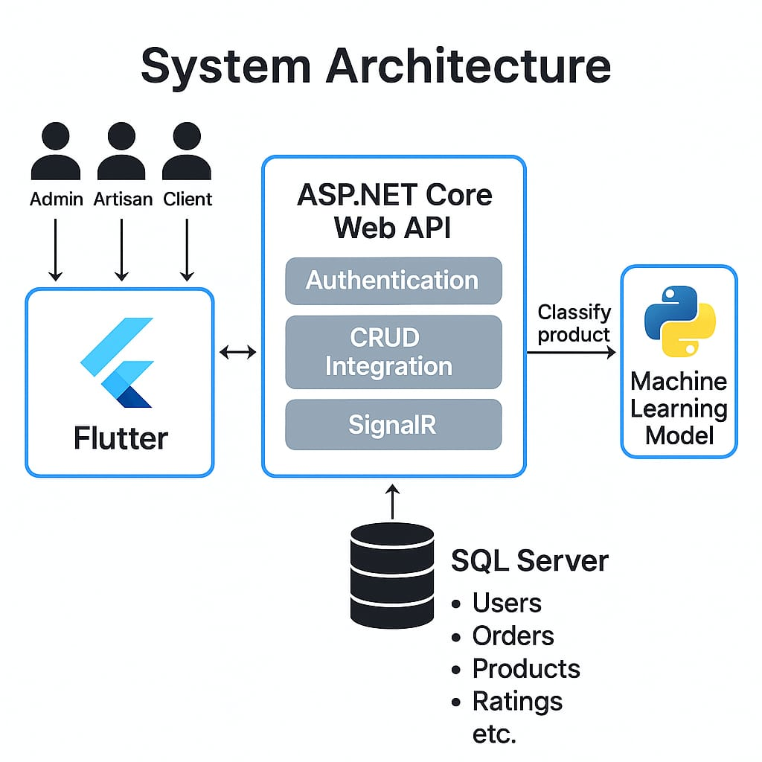

### 3.2.1 ERD Diagram

The Entity Relationship Diagram (ERD) is used to model the logical structure of the database system. It clearly illustrates how entities in the system relate to each other through foreign key relationships. This diagram helps understand the data flow and ensures consistency and integrity in database design. The ERD for this project contains all the major entities such as Users, Products, Orders, Ratings,Notifications, Complaints, and their respective relationships. It also defines primary keys, foreign keys, and the cardinality between the tables.

**The diagram below demonstrates the complete ERD for the proposed system:**

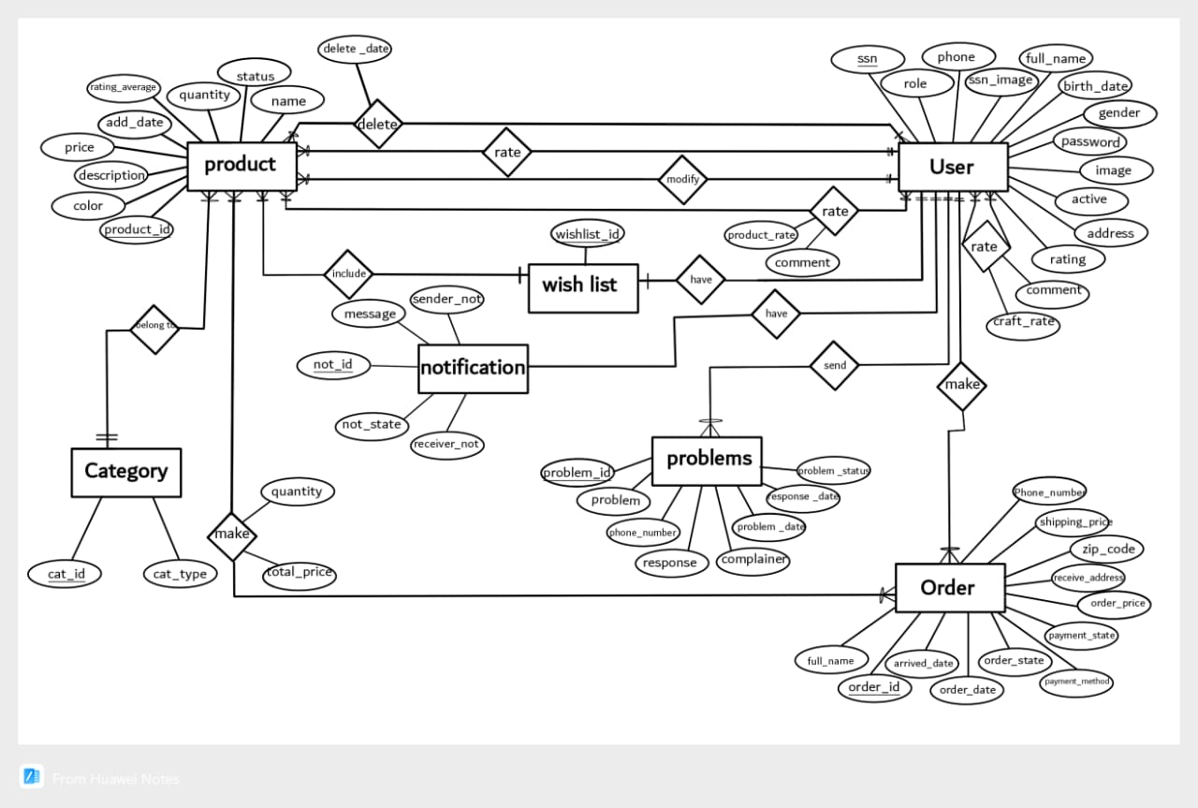

### 3.2.2.Database Schema

The database schema represents the actual structure of the database in terms of tables, columns, data types, and constraints. Unlike the ERD, which is conceptual, the schema is a more technical blueprint that maps directly to the implementation in SQL Server using Code-First approach in ASP.NET Core.

Each table is described with its fields and relationships. The schema ensures proper normalization and avoids redundancy. It is the foundation for all database operations such as insert, update, delete, and read.

**Below is the full schema diagram for the database used in this project:**

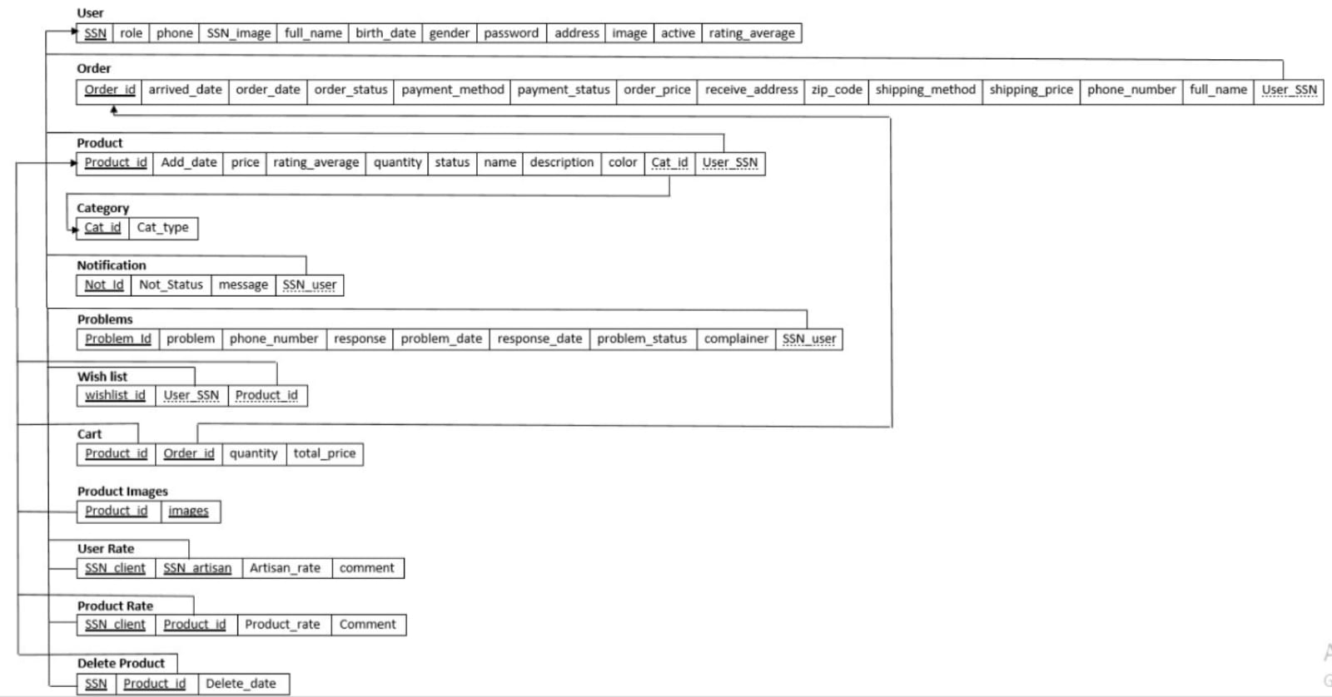

### 3.2.3. UML Use Case Diagram

The UML Use Case Diagram provides a high-level overview of the artisan-client platform’s functionalities and the interactions between the three primary actors (Admin, Artisan, Client) and the system.

**Actors and Their Roles:**

* **Admin**: Manages the platform, overseeing users, orders, products, complaints, and reports.
* **Artisan**: Creates and manages products, handles orders, views statistics, and submits complaints.
* **Client**: Browses products, manages cart and orders, rates artisans/products, and files complaints.

**Use Cases and Actor Interactions:**

**Admin**:

* **Manage Users**: Verify, suspend, or ban user accounts (artisans/clients).
* **Manage Orders**: Monitor order status, resolve issues (e.g., delays).
* **Manage Products**: Review/approve product listings, flag violations.
* **Manage Complaints**: Resolve disputes filed by clients or artisans.
* **Generate Reports**: View system analytics (e.g., sales, user activity).

**Artisan**:

* **Manage Products**: Upload, edit, or delete product listings.
* **Handle Orders**: Accept, process, and ship client orders.
* **View Statistics**: Check sales, ratings, or product performance.
* **Submit Complaints**: Report issues (e.g., client disputes).

**Client**:

* **Browse/Search Products**: View and filter products by category, price, etc.
* **Manage Cart**: Add/remove products, proceed to checkout.
* **Manage Orders**: Place, track, or cancel orders.
* **Rate Artisans/Products**: Submit ratings and reviews post-purchase.
* **File Complaints**: Report issues with products or orders.

**Relationships**:

* **Include**: Some use cases depend on others (e.g., “Place Order” includes “Manage Cart” for Clients).
* **Extend**: Optional actions (e.g., “File Complaint” extends “Manage Orders” if an issue arises).

**All actors interact with the system, but not with each other directly.**

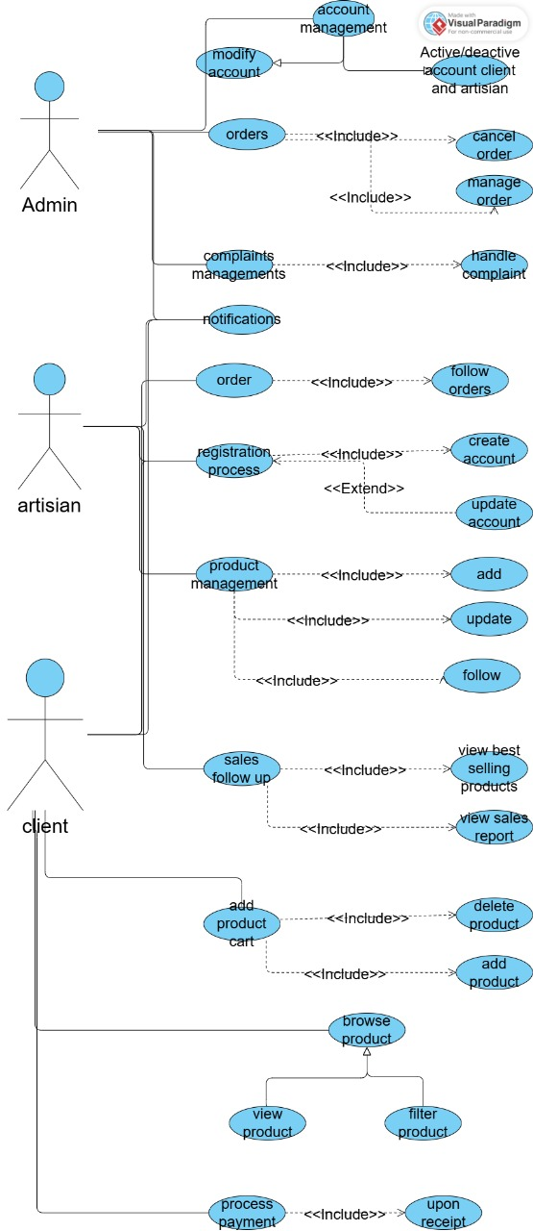

### 3.2.4.Data Flow

**Introduction:**

The Data Flow Diagram (DFD) illustrates how data moves through the "Craft Management System" among users (Client, Artisan, Admin), processes, and data stores.

**1. Client (End-User)**

* **Main Actions:**
  + Register / Login
  + Browse Products
  + Add/Remove from Cart
  + Place / Cancel Orders
  + Rate Product / Artisan / App
  + Submit Complaints
  + View Notifications
  + Update Profile
* **Data Flow:**
* Client -> [Register/Login] -> DB.Users
* Client -> [Browse Products] <- DB.Products + DB.ProductImages
* Client -> [Cart Actions] <-> DB.Carts
* Client -> [Place Order] -> DB.Orders + DB.OrderItems
* Notify Artisan -> DB.Notifications
* Client -> [Cancel Order] -> DB.Orders
* Client -> [Rate Artisan/Product/App] -> DB.UserRates / DB.ProductRates / DB.AppRatings
* Client -> [Submit Complaint] -> DB.Complaints
* Client -> [View Notifications] <- DB.Notifications

**2. Artisan (Seller)**

* **Main Actions:**
  + Register / Login
  + Add/Edit/Delete Product
  + View & Manage Orders
  + Update Order Status
  + View Ratings / Statistics
  + Submit Complaints
  + View Notifications
* **Data Flow:**
  + Artisan -> [Register/Login] -> DB.Users
  + Artisan -> [Add Product] -> DB.Products + DB.ProductImages
  + Artisan -> [Edit/Delete Product] -> DB.Products -> DB.DeleteProduct
  + Artisan -> [View Orders] <- DB.Orders + DB.OrderItems
  + Artisan -> [Update Order] -> DB.Orders
  + Artisan -> [View Ratings] <- DB.UserRates + DB.ProductRates
  + Artisan -> [Statistics] <- Aggregated from DB.Orders, DB.Products
  + Artisan -> [Notifications] <- DB.Notifications

**3. Admin (System Manager)**

* **Main Actions:**
  + Login
  + Manage Users
  + View / Cancel Orders
  + Handle Complaints
  + View Ratings / Statistics
  + Delete Violating Products
  + Manage Notifications
* **Data Flow:**
* Admin -> [Login] -> DB.Users
* Admin -> [Manage Users] -> DB.Users
* Admin -> [Cancel Order] -> DB.Orders
* Admin -> [Reply Complaint] -> DB.Complaints -> Notify Client
* Admin -> [Delete Product] -> DB.Products -> DB.DeleteProduct -> Notify Artisan
* Admin -> [View Stats/Ratings] <- DB.AppRatings, DB.Users, DB.Products, DB.Orders
* Admin -> [View Notifications] <- DB.Notifications

**Key Data Stores:**

* DB.Users
* DB.Products
* DB.ProductImages
* DB.Orders
* DB.OrderItems
* DB.Carts
* DB.UserRates
* DB.ProductRates
* DB.AppRatings
* DB.Notifications
* DB.Complaints
* DB.DeleteProduct
* DB.ConfirmationCodes

**Notes:**

* All users are authenticated via JWT tokens.
* Notifications are pushed using SignalR and stored in DB.Notifications.
* Deleted products are archived in DB.DeleteProduct.
* All complaints are stored in DB.Complaints with admin responses.

### 3.2.5. System Summary

Craft Management System is a mobile-first solution designed to revolutionize the way handmade products are managed, marketed, and purchased. Built using Flutter for cross-platform support and powered by a robust .NET Core Web API, the application serves as an integrated platform that connects artisans with clients while providing administrative tools for effective system governance. At its core, the system addresses a common issue in the handmade products ecosystem - the lack of a unified, digital, and reliable space where artisans can showcase their crafts, clients can place orders conveniently, and administrators can monitor activity and enforce policy compliance.Unlike traditional e-commerce platforms that cater mainly to industrial or commercial products, Craft Management System focuses specifically on handmade goods and the crafting community. It offers a curated experience that not only supports day-to-day transactions but also promotes trust, visibility, and long-term engagement among users.

**User Roles & Target Audience:**

1. **Artisan:**

* Registers and manages profile and SSN image
* Adds, updates, and manages handmade products
* Accepts, ships, or cancels orders
* Views product ratings and statistics (best-selling products, sales, revenue)
* Submits complaints and rates the application

1. **Client:**

* Browses and favorites products
* Adds items to cart and places orders
* Cancels pending orders
* Rates artisans and products
* Views average ratings and submits complaints

1. **Admin:**

* Manages artisan and client accounts (disable/delete)
* Handles and responds to user complaints
* Updates or cancels orders if needed
* Deletes products violating policies (price/quality/category)
* Accesses system statistics via dashboard

1. **Machine Learning Integration:**

The system features an ML model that classifies products as handmade or machine-made, ensuring platform quality. This model helps detect invalid listings and supports moderation.

**Technology Stack:**

* Mobile App: Flutter
* Backend API: ASP.NET Core
* Auth: JWT
* Database: SQL Server (EF Core)
* Notifications: SignalR
* ML Model: Classification API

**Conclusion:**

Craft Management System is a smart ecosystem for handmade commerce, bridging traditional crafting with modern digital platforms.

## 3.3.Algorithms or frameworks used.

### 3.3.1.Deep Learning

1. **Introduction**

In today’s competitive and rapidly evolving market, the ability to distinguish between **homemade** and **machine-made** products is more relevant than ever. Consumers are increasingly interested in the authenticity and craftsmanship of the products they buy, often willing to pay more for handmade items that carry cultural, emotional, or artisanal value. At the same time, businesses and online platforms are seeking smarter ways to categorize and verify product types, reduce fraud, and improve customer trust.

Traditionally, this distinction has relied on manual inspection, expert knowledge, or self-reported product descriptions—all of which are subjective, time-consuming, and prone to error. With the rise of visual platforms like Etsy and Pinterest, there's a growing need for intelligent systems that can **analyze product images and automatically determine their origin.**

Our project aims to bridge this gap using **deep learning and computer vision** to build a smart classifier that can differentiate between homemade and machine-made products based solely on image input. This kind of tool can support a wide range of applications, from online marketplaces to mobile apps for product curation, authenticity verification, or even consumer education.

We chose to develop our system using modern deep learning frameworks that allow us to train powerful models capable of detecting fine-grained visual cues. These cues might include irregularities in texture, stitching, symmetry, or finish—elements that often indicate whether a product was handcrafted or mass-produced.

Ultimately, our goal is to provide a **reliable, efficient, and scalable solution** that democratizes access to product classification. Whether it’s for independent sellers showcasing their handmade creations or for platforms looking to enhance the shopping experience, our AI-powered tool brings **transparency, efficiency, and trust** to the forefront of digital commerce.

1. **Dataset**

To train and evaluate our deep learning model, we curated a **custom image dataset** consisting of five distinct product categories, each representing a commonly handmade or machine-made item type:

* **Flowers**
* **Bags**
* **Rugs**
* **Clothes**
* **Bracelets**

The dataset was **manually collected** from popular visual platforms such as **Pinterest** and **Etsy**, where users showcase their products with visual tags and descriptions. This approach allowed us to gather real-world images that are visually rich and relevant to our classification goals.

Each category contains exactly **500 images**, carefully selected to ensure a variety of styles, angles, lighting conditions, and backgrounds. All images were verified manually to ensure quality and accurate labeling.

**Number of images per category:**

* Flowers: 500 images
* Bags: 500 images
* Rugs: 500 images
* Clothes: 500 images
* Bracelets: 500 images

**Total dataset size: 2,500 images**

This balanced and diverse dataset forms the foundation for training a multi-class classification model capable of recognizing subtle visual patterns across different product types. **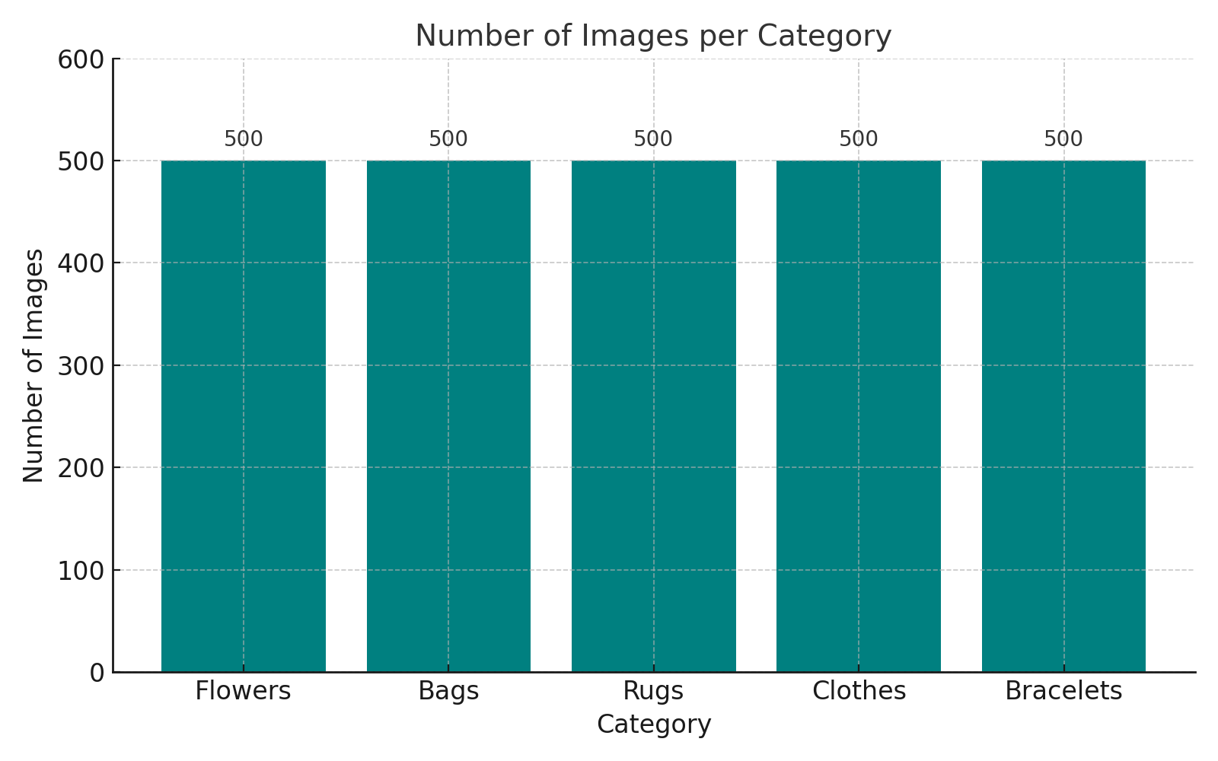**

|  |  |
| --- | --- |
| **categories** | **Samples of categories** |
| 7c771a4b-57b5-4eeb-905c-4665d7c8c082  **clothes** | Error |
| **Rugs** | Area Rugs (6)  5' X 9' Vintage Moroccan Rug, Purple - Arbana |
| **flowers** | Crochet flower pattern at Etsy Lingzhihandmade  61tYjcG0ssL._AC_UL320_ |
| **Bags** | Crochet Flower Tote Bag  Cute Summer Purse! |
| **bracelets** | AnandaEnergy - Etsy (11)  #1 Online Accessories Store_Cool Infinity Jewelries For Men and Women (1) |

**3. Preprocessing**

Preprocessing in deep learning for image classification involves a series of steps to prepare raw image data into a suitable format for training neural networks. These steps help in improving the efficiency and effectiveness of the model training process. Here are the common preprocessing tasks in image classification:

**3.1. Image Resizing**

Most neural networks expect input images of a fixed size. Therefore, images must be resized to conform to the network's input specifications. This ensures that all input images have the same dimensions (width, height, and depth) which is necessary for batching and model architecture constraints.

**3.2. Data Augmentation**

Data augmentation artificially increases the size and diversity of your training dataset by creating modified versions of images in the dataset. Common augmentations include:

* Rotating the image
* Zooming in or out
* Cropping
* Flipping the image horizontally or vertically
* Changing the brightness or contrast
* Shearing

These modifications help the model generalize better to new, unseen data by simulating various scenarios that might not be sufficiently represented in the original training data.

**3.3. ImageDataGenerator**

The ImageDataGenerator class in Keras is a powerful tool that helps in preparing and augmenting image data for deep learning models. This utility class allows you to perform image preprocessing and real-time data augmentation seamlessly. The real-time data augmentation is particularly useful in deep learning as it expands the size of the training set with modified versions of the original images, which can help improve the model's ability to generalize and reduce overfitting.

**3.3.1. Key Features of ImageDataGenerator**

Here are some of the main functionalities provided by ImageDataGenerator:

* **Preprocessing:** Normalize, standardize, or rescale image data.
* **Rotation:** Randomly rotate images during training.
* **Width and Height Shifts:** Randomly translate images vertically or horizontally.
* **Brightness Range:** Randomly change the brightness of images.
* **Shear Transformation:** Apply random shearing transformations.
* **Zoom:** Randomly zoom into images.
* **Horizontal and Vertical Flip:** Randomly flip images horizontally or vertically.
* **Fill Mode:** Specify how to fill in newly created pixels, which can appear after a rotation or a width/height shift.

**3.4. Handling Overfitting**

Preprocessing techniques like data augmentation are part of broader strategies to handle overfitting, where the model performs well on training data but poorly on unseen data. Techniques like dropout or regularization might also be configured during the model design phase but are related to managing data complexity and model capacity .

**4. Models:**

**4.1. Introduction:**

In our effort to develop a model capable of distinguishing between homemade and machine-made products, we embarked on a journey of exploration and experimentation with four distinct deep learning models. These models included resnet 50 ,mobilenet ,CNN, VGG16, VGG19, and Yolov8, each bringing its own unique approach and capabilities to the classification task.

We started by preparing a diverse dataset containing images of both homemade and machine-made products, which laid the foundation for the training process. Using this dataset, we trained each model individually, fine-tuning parameters and optimizing their architectures to achieve the best possible performance.

Once trained, each model produced its own set of results reflecting its ability to accurately classify products based on learned visual patterns. These results provided valuable insights into the strengths and weaknesses of each model, guiding our decision-making process.

Through careful analysis and comparison of the performances of CNN, VGG16, VGG19, and Yolov8, we identified the most effective model in terms of accuracy, computational efficiency, and robustness.

Therefore, we selected the model that demonstrated the highest accuracy and reliability to ensure precise classification of products as either homemade or machine-made. This model will serve as the foundation of our project, aimed at improving product classification quality and supporting decision-making through advanced AI technologies.

**4.2. Convolutional Neural Networks (CNN) model :**

**4.2.1. Introduction**

A Convolutional Neural Network (CNN) is a deep learning algorithm designed to automatically and adaptively learn spatial hierarchies of features from input images. Unlike traditional classification methods that require manual feature extraction, CNNs learn filters directly from the data through training. This makes them highly effective for image classification tasks.

**Project Overview:**

This project focuses on classifying images of products using a CNN model. The goal is to distinguish between machine-made and homemade products based on their visual characteristics.

**Importance of the Project:**

Accurate classification of machine-made versus homemade products has significant implications in fields such as automated quality control, inventory management, and product labeling. Using a CNN model enhances the ability to automate this process with high accuracy.

**4.2.2. CNN Architecture :**

The CNN model consists of multiple convolutional and pooling layers followed by fully connected (Dense) layers. The architecture is designed to progressively extract high-level features from raw image pixels and use them for classification.

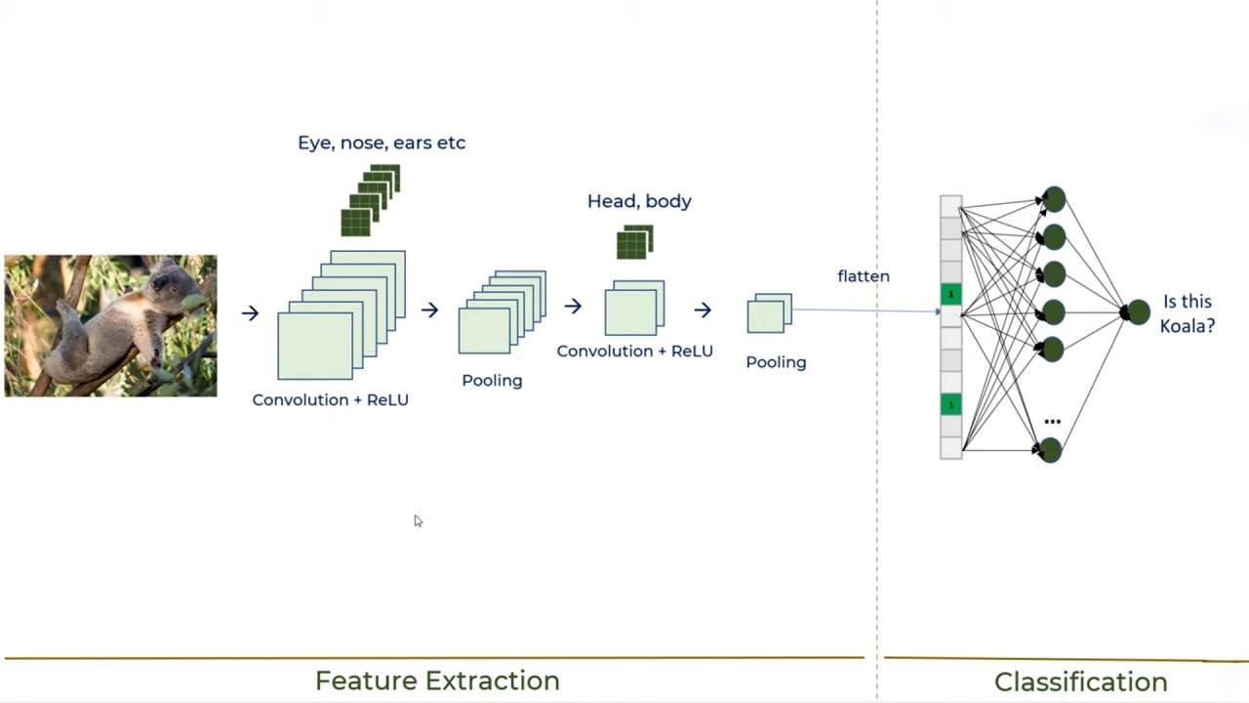

**4.2.3. Convolutional Layers:**

* Convolutional layers are the core components of a CNN. They extract features from input images by performing a dot product between the image and a set of learnable filters or kernels. These filters slide over the input to detect patterns such as edges, shapes, and textures.
* The first layer, "Convolution + ReLU", applies convolution followed by a ReLU activation function to introduce non-linearity
* Additional convolutional layers further extract complex and abstract features from the image.
* The ReLU activation ensures the network can learn complex relationships between pixels.introduces non-linearity which allows the network to learn more complex features [1].
* After the first convolutional layer, there can be multiple additional convolutional layers, each using different filters to extract higher-level features [2]. The image depicts one more convolutional layer followed by a ReLU activation function.

**4.2.4. Pooling Layers:**

Pooling layers are used after convolutional layers to reduce the spatial dimensions of the feature maps, which helps minimize computational cost and avoid overfitting.

This model uses MaxPooling2D with a pool size of (2,2), which takes the maximum value in each 2×2 window.

Pooling retains the most important features while reducing the data size and complexity

**4.2.5. Fully Connected Layers:**

After convolution and pooling, the data is flattened into a 1D vector and passed through Dense layers:

The Flatten layer reshapes the feature maps.

A Dense layer with 512 neurons and ReLU activation learns complex patterns.

Followed by another Dense layer with 256 neurons and a Dropout layer to prevent overfitting.

The final Dense layer with 2 neurons uses a softmax activation to output probabilities for the two classes: homemade and machine-made.

**4.2.6. layers that we use in CNN model:**

Conv2D: Applies convolutional filters to capture spatial features. Used with filter sizes of 32, 64, 128, 256, and 512 and ReLU activation.

BatchNormalization: Normalizes outputs to stabilize and speed up training.

MaxPooling2D: Reduces the spatial size of the feature maps.

Flatten: Converts 2D matrices into a 1D vector before passing to Dense layers.

Dense: Fully connected layers used for learning decision boundaries.

Dropout: Prevents overfitting by randomly deactivating neurons during training.

Softmax Layer: Outputs a probability distribution over the two output classes.

**4.3. Visual Geometry Group )VGG16( model**

**4.3.1 Introduction**

VGG16 is a convolutional neural network architecture named after the Visual Geometry Group (VGG) at the University of Oxford, where it was developed.

It is one of the most widely used deep learning models for image classification tasks.

The VGG16 architecture consists of 16 layers, including 13 convolutional layers and 3 fully connected layers. The convolutional layers are comprised of 3x3 filters with a stride of 1 pixel, and they are followed by max-pooling layers with 2x2 filters and a stride of 2 pixels.

The use of small convolutional filters with a stride of 1 allows VGG16 to have a very deep network while maintaining a relatively simple and uniform architecture. This simplicity and uniformity make it easy to understand and implement, which contributed to its popularity.

Although VGG16 has been surpassed in terms of performance by more recent architectures like ResNet and DenseNet, it still serves as a benchmark in the field of deep learning and is often used as a baseline for comparison when developing new models or evaluating new techniques.

One notable characteristic of VGG16 is its high number of trainable parameters, which can make training and deploying the model computationally expensive, especially when working with large datasets or limited computational resources. However, its straightforward architecture and strong performance on various image recognition tasks have made it a popular choice in both research and practical applications.

**4.3.2. VGG16 Architecture:**

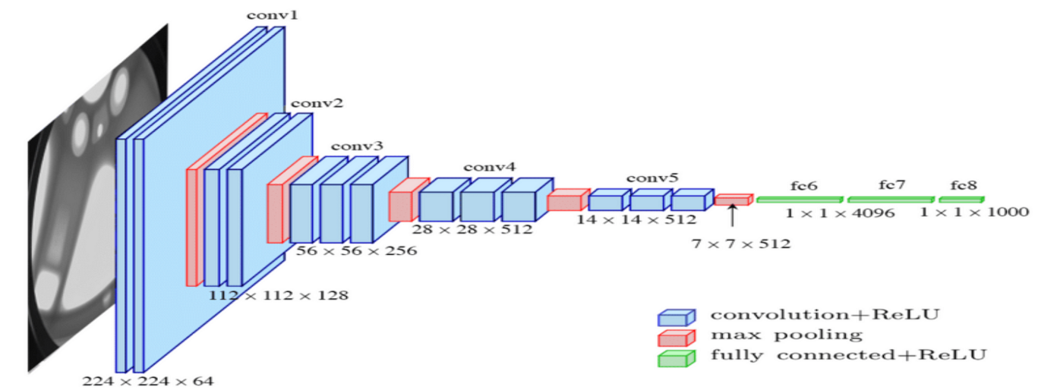

**Input:**

The model takes input images with dimensions **224x224x3** (height × width × RGB channels). This is standard for VGG16.

**Convolutional Layers:**

The VGG16 model contains **13 convolutional layers** using **3×3 filters** with stride 1 and 'same' padding. These small filters are effective in capturing spatial relationships like edges and corners. The depth of the filters increases as follows:

**2 Conv layers with 64 filters**

**2 Conv layers with 128 filters**

**3 Conv layers with 256 filters**

**3 Conv layers with 512 filters**

**3 Conv layers with another set of 512 filters**

Each convolution layer is followed by a **ReLU activation** function.

**Max-Pooling Layers:**

After each block of convolutional layers, a **MaxPooling2D** layer with a pool size of 2×2 is used to downsample the feature maps, reducing spatial dimensions and computation.

**Fully Connected Layers:**

After flattening the output from the last pooling layer:

**Dense(4096) + ReLU**

**Dense(4096) + ReLU**

**Dense(2) + Softmax** ← customized for binary classification (homemade vs machine-made)

**Activation Functions:**

**ReLU** is used after every convolutional and dense layer except the final one.

**Softmax** is used in the last dense layer to output class probabilities for 2 classes

**4.3.3. layers that we use in VGG16 model:**

We use the VGG16 pre-trained model that is being loaded. VGG16 is a convolutional neural network model proposed by K. Simonyan and A. Zisserman from the University of Oxford in the paper “Very Deep Convolutional Networks for Large-Scale Image Recognition”. The model achieves 92.7% top-5 test accuracy in ImageNet, which is a dataset of over 14 million images belonging to 1000 classes.

weights=‘imagenet’: This argument tells the function to load the model with weights that were learned from training on the ImageNet dataset.

include\_top=False: This argument is used when we want to fine-tune or transfer-learn the model on a new task. By setting include\_top=False, we remove the last (top) layer which is responsible for classification, and replace it with layers that are suitable for our task.

input\_shape=(224, 224, 3): This tuple defines the shape of the image input to the model. The dimensions 224x224 refer to the height and width of the images in pixels, and the 3 refers to the number of color channels in the image (red, green, and blue).

**4.4. Visual Geometry Group )VGG19( model**

**4.4.1. Introduction**

VGG19 is an extension of the VGG16 architecture, also developed by the Visual Geometry Group (VGG) at the University of Oxford. Like VGG16, it gained prominence for its effectiveness in image classification tasks, particularly after its performance in the ImageNet Large Scale Visual Recognition Challenge (ILSVRC) in 2014.

As the name suggests, VGG19 comprises 19 layers, including 16 convolutional layers and 3 fully connected layers. The architecture is similar to VGG16 but with additional convolutional layers, which are aimed at capturing more complex features from input images.

Similar to VGG16, VGG19 utilizes 3x3 convolutional filters and 2x2 max-pooling layers throughout the network. This uniformity in architecture, with small convolutional filters and max-pooling layers, contributes to its ease of understanding and implementation.

Just like its predecessor, VGG19 achieved impressive results in various image classification tasks due to its deep architecture and effective feature extraction capabilities. However, similar to VGG16, the depth of the network results in a large number of trainable parameters, making it computationally demanding to train and deploy.

While newer architectures have since emerged with improved efficiency and performance, VGG19 remains a significant benchmark in the field of deep learning. It serves as a reference point for comparing the performance of newer models and continues to be used in research and practical applications for tasks such as image recognition, object detection, and image generation.Top of Form

**4.4.2. VGG19 Architecture :**

**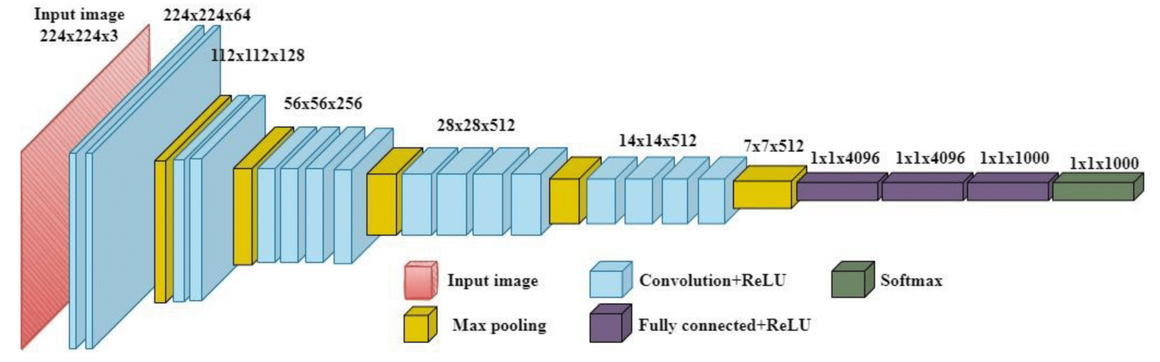**

**Input:**

The VGG19 model receives an input of size **224x224x3** (height x width x channels), corresponding to RGB images resized for the model.

**Convolutional Layers:**

The pre-trained **VGG19** model includes **16 convolutional layers**, using **3x3 filters**. These small receptive fields help detect fine features such as edges and corners. The number of filters increases progressively:

**64**, then **128**, then **256**, and finally **512** in deeper layers.

These layers capture hierarchical features of increasing complexity.

**Max-Pooling Layers:**

After specific convolution blocks**, MaxPooling2D** layers reduce the spatial dimensions of the feature maps (height and width), which helps:

* Decrease computational load
* Retaining important spatial features

**Fully Connected Layers:**

Instead of the default ImageNet FC layers (4096, 4096, 1000), the model uses a custom head:

* **GlobalAveragePooling2D** to flatten the feature maps.
* **Two Dense layers with 256 units** each, both using **ReLU activation**.
* Final **Dense layer with 2 units** and **softmax** activation for binary classification.

**Activation Function:**

**ReLU (Rectified Linear Unit)** is used after each convolutional and dense layer (except the output layer).

Provides non-linearity and helps in faster convergence.

**Output Layer (Softmax):**

The final layer uses **softmax** to output probabilities for **2 classes**, making it suitable for binary classification.

**Transfer Learning Setup:**

**weights='imagenet'**: Loads the VGG19 model pre-trained on the ImageNet dataset.

**include\_top=False**: Removes the original classifier head to allow adding custom layers for the specific task.

**input\_shape=(224, 224, 3)**: Accepts standard RGB images resized to 224x224.

**Training Details:**

**train\_generator** and **test\_generator** are used to load training and validation datasets from folders, with real-time image augmentation.

**Batch Size**: 32

**Optimizer**: Adam with learning rate of **0.0001**

**Loss Function**: sparse\_categorical\_crossentropy (since labels are integers, not one-hot encoded)

**Epochs**: 30

**4.5. )Mobile net) model**

**4.5.1. Introduction**

MobileNetV2 is a type of Convolutional Neural Network (CNN) optimized for performance and efficiency, especially on devices with limited resources such as MobilePhones.  
In this project, the objective is to classify images to distinguish between homemade and machine-made products using MobileNetV2 as the feature extractor.  
This task is important for applications like quality control or online selling, where accurate classification helps automate decision-making and improve reliability.

**4.2.2 MobileNetV2 Architecture**

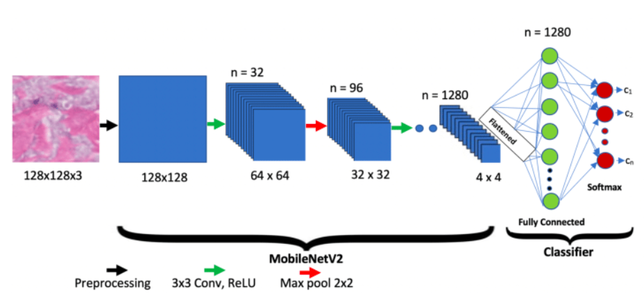

MobileNetV2 uses Depthwise Separable Convolutions to reduce the number of parameters and computations compared to traditional CNNs.  
The model includes an initial Conv2D layer, followed by multiple Inverted Residual Blocks with shortcut connections, and ends with a GlobalAveragePooling2D layer.

**4.2.3 Feature Extraction Layer**

Instead of building a CNN from scratch, MobileNetV2 with pre-trained weights (ImageNet) was used as a feature extractor by setting include\_top=False to remove the original classification head.

**4.2.4 Classification Head**

The following layers were added on top of the MobileNetV2 base:

* GlobalAveragePooling2D: To flatten the output of the feature maps.
* Dense(2, Softmax): Final layer for binary classification (homemade or machine- made).

**4.2.5 Model Summary**

* MobileNetV2: Pre-trained feature extractor.
* GlobalAveragePooling2D: Reduces dimensionality of feature maps.
* Dense(256): Two layers to learn new representations.
* Dense(2, softmax): Final classification output.

**4.2.6 Model Training**

* Optimizer: Adam with learning rate of 0.0001.
* Loss Function: sparse\_categorical\_crossentropy.
* Epochs: 30.
* Batch Size: 32.
* Data Augmentation: Applied using ImageDataGenerator (rotation, shift, shear, zoom, horizontal flip).

**4.6.ResNet-50: Deep Residual Network**

**4.6.1 Introduction:**

ResNet-50 is a widely used convolutional neural network (CNN) architecture introduced by Microsoft Research in 2015. It gained significant attention after winning the ImageNet Large Scale Visual Recognition Challenge (ILSVRC) in 2015. The core innovation of ResNet lies in the concept of **residual learning**, which helped overcome the degradation problem in very deep neural networks, where increasing depth can actually hurt model performance due to vanishing gradients.

ResNet-50 consists of 50 layers, including convolutional layers, batch normalization, and fully connected layers. The key idea is the use of **skip connections** or **shortcut connections**, which allow the model to pass information directly from earlier to later layers, effectively bypassing some layers and enabling the training of much deeper networks.

**4.6.2. ResNet-50 Architecture**

****

**Input:**

The ResNet-50 model takes input images of size 224x224x3, which corresponds to standard RGB images resized to match the model's expected input dimensions.

**Convolutional Layers and Residual Blocks:**

The network begins with a standard convolutional layer followed by max-pooling. After that, the architecture includes four major stages of residual blocks. Each residual block follows a specific pattern:

**Convolution → BatchNorm → ReLU → Convolution → BatchNorm → Add input → ReLU**

This block not only transforms the input but also adds it back to the output, helping the model learn residual mappings rather than the full transformation, which simplifies the learning process.

The ResNet-50 model is organized as follows:

**Initial Layer:** 7x7 convolution followed by max pooling

**Stage 1 (Conv2\_x):** 3 residual blocks with 64 filters

**Stage 2 (Conv3\_x):** 4 residual blocks with 128 filters

**Stage 3 (Conv4\_x):** 6 residual blocks with 256 filters

**Stage 4 (Conv5\_x):** 3 residual blocks with 512 filters

**Batch Normalization:**

Batch normalization is used after each convolutional layer to normalize the feature maps. This stabilizes and accelerates training and helps reduce internal covariate shift.

**Fully Connected Layers:**

Once the model extracts high-level features, the output from the final convolutional block is passed through a **Global Average Pooling** layer to reduce spatial dimensions. Then, the result is fed into:

A final **Dense (Fully Connected)** layer, with the number of units depending on the number of target classes.

**Activation Function:**

The **ReLU (Rectified Linear Unit)** activation function is used after each convolution and dense layer (except the output layer).

The **final layer uses softmax** activation to output probabilities for each class, suitable for multi-class classification.

**Transfer Learning Setup:**

**weights='imagenet'**: The model is initialized with pre-trained weights from ImageNet.

The **original classifier head is removed** (typically a 1000-class output) and replaced with a custom classification head suitable for the specific task.

The model input is set to **(224, 224, 3),** standard for pre-trained CNNs.

**Training Details:**

**Loss Function**: CrossEntropyLoss is used for classification tasks with integer labels.

**Optimizer**: AdamW is used, which combines Adam optimization with weight decay for better generalization.

**Learning Rate Scheduler**: A scheduler reduces the learning rate when validation loss plateaus, helping the model converge smoothly.

**Batch Size**: 32

**Epochs**: 30

**4.7. You Only Look Once (YOLOv8l-cls) model**

**4.5.1. Introduction**

The YOLO (You Only Look Once) model is primarily known for its capabilities in object detection, and image classification. However, the principles of deep learning used in YOLO for object detection can also be adapted for image classification tasks, albeit with some modifications.

**YOLO for Object Detection**

In object detection, YOLO predicts both the class probabilities and bounding boxes of objects in an image simultaneously. This makes it highly efficient for scenarios where both the identification of objects and their locations within the image are required.

**Adapting YOLO for Image Classification**

For pure image classification tasks—where the goal is to categorize the entire image into a single class label—using YOLO might be overkill because YOLO’s architecture is designed to handle multiple objects in various locations across the image. However, if you want to adapt YOLO for image classification, it could be done by modifying its output layer to predict only class labels without spatial bounding boxes. This approach would essentially transform the grid-based prediction model into a global image classifier.

* **YOLOv8 :-**

YOLOv8 Detect, Segment and Pose models pretrained on the COCO dataset are available here, as well as YOLOv8 Classify models pretrained on the ImageNet dataset. Track mode is available for all Detect, Segment and Pose models.

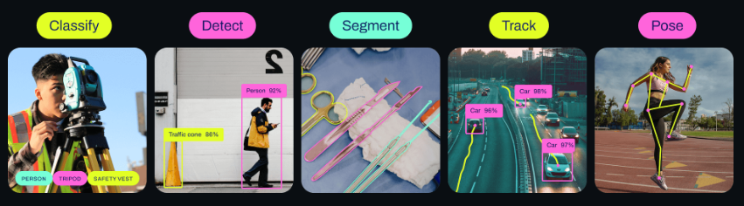

YOLOv8 pretrained Classify models are shown here. **Detect**, **Segment** and **Pose models** are pretrained on the **COCO dataset**, while **Classify** **models** are pretrained on the **ImageNet** **dataset**.

**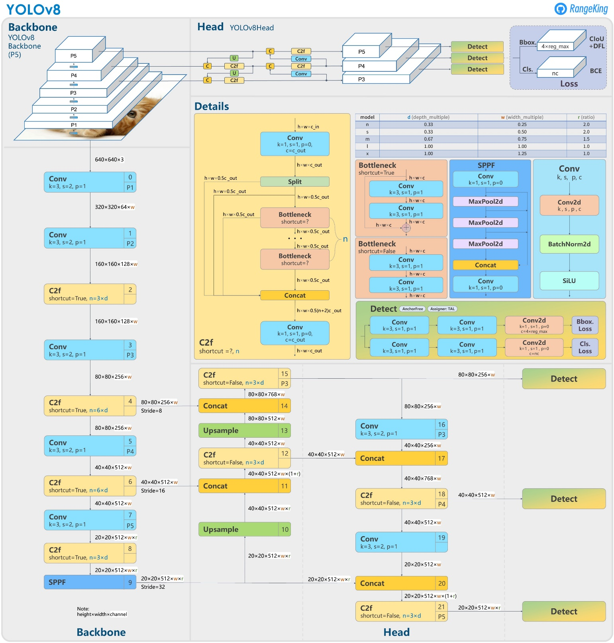4.5.2 YOLOv8 Architecture:**

**Backbone:** The backbone of YOLOv8 is a convolutional neural network (CNN) that extracts features from the input image. It uses a custom CSPDarknet53 backbone, which includes cross-stage partial connections to enhance information flow and accuracy.

**Neck:** Also known as the feature extractor, the neck merges feature maps from different stages of the backbone. YOLOv8 introduces a novel C2f module, which combines high-level semantic features with low-level spatial information, leading to better detection accuracy, especially for small objects.

**Head:** The head of the model makes predictions. It employs multiple detection modules that predict bounding boxes, objectness scores, and class probabilities for each grid cell in the feature map. These predictions are then aggregated to obtain the final detections.

Key innovations in YOLOv8 include a spatial attention mechanism that focuses on relevant parts of the image for more precise object localization, and the C2f module for effective feature fusion. The architecture also incorporates bottlenecks and an SPPF (Spatial Pyramid Pooling Fast) layer to reduce computational complexity while capturing features at multiple scales.

**4.5.3. We use yolov8-cls for image classification :**

****

**4.5.4. Type of yolov8-cls :**

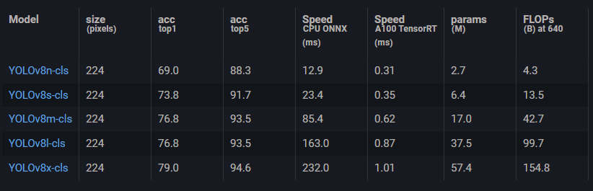

### 3.3.2.Flutter (Frontend Algorithm)

**Role:**

We used Flutter to build the user interface, and we prepared a customized interface for each user role (artisan, customer, admin).

**Smart Features Implemented:**

* Real-time messaging using Firebase.
* Animated navigation bar for a smoother user experience.
* Product rating page to allow customers to review items.
* Role-based login interface (Admin - Employee).
* Displaying task status (Pending - In Progress - Completed).

### 3.3.3.C# .NET (Backend Logic / Algorithms)

**Role:**

We used .NET to build the API that connects the application to the database and manages accounts, products, orders, and more.

**Examples of Implemented Logic:**

* Product filtering based on user preferences.
* Assigning tasks to employees.
* Order status control, such as changing from "In Progress" to "Completed".
* Managing permissions and access levels for admins and users.

# Chapter 4

**Implementation**

## 4.1 Technologies, tools, and programming languages used.

### 4.1.1. Mobile Application

An application software that is intended to operate on a mobile device, like a smartphone or tablet computer, is known as a mobile application, or simply an app. Mobile apps often function as give consumers access to services that are comparable to those found on PCs.

Apps are typically discrete, tiny software packages with a single purpose. This kind of app software was first made famous by Apple Inc. and its App Store, which provides thousands of applications for the iPhone, iPad, and iPod Touch.

An app, web app, online app, iPhone app, or smartphone app are several names for a mobile application.

Mobile applications are a move away from the integrated software systems generally found on PCs. Instead, each app provides limited and isolated functionality such as a game, calculator or mobile web browsing. Although applications may have avoided multitasking because of the limited hardware resources of the early mobile devices, their specificity is now part of their desirability because they allow consumers to hand-pick what their devices are able to do.

The most basic mobile apps transfer PC-based programs to a mobile platform. With the increasing complexity of mobile apps, this method is a little inadequate. A more advanced strategy entails creating especially for the mobile environment, utilizing both its benefits and drawbacks. For instance, because the user is not restricted to a place as they would be on a PC, programs that utilize location-based capabilities are naturally designed with mobile devices in mind.

### 4.1.2. Flutter

#### 4.1.2.1.Introduction

Flutter was first announced by Google in May 2017 at the Google I/O conference. The initial alpha release was made available in May 2017, followed by a beta release in February 2018. The stable 1.0 version of Flutter was released in December 2018. Since then, Flutter has continued to evolve with regular updates and releases, becoming increasingly popular among developers for its cross-platform capabilities and efficient UI development.

With the Flutter - a framework, which Google built, you can quickly create stunning native mobile apps by learning just one language, Dart. Flutter is an SDK that offers a wealth of pre-built and pre-styled UI elements (also known as widgets) that you can use to create your own user interfaces. It also provides the tools necessary to compile Dart code into native code.

Now is the perfect moment to learn Flutter because it's highly popular and utilized for important Google projects like their AdWords app. It's now marked as "ready for production"!

There is no prerequisite knowledge for Flutter or Dart as this course will teach you both from start! Furthermore, since the goal of Flutter is to just require one language to learn, you most definitely don't need any prior experience with Android or iOS development.

Throughout this course, we will not only cover the theory of Flutter, but also develop a fully functional app. This app will have all the essential functions in addition to more sophisticated ones like the ability to use the device camera, add animations, and use Google Maps!

#### 4.1.2.2. Advantages of Flutter

**Here are some advantages of Flutter:**

**Fast Development:** Flutter offers hot reload functionality, allowing developers to instantly see changes they make to the code reflected in the app, speeding up the development process.

**Single Codebase:** With Flutter, you can write code once and deploy it on multiple platforms like Android, iOS, web, and desktop, saving time and effort in maintaining separate codebases.

**Beautiful UI:** Flutter provides a rich set of customizable widgets and a flexible UI framework, enabling developers to create stunning and highly interactive user interfaces that adhere to the platform’s design guidelines.

**High Performance:** Flutter uses a compiled programming language (Dart) and its own rendering engine, resulting in high-performance apps with smooth animations and fast rendering, even on older devices.

**Access to Native Features:** Flutter allows seamless integration with native code, enabling developers to access platform-specific features and APIs, providing a native-like user experience.

**Growing Community:** Flutter has a vibrant and rapidly growing community of developers, providing extensive documentation, tutorials, plugins, and support, making it easier for developers to learn and build with Flutter.

**Open Source:** Flutter is an open-source framework maintained by Google, which means it is continuously updated and improved by the community, ensuring long-term support and stability.

**Cost-Effective:** By enabling faster development, single codebase maintenance, and access to a wide range of features, Flutter can significantly reduce development costs for businesses and startups.

These advantages make Flutter an excellent choice for building cross-platform mobile, web, and desktop applications can Create stunning, completely configurable apps quickly and with absolutely little work by utilizing Google's Material Design. Adding standard UI elements like buttons, switches, forms, toolbars, lists, and more is easy with Flutter's extensive widget suite. Alternatively, you can easily create your own widgets with Flutter's help.

#### 4.1.2.3. Packages in Flutter

* **cupertino\_icons:**

It is a package that contains icons representing the design of the iOS operating system (Cupertino). These icons can be used in Flutter applications to customize interfaces and add a touch of elegance and fluidity.

* **Image\_picker:**

An image picker is one of the most widely used components in any app, is used in Flutter applications to select images from the device's gallery or capture new images using the device's camera. It provides an easy-to-use API for developers to integrate image picking functionality into their apps seamlessly.

* **Tflite (Tensor Flow Lite):**

TensorFlow Lite is a framework designed to execute machine learning models on mobile devices such as smartphones, smart sensors, and more. TensorFlow Lite is known for its efficient and lightweight performance, making it suitable for applications that require AI and machine learning execution efficiently on resource-constrained devices. It allows developers to easily integrate their models into their applications to achieve advanced and intelligent user experiences.

* **Firebase:**



package is a collection of Flutter plugins that enable Flutter apps to interact with Firebase services. Firebase offers a wide range of services including authentication, cloud storage, real-time database, cloud messaging, analytics, and more. Using …

* **Firebase\_auth:**

The firebase\_auth package provides means for authentication and user identity management in Firebase applications. It can be used for logging in, logging out, password reset, user management, and more. Firebase\_auth supports a variety of authentication methods such as email and password, as well as social identities like Google, Facebook, Twitter, and others. These methods provide security and full control over the user experience and account management in applications.

* **Firebase\_core:**

The firebase\_core package is a fundamental part of the Firebase SDK for developing applications on the Firebase platform. It provides the necessary tools to configure and manage the connection between the application and various Firebase services, such as Firestore, Cloud Storage, Authentication, and more.

Firebase\_core serves as a starting point for configuring a Firebase project and enabling communication between the application and Firebase servers.

* **Firebase\_storage:**

The firebase\_storage package allows developers to interact with Firebase Cloud Storage, which is a powerful, secure, and scalable object storage service provided by Firebase. With firebase\_storage, developers can upload and download files, manage file metadata, generate download URLs, and perform other operations related to storage management in Firebase applications. This package simplifies integration with Firebase Cloud Storage, enabling developers to store and retrieve files efficiently while benefiting from Firebase's infrastructure and security features.

* **Google\_fonts:**

Google Fonts is a web library that provides a wide range of free fonts for use in website and app design. It offers an API that allows developers to easily embed fonts into their online projects. With Google Fonts, users can download fonts directly to their sites or link to them via the web, providing great flexibility in customizing the user experience in an attractive and coordinated manner.



#### 4.1.2.4. Flutter runs the code on Android

Flutter runs the code on Android by compiling Dart code into native ARM machine code using the Flutter engine. This engine is written in C++ and provides a bridge between the Dart code and the underlying platform APIs on Android. The compiled code is then bundled into an APK (Android Package) file, which contains everything needed to run the Flutter app on an Android device. This approach ensures high performance and native-like behavior, allowing Flutter apps to seamlessly run on Android devices.

#### 4.1.2.5. Flutter runs the code on IOS

Flutter runs code on iOS devices by compiling it directly into ARM code, providing high performance and a smooth user experience. It supports the Cupertino design language for iOS apps and offers a rich set of widgets that resemble the native iOS look and feel. Flutter also features hot reload functionality, allowing developers to see changes instantly on iOS devices without rebuilding the entire app.

##### 4.1.2.5.1 Dart Flutter

Dart is a programming language developed by Google, primarily used for building mobile, web, and server-side applications. It's known for its simplicity, efficiency, and strong typing system, making it suitable for both frontend and backend development.

Flutter, on the other hand, is a UI toolkit developed by Google for building natively compiled applications for mobile, web, and desktop from a single codebase. It uses the Dart programming language as its primary language for app development.

Dart is the programming language used to write code in Flutter, and Flutter is the framework used to build UI components and structure the app's logic. Together, Dart and Flutter provide a powerful and efficient platform for developing cross-platform applications.

**Dart language supports the following data types :**

* **Numbers:** It is used to represent numeric literals Integer and Double.
* **Strings**: It represents a sequence of characters. String values are specified in

either single or double quotes.

* **Booleans:** Dart uses the bool keyword to represent Boolean values true and false.
* **Lists and Maps:** It is used to represent a collection of objects. Asimple List can be defined as below.

##### 4.1.2.5.2. Dart libraries :

Dart libraries provide a range of functionalities for building applications. These libraries cover core features, asynchronous programming, I/O operations, data conversion, mathematics, and platform-specific functionality. They offer developers a comprehensive toolkit to create efficient and powerful applications.

**Many Dart libraries like:**

* Built-in types, collections, and other core functionality for every Dart program (dart: core).

* Richer collection types such as queues, linked lists, hash maps, and binary trees (Dart: collection).
* Encoders and decoders for converting between different data representations, including JSON and UTF-8 (Dart: convert).

#### *4.1.*2.6.Firebase :

Firebase is an integrated development platform offered by Google for building web, mobile, and other applications. Firebase services include Firestore, cloud storage, authentication, hosting, analytics, real-time messaging, remote configuration, and much more, enabling developers to build high-quality applications quickly and easily using trusted Google tools.

Firebase Database: Provides a flexible document-based database structure for storing and organizing data.

Firebase Authentication: Offers secure and user-friendly authentication mechanisms for user login and identity management.

Firebase Hosting: Allows you to easily host web applications and web pages, with support for fast and secure hosting.

Firebase Analytics: Provides detailed data on app usage and performance to help understand users and improve their experience.

Firebase Cloud Messaging: Enables efficient and easy sending of instant messages and notifications to app users.

Firebase Performance Monitoring: Provides detailed information on app performance to help improve app performance and user experience.

Firebase Remote Config: Allows app configuration from the cloud without the need for new app versions.

Firebase Test Lab: Enables app testing on a variety of devices and environments to ensure app quality and stability.

Firebase Machine Learning: Facilitates integration of artificial intelligence and machine learning into applications easily using pre-trained models.

Firebase Extensions: Offers a collection of ready-to-use extensions for quick use in app development.

These are some of the key services provided by Firebase to help you build your applications easily and effectively.

#### 4.1.2.7. Key Features :

the key features of Firebase listed in bullet points:

- Real-time database

- Authentication

- Hosting

- Analytics

- Cloud messaging

- Crash reporting

- Performance monitoring

- Remote configuration

- Testing

- Machine learning integration

#### 4.1.2.8. Tflite (TensorFlow Lite):

TensorFlow Lite (TFLite) is an open-source framework provided by TensorFlow for running machine learning models on mobile, embedded, and resource-constrained devices.

TFLite aims to improve the speed and efficiency of model execution compared to other TensorFlow versions, making it ideal for applications requiring immediate response and fast data processing.

TFLite enables the conversion of standard TensorFlow models into lighter and more resource-efficient runtime formats. It also includes tools for optimizing and fine-tuning models to ensure excellent performance on mobile and embedded devices.

With TensorFlow Lite, developers can embed artificial intelligence into their applications in a cost-effective and performance-efficient manner, allowing for the development of smart and efficient applications on a variety of devices, including smartphones, wearables, embedded devices, and more.

##### 4.1.2.8.1. Linking the YOLOv8-Lite model with mobile application:

We, as a team of developers, are integrating the YOLOv8 model, which is used to detect objects in images, into our mobile application using TensorFlow Lite (TFLite).

We start by converting the original model, which is usually heavy weight and requires significant resources, into the TFLite format tailored for mobile devices. This conversion involves reducing the model size and improving its efficiency in running on the limited resources of smartphones.

Next, we integrate the converted model into the mobile application, where we load it using the TFLite Interpreter. The TFLite Interpreter allows us to run the model smoothly and quickly on the mobile device, whether the data is coming from the camera or loaded images.

After using the model to analyze images and detect objects, we process the results and present them in a user-friendly manner. This may include displaying bounding boxes around detected objects in the image or classifying them appropriately.

Finally, we conduct comprehensive testing to ensure that the application functions correctly and interacts well with users. This is done by testing the application on a variety of images and analyzing response and performance results.

##### 4.1.2.8.2 Android studio:

Android Studio is an integrated development environment (IDE) designed specifically for building Android applications.

**It offers a range of features including:**

* A stable and user-friendly interface.
* An advanced code editor with features like auto-completion and error detection.
* A visual layout editor for easily building and customizing user interfaces.
* A versatile emulator for testing apps on various Android devices.
* Powerful tools for debugging, analyzing, and optimizing app performance.
* Full support for external libraries and frameworks.
* Integration with Google services to simplify development using services like Firebase and Google Cloud Platform.
* With Android Studio, developers can efficiently build high-quality Android applications, helping them achieve their goals quickly.

### 4.1.3. Deep learning:

Deep learning is a subfield of machine learning that uses algorithms inspired by the structure and function of the brain, called artificial neural networks. Over the past decade, deep learning has made tremendous strides and is now a key technology behind many applications that were once thought to be beyond the capabilities of machines.

#### 4.1.3.1. Basics of Deep Learning:

##### 4.1.3.1.1. Neural Networks:

Deep learning models are based on neural networks. A neural network consists of layers of interconnected nodes (neurons), each connected to others through 'weights' which are adjusted during training. The basic units of these networks are:

Input Layer: Receives the initial data.

Hidden Layers: Intermediate layers where most computations are done.

Output Layer: Produces the final predictions or classifications.

##### 4.1.3.1.2. Forward Propagation:

This is the process by which inputs are passed through the network to obtain an output. Each neuron applies a simple operation on its inputs: a weighted sum followed by a non-linear function (often called activation function like ReLU, sigmoid, or tanh).

##### 4.1.3.1.3. Loss Function:

This is a function that measures how well the network’s output matches the expected results. Common examples include mean squared error for regression tasks and cross-entropy loss for classification tasks.

##### 4.1.3.1.4. Back propagation:

In order to improve the model, deep learning employs backpropagation—a method for calculating the gradient of the loss function with respect to the network’s weights. It involves:

#### 4.1.3.2. Training Deep Neural Networks:

##### 4.1.3.2.1. Data:

Deep learning requires large amounts of data to perform well. This data is used to train the model, validate its accuracy, and test how well it generalizes to new, unseen data.

##### 4.1.3.2.2. Hardware:

Due to the computationally intensive nature of deep learning, especially when dealing with large datasets and deep networks, high-performance GPUs (Graphical Processing Units) or specialized hardware like TPUs (Tensor Processing Units) are often employed.

##### 4.1.3.2.3. Overfitting and Regularization:

Overfitting occurs when a model learns the details and noise in the training data to an extent where it negatively impacts the performance of the model on new data. Techniques to combat overfitting include:

Dropout: Randomly dropping units from the neural network during training.

Regularization: Adding a penalty on the size of the coefficients.

##### 4.1.3.2.4. Hyper parameter Tuning:

Choosing the best parameters for the model (like number of layers, number of neurons per layer, type of activation function, learning rate, etc.) is critical for good performance.

#### 4.1.3.3. Applications of Deep Learning:

##### 4.1.3.3.1. Deep learning is applied in numerous fields:

**Computer Vision:** Object detection, image classification, face recognition.

**Natural Language Processing:** Machine translation, sentiment analysis, question answering.

**Autonomous Vehicles:** Self-driving cars use deep learning for vehicle detection, traffic sign recognition, and path planning.

**Healthcare:** From diagnosing diseases from imaging data to predicting patient outcomes with electronic health records.

**Voice Assistants:** Powering systems like Siri, Alexa, and Google Assistant.

Deep learning has transformed the landscape of artificial intelligence and continues to push the boundaries of what machines can do, providing solutions to complex problems across various domains.

#### 4.1.3.4. Image processing in Deep Learning:

Image processing in the context of deep learning is an essential aspect because it involves preparing raw images in ways that make them suitable for training deep neural networks. The main goal is to extract useful features from images automatically, allowing the networks to learn to recognize patterns or perform specific tasks like classification, detection, or segmentation. Here are the primary steps and considerations involved:

##### 4.1.3.4.1. Data Collection

The first step is gathering images that are representative of the problem you want to solve. This can be a diverse dataset that includes variations in lighting, angles, backgrounds, and other factors.

##### 4.1.3.4.2. Pre-processing

Before feeding images into a neural network, they usually need to be processed to make the learning process more efficient:

**Resizing:** Standardizing image dimensions as input size needs to be consistent.

**Normalization:** Scaling pixel values (e.g., from 0-255 to 0-1) to help in faster convergence during training.

**Augmentation:** Techniques such as rotation, scaling, cropping, flipping, and color changes are used to increase the diversity of the training dataset, which helps prevent overfitting and makes the model robust to variations in new images.

##### 4.1.3.4.3. Feature Extraction

Deep learning automates the feature extraction process using layers of a neural network:

Convolutional Neural Networks (CNNs) are predominantly used for tasks involving images. These networks apply various filters to the input to create feature maps that represent different aspects of the image.

Layers deeper in the network combine features from earlier layers to detect more complex patterns (like shapes and objects).

#### 4.1.3.5. Model Training

With a prepared dataset:

The model learns by adjusting the weights of the network to minimize the error in its predictions compared to the true data labels.

Techniques such as dropout, batch normalization, and regularization are employed to improve training dynamics and prevent overfitting.

##### 4.1.3.5.1. Evaluation and Fine-tuning

The model is evaluated using a separate validation dataset not seen during training to check its performance.

Hyperparameters may be adjusted based on performance metrics (like accuracy, precision, recall, F1-score), and the model might be trained further with these new parameters to improve results.

##### 4.1.3.5.2. Deployment and Inference

Once trained and validated, the model is deployed to make predictions on new data.

For real-time applications, considerations related to speed and computational resources are crucial.

#### 4.1.3.6. Libraries and Frameworks :

##### 4.1.3.6.1. First visualization libraries :

###### 4.1. 3.6.1.1. Matplotlib

**Overview:** Matplotlib is a versatile plotting library. While it's generally used for creating static, animated, and interactive visualizations in Python, it also supports basic image operations.

**Image-Related Uses:** You can use Matplotlib to display images (using imshow for displaying array data), adjust image brightness and contrast, and overlay plots on images to highlight specific features or data points.

**Importing :**

import matplotlib.pyplot as plt

import matplotlib.image as mpimg

###### 4.1.3.6.1.2. OpenCV

**Overview:** OpenCV (Open Source Computer Vision Library) is an open-source computer vision and machine learning software library. It provides a comprehensive set of both classic and state-of-the-art computer vision and machine learning algorithms.

**Image-Related Uses**: It is widely used for operations like reading, displaying, and saving images, image transformations, and visual feature extraction. OpenCV uses BGR as its default colour order for images, matplotlib uses RGB, so if you read an image with OpenCV and want to display it with Matplotlib, you need to convert it from BGR to RGB.

**Importing :** import cv2

###### 4.1.3.6.1.3. Seaborn

Overview: Seaborn is built on top of Matplotlib and integrates closely with pandas data structures. It is a statistical plotting library that simplifies the creation of many types of visualizations.

**Image-Related Uses:** While not directly used for image data, Seaborn is excellent for visualizing the statistical results of image processing, such as visualizing the distribution of pixel values or the color histograms.

**Importing :** import seaborn as sns

###### 4.1.3.6.1.4 OS Module

The os library in Python provides a way to interact with the operating system and is included in the Python Standard Library, so it's available in any standard Python installation. The os module includes a wide range of functions to interact with the filesystem, manage processes, and access the operating system's environment variables. Here's a brief overview of some of its key capabilities:

* **Key Features of the os Module**
* **Directory and File Manipulation**

|  |  |
| --- | --- |
| Function | Use |
| os.chdir(path) | changes the current working directory. |
| os.getcwd() | returns the current working directory. |
| os.listdir(path) | lists the files and directories in the specified path. |
| os.mkdir(path) | creates a new directory at the specified path. |
| os.makedirs(path) | creates directories recursively. |
| os.remove(path) | deletes a file. |
| os.rmdir(path) | deletes an empty directory. |
| os.rename(src, dst) | renames a file or directory from src to dst. |
| os.path.join() | constructs a pathname out of one or several parts by appending any subsequent path component to the first. |
| os.path.split() | splits the pathname into a pair (head, tail) where tail is the last pathname component and head is everything leading up to that. |
| os.path.exists(path) | checks if a path exists. |

#### 4.1.3.7. Second Deep Learning Library :

##### 4.1.3.7.1. TensorFlow

TensorFlow is an open-source software library for numerical computation using data flow graphs. It was originally developed by researchers and engineers working on the Google Brain Team within Google's Machine Intelligence Research organization for the purposes of conducting machine learning and deep neural networks research. TensorFlow is broadly regarded as one of the most popular deep learning frameworks and is used by a wide array of developers and researchers to implement, train, and deploy machine learning models.

###### 4.1.3.7.1.1. Key Features of TensorFlow:

**1. Flexible and Comprehensive Toolkit:**

TensorFlow provides a comprehensive collection of tools, libraries, and community resources that allows researchers to push the state-of-the-art in ML and developers to easily build and deploy ML-powered applications.

**2. Strong GPU and TPU Support:**

TensorFlow executes seamlessly on both CPUs and GPUs (and TPUs, Google’s specialized hardware accelerators for deep learning), which accelerates the process needed to train models with large datasets.

**3. Scalability:**

It is designed to scale from running locally on a single device to running across multiple CPUs or GPUs in desktop, server, or mobile environments, and even across a distributed setup involving multiple machines.

**4. Extensible and Modular:**

You can use TensorFlow’s flexible and modular design to craft, train, and deploy different kinds of neural networks. The framework provides multiple abstraction levels for building models, from the highest level (Keras) to the most granular level (raw graph execution).

**5. Strong Community and Ecosystem:**

TensorFlow has a robust ecosystem of additional tools and libraries to help with the development of machine learning applications, including TensorBoard for visualization, TensorFlow Extended for end-to-end ML pipelines, and more.

**6. Production Ready:**

TensorFlow models can easily be moved to production without requiring a rewrite of the code, and they can run on different devices, including mobile and edge devices through TensorFlow Lite.

**7. Keras Integration:**

TensorFlow 2.x has embraced Keras as its high-level API, making it significantly more user-friendly by providing simpler APIs for building and training models.

##### 4.1.3.7.2. Keras

**Keras** is a powerful and user-friendly open-source library for developing and evaluating deep learning models. It acts as an interface for the TensorFlow library, bundling complex operations into simple, high-level functions, which makes TensorFlow easier to use without the need to interact directly with the underlying TensorFlow engine. Originally developed by François Chollet in 2015, Keras is designed to enable fast experimentation with deep neural networks and focuses on being modular, extensible, and easy to use.

###### 4.1.3.7.2.1. Key Features of Keras:

**1. User-Friendly API:**

Keras has a simple, consistent interface optimized for common use cases. It provides clear and actionable error messages, which makes it excellent for both beginners and experts.

**2. Modularity:**

A model is understood as a sequence or a graph alone. All the components of a Keras model are modular, configurable, and can be easily connected together with few restrictions.

**3. Easy Extensibility:**

It is suitable for advanced users who want to extend Keras to work with new types of layers or different piecewise training algorithms.

**4. Work with Python:**

The models are Python code which makes them easy to debug and allows for ease of extensibility.

**5. Integration with TensorFlow:**

Keras is tightly integrated into the TensorFlow library, giving you access to all the functionalities of TensorFlow directly from Keras. TensorFlow 2.x uses Keras as its official high-level API, making every TensorFlow tool available to Keras.

##### 4.1.3.7.3. Layers

Layers are the basic building blocks of neural networks in Keras. A layer consists of a tensor-in tensor-out computation function (the layer's call method) and some state, held in TensorFlow variables (the layer's weights).

While Keras offers a wide range of built-in layers, they don't cover ever possible use case. Creating custom layers is very common, and very easy.

known for its performance in deploying CNNs on both CPU and GPU.

##### 4.1.3.7.4.Activation

###### 4.1. 3.7.4.1. Relu function :

Applies the rectified linear unit activation function.

With default values, this returns the standard ReLU activation: max(x, 0), the element-wise maximum of 0 and the input tensor.

Modifying default parameters allows you to use non-zero thresholds, change the max value of the activation, and to use a non-zero multiple of the input for values below the threshold.

**Arguments**

* **x:** Input tensor or variable.
* **alpha:** A float that governs the slope for values lower than the threshold.
* **max\_value:** A float that sets the saturation threshold (the largest value the function will return).
* **threshold:** A float giving the threshold value of the activation function below which values will be damped or set to zero.

**Returns**

A Tensor representing the input tensor, transformed by the relu activation function. Tensor will be of the same shape and dtype of input x.

###### 4.1.3.7.4.2. Sigmoid function :

Sigmoid activation function, $Sigmoid \left(x\right)=\frac{1}{1+ e^{-x}}$

Applies the sigmoid activation function. For small values (<- 5), sigmoid returns a value close to zero, and for large values (>5) the result of the function gets close to 1.

Sigmoid is equivalent to a 2-element Softmax, where the second element is assumed to be zero. The sigmoid function always returns a value between 0 and 1.

**Arguments**

• **x:** Input tensor.

**Returns**

• **Tensor with the sigmoid activation**: 1 / (1 + exp(-x)).

###### 4.1.3.7.4.3. Softmax function :

Softmax converts a vector of values to a probability distribution. The elements of the output vector are in range (0, 1) and sum to 1.

Each vector is handled independently. The axis argument sets which axis of the input the function is applied along.

Softmax is often used as the activation for the last layer of a classification network because the result could be interpreted as a probability distribution.

The softmax of each vector x is computed as exp(x) / tf.reduce\_sum(exp(x)).

The input values in are the log-odds of the resulting probability.

**Arguments**

* **x :** Input tensor.
* **axis:** Integer, axis along which the softmax normalization is applied.

**Returns**

Tensor, output of softmax transformation (all values are non-negative and sum to 1).

##### 4.1.3.7.5. Dense

Is the regular deeply connected neural network layer. It is most common and frequently used layer. Dense layer does the below operation on the input and return the output.

output = activation (dot (input, kernel) + bias) Where,

• **input** represent the input data

• **kernel** represent the weight data

• **dots** represent numpy dot product of all input and its corresponding weights

• **bias** represent a biased value used in machine learning to optimize the model.

• **Activation** represent the activation function.

The output shape of the dense layer will be affected by the number of neuron / units specified in the dense layer

The argument supported by dense layer is as follows −

• **Units** represent the number of units and it affects the output layer.

• **Activation** represents the activation function.

• **use\_bias** represents whether the layer uses a bias vector.

• **kernel\_initializer** represents the initializer to be used for kernel.

• **bias\_initializer** represents the initializer to be used for the bias vector.

• **kernel\_regularizer** represents the regularizer function to be applied to the kernel weights matrix.

• **bias\_regularizer** represents the regularizer function to be applied to the bias vector.

• **activity\_regularizer** represents the regularizer function tp be applied to the output of the layer.

• **kernel\_constraint** represents constraint function to be applied to the kernel weights matrix.

• **bias\_constraint** represent constraint function to be applied to the bias vector.

##### 4.1. 3.7.6. Flatten

In the context of deep learning, particularly within the TensorFlow and Keras ecosystems, "Flatten" refers to a type of layer that is used within neural network architectures, rather than a standalone library. The Flatten layer in Keras is typically used as part of a model to transform a multi-dimensional input (e.g., matrices for images) into a single-dimensional array that can be fed into a dense (fully connected) layer. This is a common operation in convolutional neural networks (CNNs) where spatial data from image inputs needs to be converted into a format suitable for classification.

**What Does a Flatten Layer Do?**

The Flatten layer takes all the input dimensions except for the batch size and collapses them into a single dimension. For example, if the input to the layer is a batch of images with the shape (batch\_size, height, width, channels), the output of the layer will have the shape (batch\_size, height \* width \* channels).

##### 4.1.3.7.7. Ultralytics

Ultralytics is a technology company known for its development and maintenance of the YOLOv5 object detection model, among other AI-based solutions. The company provides various tools and libraries primarily around YOLO, making it one of the more accessible and popular choices for object detection tasks in the machine learning community. The YOLOv5 model from Ultralytics is implemented in PyTorch, which contrasts with earlier YOLO versions that were implemented using the Darknet framework.

##### 4.1. 3.7.8. PyTorch

PyTorch is an open-source machine learning library developed by Facebook's AI Research lab (FAIR). It is widely used for applications such as natural language processing and computer vision. PyTorch is known for its flexibility, ease of use, and native support for dynamic computational graphs (dynamic neural networks). Here’s an overview of the main features and components of PyTorch:

**Components of PyTorch:**

**torch:** The main namespace of PyTorch. It includes modules for creating and manipulating tensors.

**torch.nn :** This module provides classes and functions to create and train neural networks. You can define all layers, activation functions, and parameters.

**torch.optim :** It includes standard optimization algorithms like Adam and SGD that can be used to update weights during training.

**torch.utils.data :** Utilities for efficient data loading for your models, such as data loaders and transformers for creating batches of data.

**torch.autograd :** Provides classes and functions for automatic differentiation operations on tensors. It is PyTorch’s automatic differentiation engine that powers neural network training.

**torchvision:** A separate package that includes datasets, model architectures, and common image transformations for computer vision.

**torchtext:** Another package that provides data processing utilities and popular datasets for natural language processing.

##### 4.1.3.7.9. Optimizers

Optimizers are the expanded class, which includes the method to train your machine/deep learning model. Optimizers are necessary for your model as they improve training speed and performance.

Optimizers are Classes or methods used to change the attributes of your machine/deep learning model such as weights and learning rate in order to reduce the losses. Optimizers help to get results faster.

###### 4.1.3.7.9.1. Adam

Adam stands for adaptive moment estimation, which is another way of using past gradients to calculate current gradients, Adam utilizes the concept of momentum by adding fractions of previous gradients to the current one, it is practically accepted in many projects during training neural nets.

Adam optimization is a stochastic gradient descent method that is based on adaptive estimation of first-order and second-order moments.

You can call it using Tensorflow by leveraging the below commands into your project.

**tf.keras.optimizers.Adam(**

**learning\_rate=0.001, beta\_1=0.9, beta\_2=0.999, epsilon=1e-07, amsgrad=False,**

**name='Adam', \*\*kwargs)**

**Arguments:-**

**learning\_rate :-** A Tensor, floating point value, or a schedule that is a tf.keras.optimizers.schedules.LearningRateSchedule, or a callable that takes no arguments and returns the actual value to use, The learning rate. Defaults to 0.001.

**beta\_1:-** A float value or a constant float tensor, or a callable that takes no arguments and returns the actual value to use. The exponential decay rate for the 1st moment estimates. Defaults to 0.9.

**beta\_2:-** A float value or a constant float tensor, or a callable that takes no arguments and returns the actual value to use, The exponential decay rate for the 2nd moment estimates. Defaults to 0.999.

**epsilon :-** A small constant for numerical stability. Defaults to 1e-7. amsgrad :- Boolean. Whether to apply AMSGrad variant of this

algorithm from the paper "On the Convergence of Adam and beyond". Defaults to False.

name Optional name for the operations created when applying gradients. Defaults to "Adam".

\*\*kwargsKeyword arguments. Allowed to be one of "clipnorm" or "clipvalue". "clipnorm" (float) clips gradients by norm; "clipvalue" (float) clips gradients by value.

##### 4.1.3.7.10. Metrics

**Metrics** are crucial for evaluating the performance of a model. Unlike loss functions, which are used to guide the training process by optimizing the model parameters, metrics are used to understand and measure how well the model is performing according to specific criteria that make sense for the given problem.

**Key Points about Metrics:**

**Non-Training Role:** Metrics are used for monitoring and measuring model performance but do not influence the training directly. This means they can be more interpretable and less constrained compared to loss functions.

**Interpretability:** Metrics are usually chosen to be understandable and meaningful for human evaluators, stakeholders, and other non-technical audiences. Examples include accuracy, recall, and precision.

**Comparison:** They allow for the comparison between different models or the same model under different configurations or hyperparameters.

**Model Validation:** They are critical in validating the model during testing and validation phases, providing feedback that helps in tuning the model’s hyperparameters.

## 4.2.Key components/modules of the system.

### 4.2.1 Desings

#### 4.2.1.1. Client Interface

##### 4.2.1.1.1.Logo Screen

The Herfa logo screen is the first page users see when they open the app.

It features the elegant and attractive Skin Vision logo design, with a focus on handcrafted lettering.

**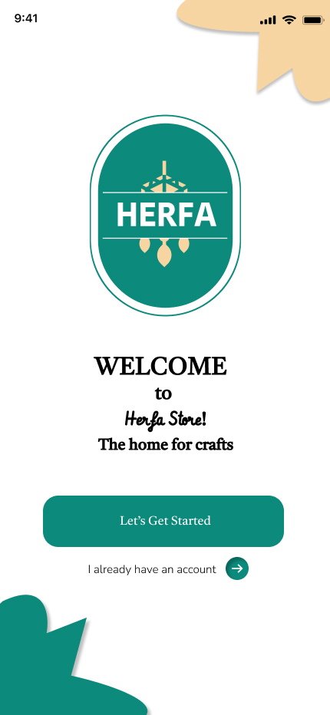**The colors used create a relaxing and stimulating atmosphere for users, positively

impacting their mood and psychological state.

The logo screen aims to enhance the Herfa app's visual identity and highlight its features and quality.

##### A screenshot of a login page AI-generated content may be incorrect.4.2.1.1.2. Login Screen

The **login page** in the Herfa application

is the gateway through which the user accesses

their account. The page relies on logging in

using a **phone number and password**, which

makes access easy and fast for any user.

The interface of the page is simple and clear,

with a field to enter your phone number and

another for your password, along with icons

that clarify each field. There's also a button

in case you forgot your password, which helps

you recover your account. At the bottom,

there’s a link for users who haven’t created

an account yet to sign up.The page is designed to

suit all users, even those who are not familiar

with using applications, and it offers a secure

and user-friendly login experience.

##### A screenshot of a phone login AI-generated content may be incorrect.4.2.1.1.3. Registration Screen

With the Herfa app, we allow you to

join a world of creativity and skill.

Artisans can easily create an account to

showcase their unique handmade products,

while customers can register to enjoy a unique

shopping experience, discovering and purchasing

the most beautiful handcrafted products directly

from their owners.

**4.2.1.1.4.Home Scree

The home page of the **"**Herfa**"** app combines

simplicity and elegance, offering users a rich

and inspiring browsing experience.  
Recommended and new products are displayed

in an attractive way, with well-organized sections

that help users discover the finest handmade crafts.  
The user-friendly interface allows smooth interaction,

enabling users to easily search for products that match their taste from the creations of talented artisans.  
There are also buttons that lead to the Categories page (which displays all products), and from there, users can access the My Orders, Notifications, Profile Settings, and My Cart pages.

The product details page is specially designed to give the customer a

comprehensive view of all products: through their description and the presence of their reviews, which helps them make a more discerning purchase.

##### A screenshot of a phone AI-generated content may be incorrect.4.2.1.1.5.My Cart Screen

The My Cart page organizes the products a customer has selected for purchase in an organized and easy-to-navigate manner. Through it, they can review purchases, update quantities, or delete items before easily proceeding to the checkout process to complete their order.

##### A screenshot of a shopping bag AI-generated content may be incorrect.A close-up of a receipt AI-generated content may be incorrect.A screenshot of a phone AI-generated content may be incorrect.4.2.1.1.6.Checkout Screen

The Checkout pages are designed in an organized and user-friendly way to ensure a smooth shopping experience for the user. The process is divided into three main steps:

**Shipping Page:**The customer fills in the basic shipping details such as name, phone number, address, and postal code. They can also choose the preferred shipping method, whether it's free shipping, paid delivery, or express delivery, with a clear indication of the estimated delivery time.

**Payment Page:**  
The user is shown a summary of the order, including the cost of the products, shipping fees, and the final total. The available payment method is selected, such as *Cash on Delivery*, and the order can be confirmed easily through the "Place My Order" button.

Order Completed Page:  
Once the process is complete, a confirmation message appears to inform the user that the order was successful. They are guided to track their order status through the "My Orders" section. The user can also return to shopping by clicking the "Continue Shopping".

##### A screenshot of a phone AI-generated content may be incorrect.4.2.1.1.7.My Order Screen

The My Orders page in the

Herfaapp allows users to track the status of their orders step by step with full clarity and transparency.  
After confirming the purchase, the order begins with the status Pending (awaiting review), then moves to Processing (being prepared), followed by Shipped, then Delivered, and finally marked as Complete once the customer successfully receives the product.

During the early stages, the customer also has the option to cancel the order if desired.  
After receiving the product, they can rate their experience and leave a review to support the artisans and help improve the quality of service.

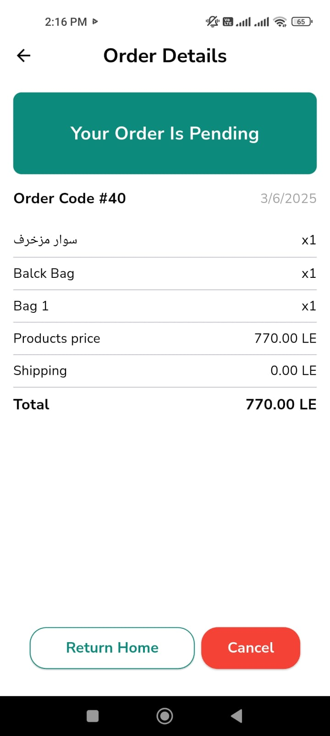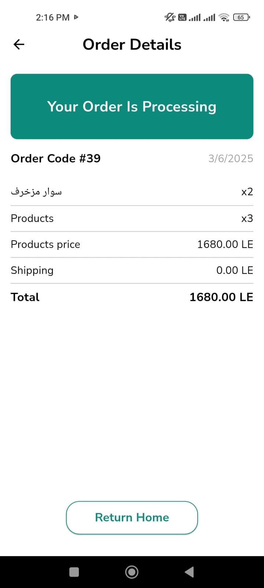

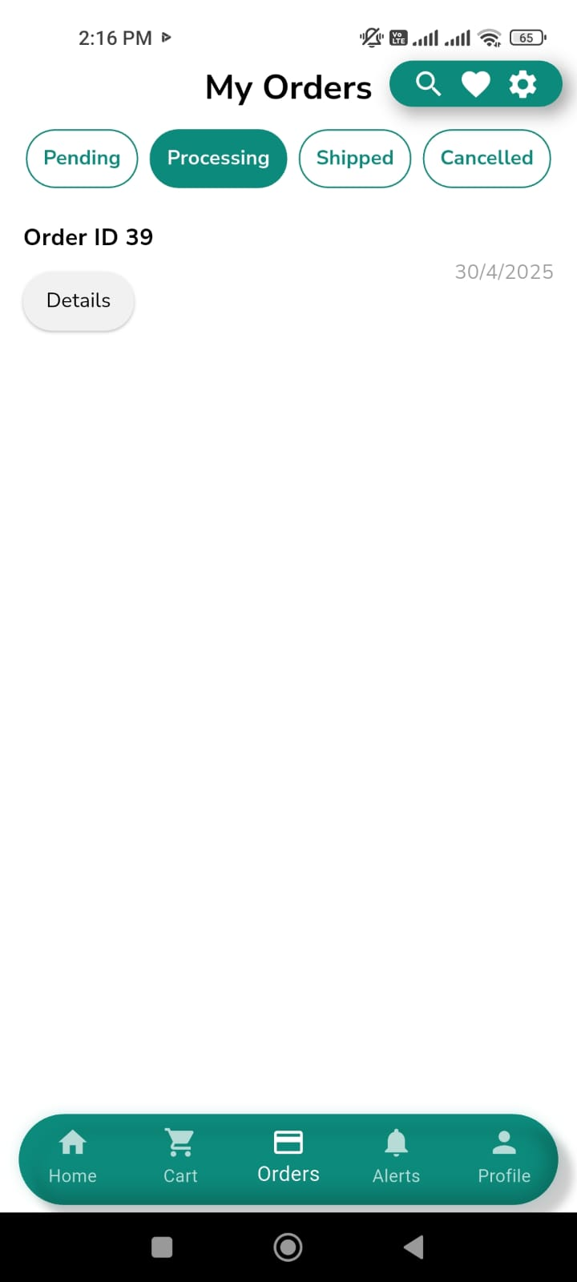

.

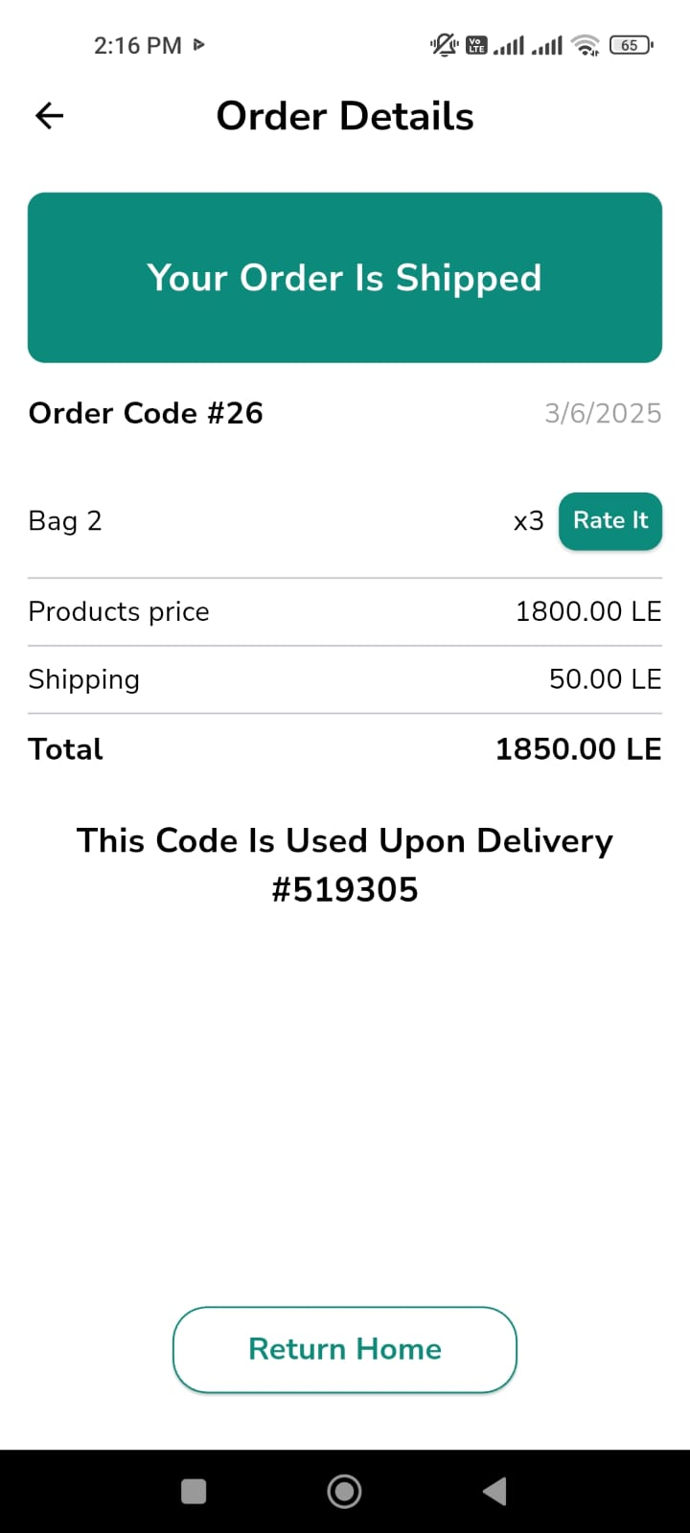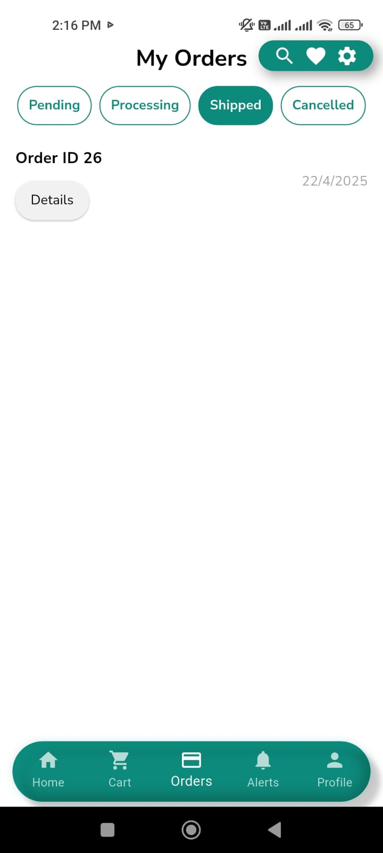

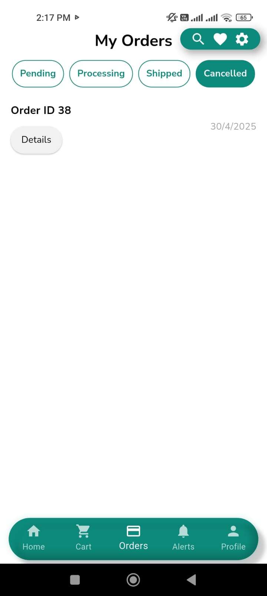

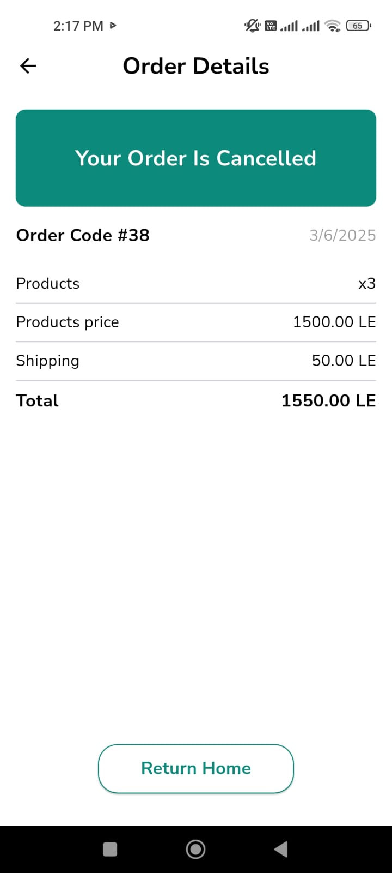

##### A screenshot of a phone AI-generated content may be incorrect.4.2.1.1.8.Notifications Screen

The Notifications page in the Herfaapp is a key tool for keeping users constantly informed about the status of their orders.  
It provides real-time, up-to-date alerts covering every stage of the order process, including:

* Order Accepted
* In Process
* Shipped
* Delivered

These notifications help users track their order progress step by step without needing to frequently check the orders page, enhancing the user experience and ensuring transparent communication

##### 4.2.1.1.9.Profile Settings Screen

The Herfa app's profile settings page allows users to easily control their accounts.

Artisan can update their personal information, browse support options, and read the privacy policy to understand how their data is handled.

They can also rate their experience with the app using the "Rate the App" option, or simply log out using the "Log Out" button.

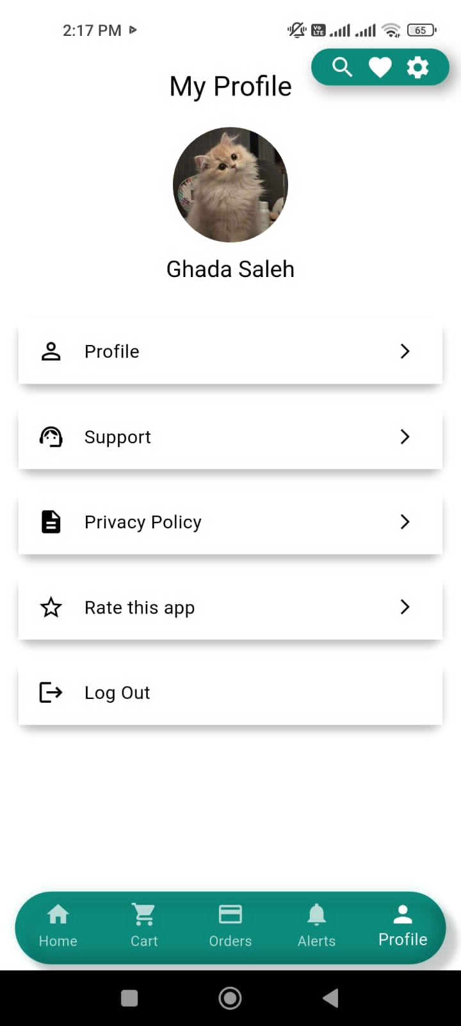

**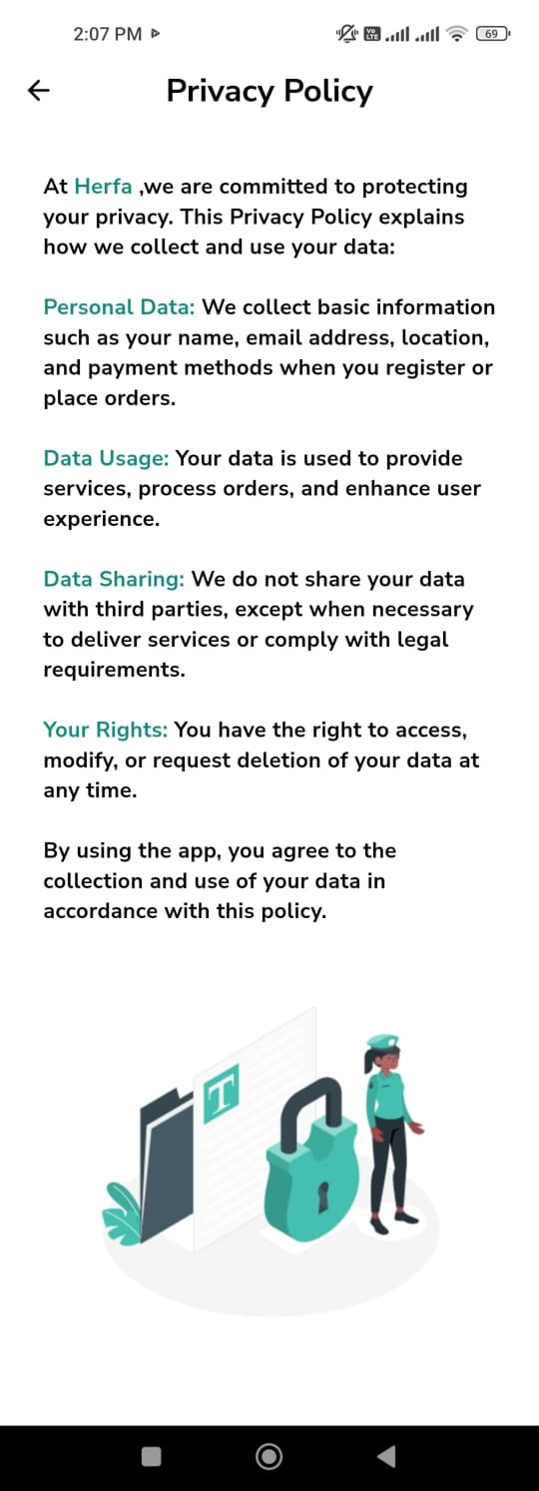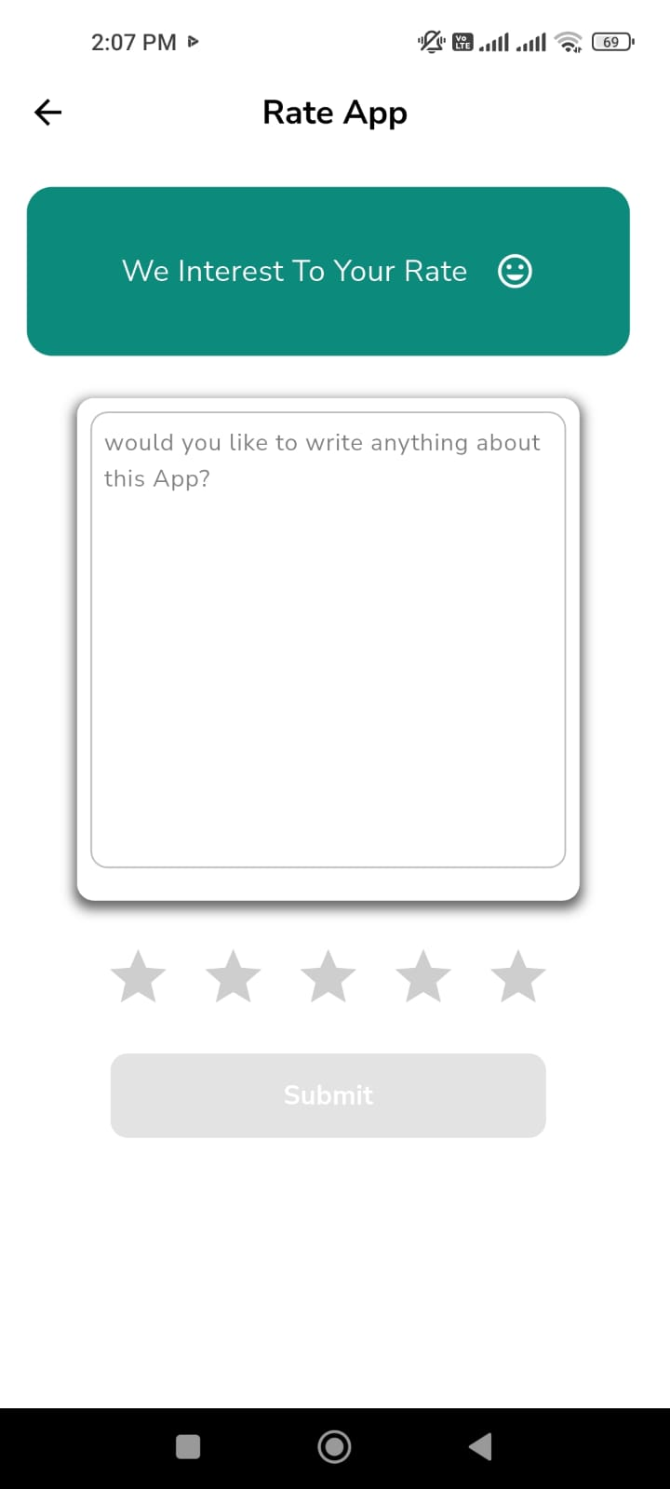**

##### A screenshot of a cell phone AI-generated content may be incorrect.4.2.1.1.10. Categories Screen

The categories page in the Herfa app provides users with an organized and easy browsing experience by displaying a set of main categories that include various types of handicrafts.

The page includes 10 main categories, such as: Bags, Accessories, Mobile Covers, Decor, Clothing, Pottery, Blacksmithing, Textiles, Flowers, and Wood.

When clicking on any category, the user can: Browse all products related to that categor

**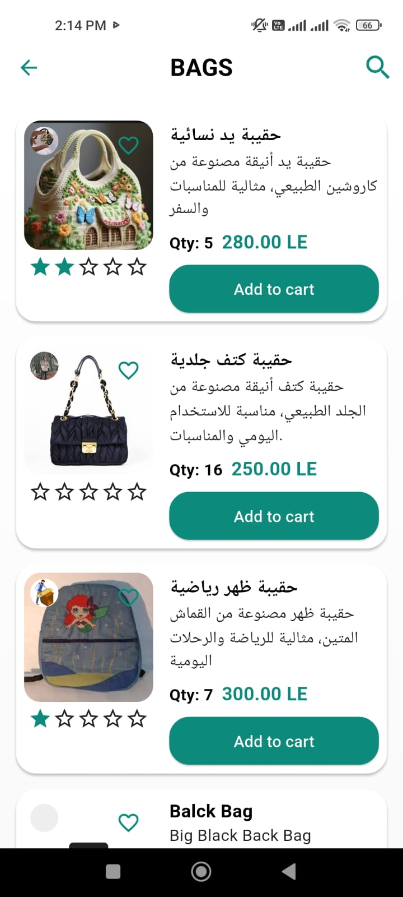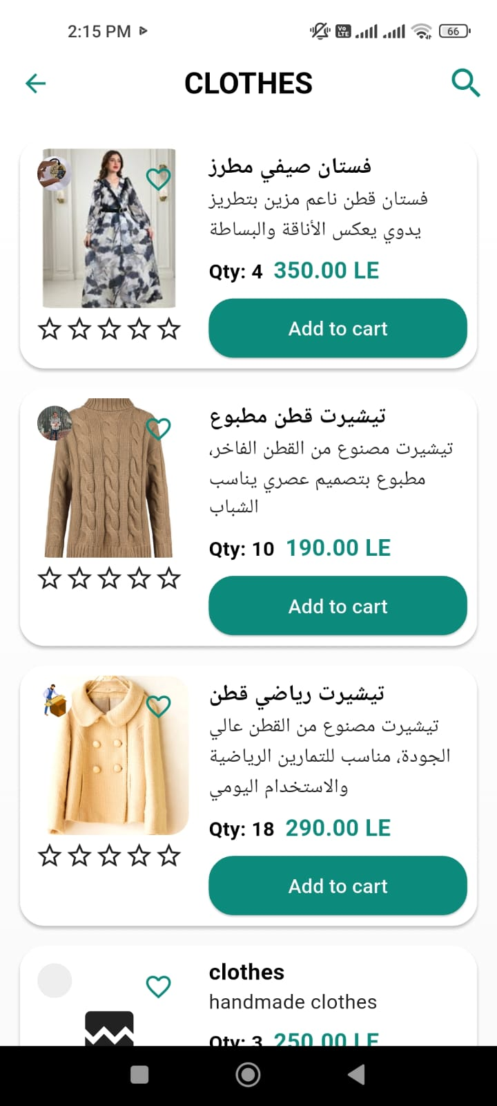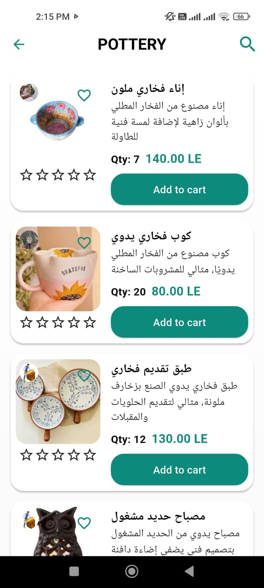**

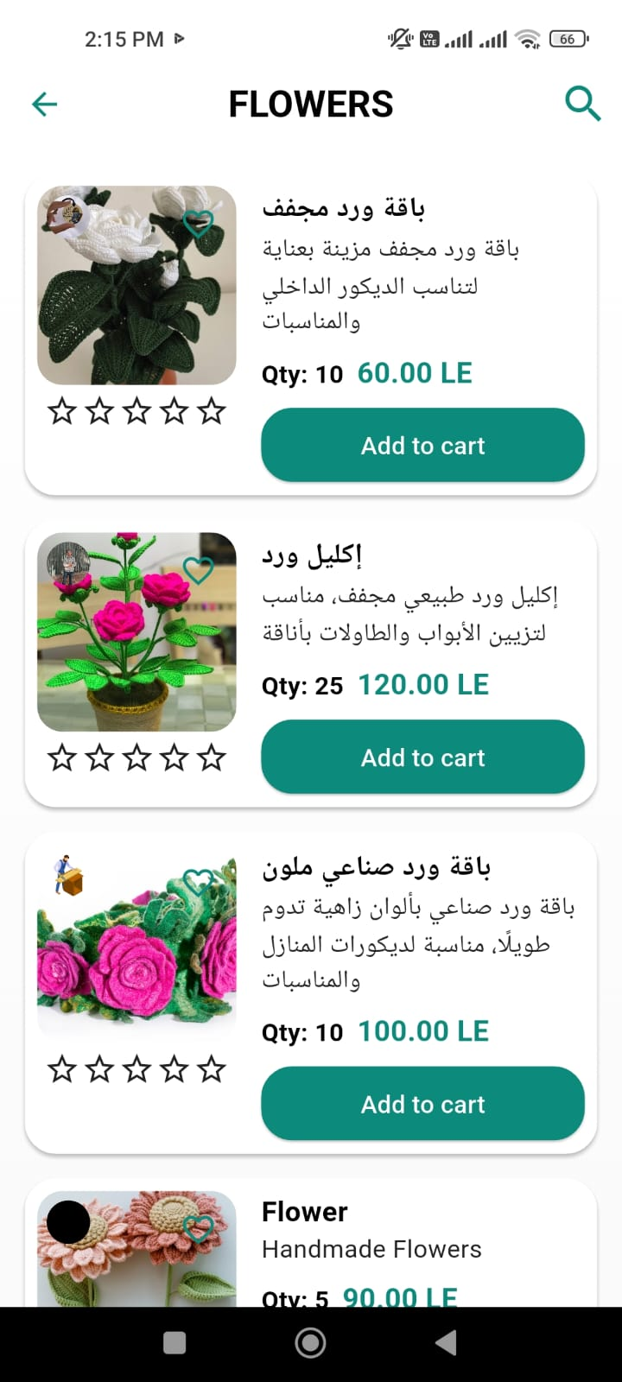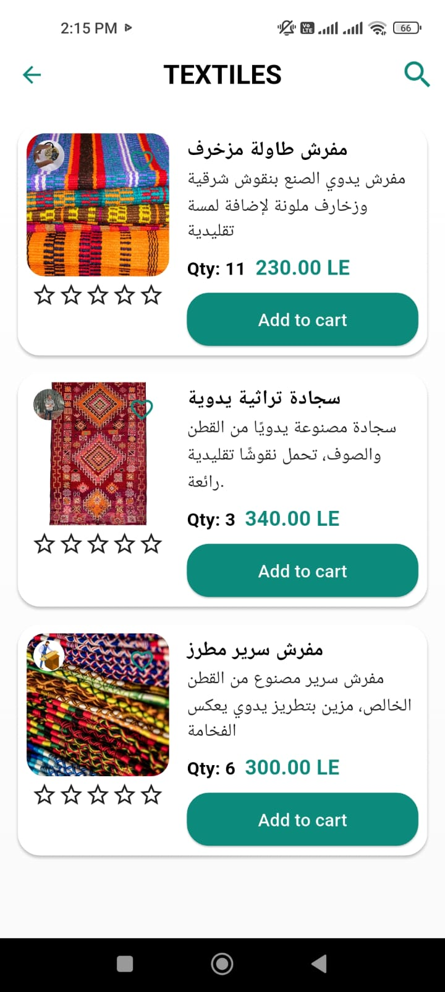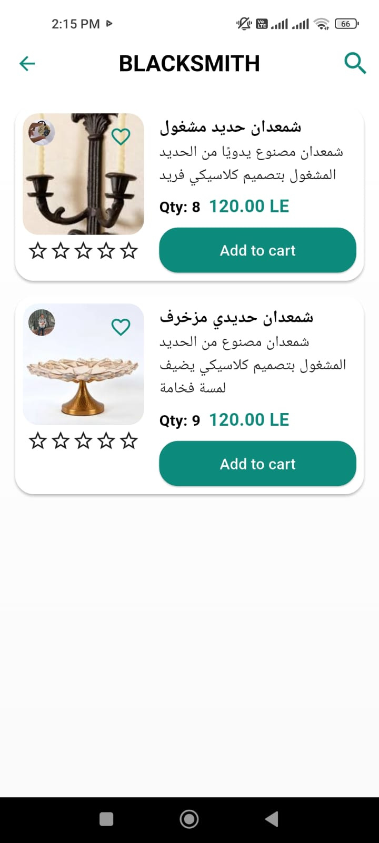

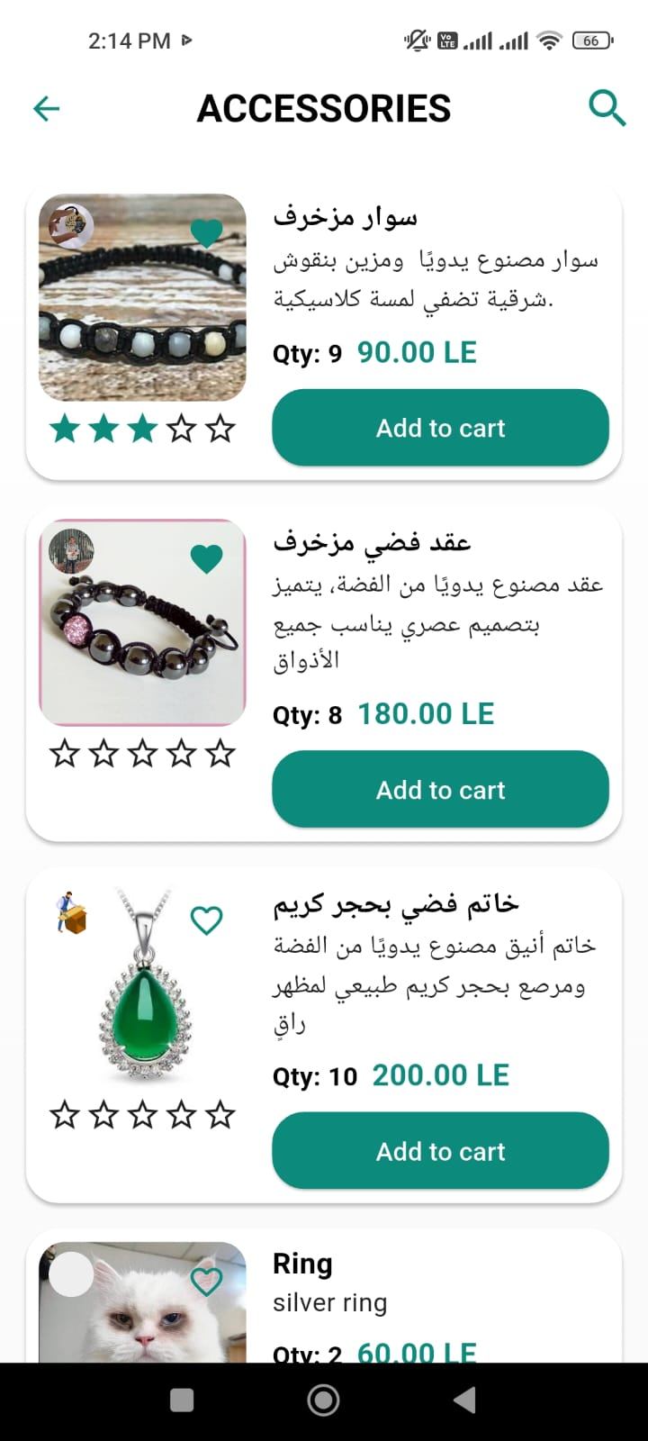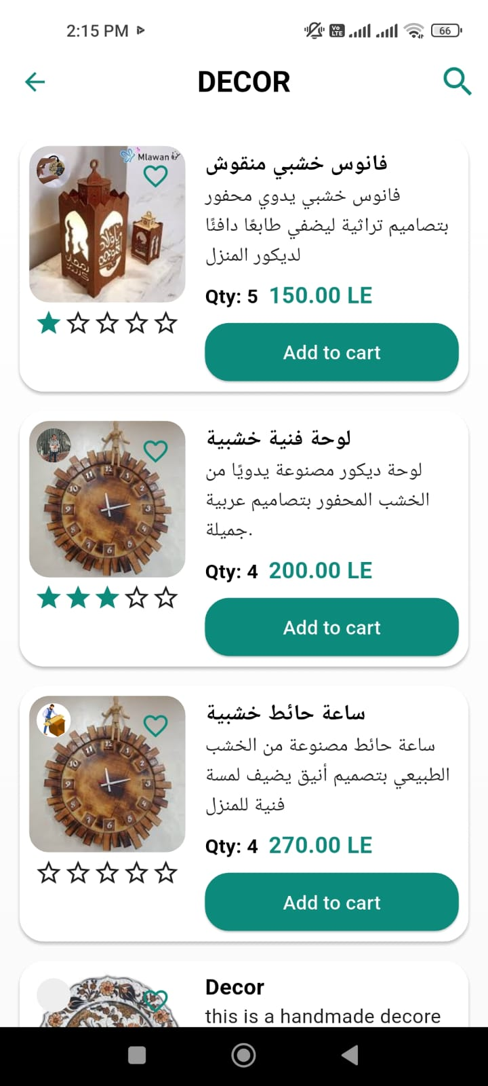

##### A screenshot of a cell phone AI-generated content may be incorrect.4.2.1.1.11.Profile Artisan Screen

The Craftsman Profile page in the Herfa app

offers a unique space to showcase each artisan's

identity and creations.  
The page includes:

* Detailed information about the Artisan, such as their name, a brief overview of their experience, and their field of work.
* A display of all the products crafted by the artisan, allowing users to browse them easily.

The page is designed to build trust between the craftsman and the customer while highlighting the artisan's unique skills in a professional and appealing way.

##### A screenshot of a phone AI-generated content may be incorrect.4.2.1.1.12.Rate Artisan Screen

The page in the Herfa app highlights the importance of customer feedback by allowing users to:

* Rate their experience with the craftsman based on product quality, punctuality, and overall interaction.
* Write a review or comment expressing their impression of the service.
* Contribute to improving the platform’s performance and help other users choose the right craftsman.

The rating system is built on transparency and credibility to ensure a better experience for everyone

##### 4.2.1.1.13.Settings Screen

Settings Page – **Herfa** App:

**1-Notifications:**  
Access all alerts related to orders and updates within the app.

**2-Support:**  
Directly contact the support team if you encounter any issues or have inquiries.

**3-Terms of Use:**  
View the rules and policies that govern how the app is used.

**4-Privacy Policy:**  
Learn how your data is collected and protected within the app.

**5-About Us:**  
An introductory page that highlights who the Herfa team is, along with

the app’s vision and goals.

**6- Appearance Mode (Light/Dark):**  
Easily switch between light and dark modes based on your comfort and preference.

Each item in this list directs you straight to its specific page, ensuring

quick access and full control over your account within the app.

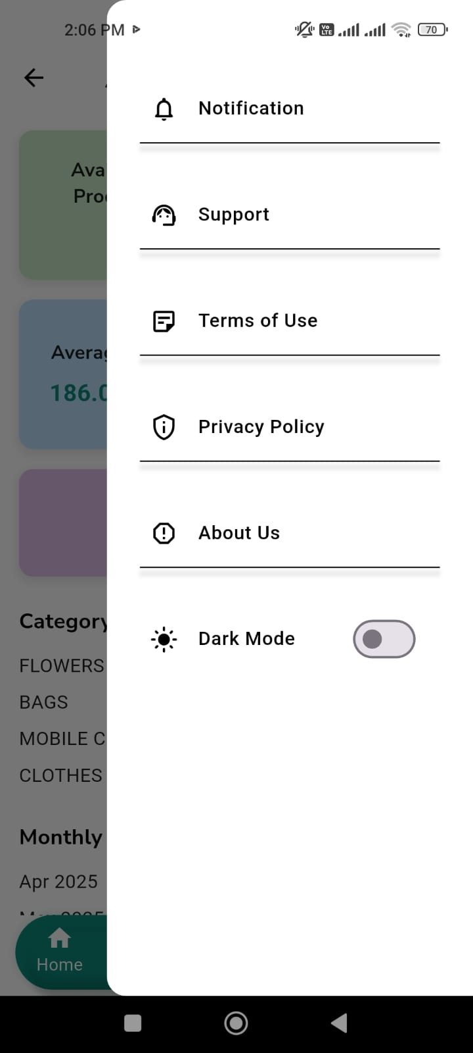

**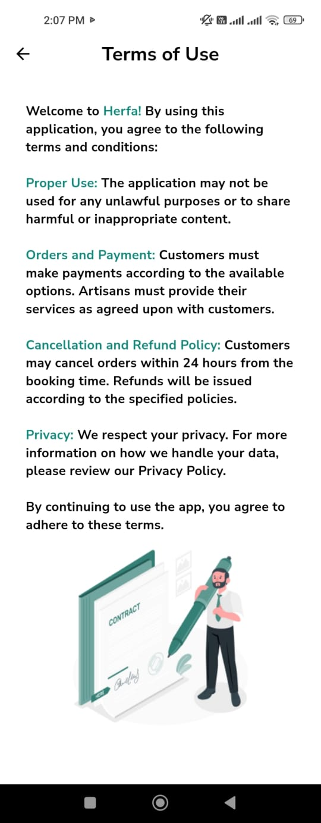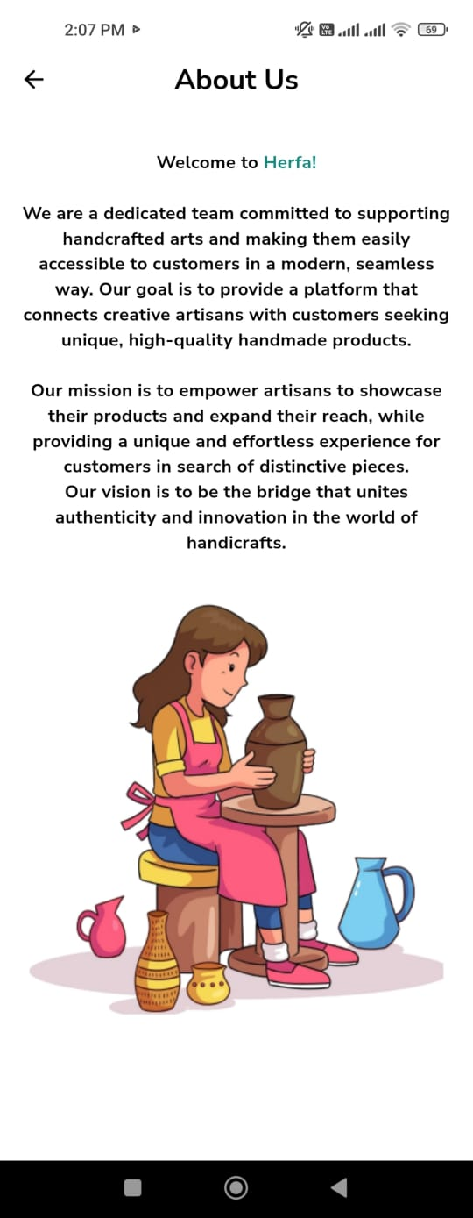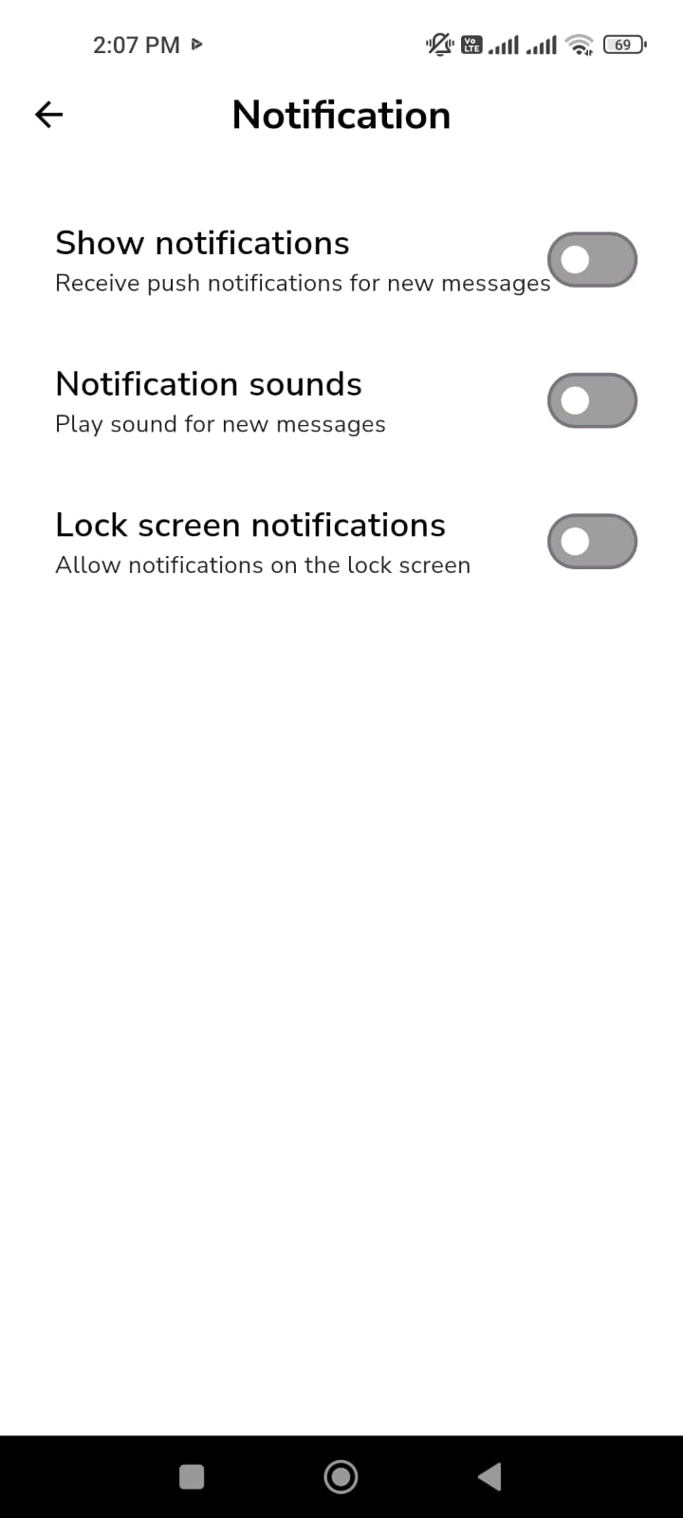**

##### A screenshot of a phone AI-generated content may be incorrect.4.2.1.1.14.Search Screen

The Search page in the Herfa app

provides a simple and fast way to find desired

products.Users can search by product name or

category name, allowing direct access to what

they’re looking for.This feature ensures a smooth

and efficient browsing experience without the

need to navigate through multiple pages.

##### A screenshot of a phone AI-generated content may be incorrect.4.2.1.1.15.Rate Product Screen

The product rating page allows users to rate the products they have purchased based on their experience. This helps craftsmen improve the quality of their products and enables other users to make better purchasing decisions. The page includes:

A star rating system (from 1 to 5 stars).

A text field for writing a review or feedback about the product.

A "Submit" button to save the rating to the database.

#### 4.2.1.2. Admin Interface

##### 4.2.1.2.1. Dashboard Screen

The Dashboard Page in the Herfa app provides an overview of the platform’s overall performance, displaying a total of five key elements:

1. Total Clients
2. Total Artisans
3. Total Categories
4. Total Orders
5. Total Complaints and Support

All of these statistics are displayed in clear, organized cards, allowing the admin to quickly and efficiently monitor the platform’s activity.

##### A screenshot of a phone AI-generated content may be incorrect.A screenshot of a phone AI-generated content may be incorrect.4.2.1.2.2.ArtisanManagement Screen

The Artisan Management Page in the Herfaapp is a powerful and comprehensive tool that enables the admin to have full control over the registered craftsmen on the platform.  
Through this clean and well-organized interface, the admin can view a list of craftsmen along with their basic details such as name, gender, phone number, address, and age.

This page offers several key administrative functions:

1-Easy search for any craftsman using the top search bar.  
 2-Edit craftsman information through the Edit button.  
3- Delete Artisan when needed.  
 View a copy of the national ID for verification purposes.

This page helps the admin monitor and maintain the quality of displayed content and ensures the accuracy of Artisan data contributing to the credibility of the platform and simplifying performance tracking.

##### A screenshot of a phone AI-generated content may be incorrect.4.2.1.2.3.Client Management Screen

The Client Management page allows the admin to have full control over client accounts within the app. It includes the following functions:

View Data: Access client information such as name, national ID number, and phone number.

Edit Data: Update client information such as name or email address.

Delete Account: Remove the client account completely from the system.

Disable Account: Temporarily deactivate the client account with the ability to reactivate it later.

Search: Search for clients based on specific criteria such as national ID number or phone number.

**4.2.1.2.4.Order Management Screen

The Orders Management page for the Admin in the Herfaapp allows the administrator to monitor order flow with precision and efficiency.  
The page features a well-organized list of orders with search and sorting options by date or status, making it easy to quickly locate any order.

Each order displays key details such as the order code, shipping and delivery dates, the craftsman’s and customer’s names, address, and total price.

The admin can also view the payment status (Paid / Unpaid) and has the ability to edit or delete orders directly from the interface.  
By clicking on “Details,” the admin can access more specific information such as updating dates or changing the order status — all of which contribute to better customer service and ensure operational quality within the app.

##### A screenshot of a phone AI-generated content may be incorrect.4.2.1.2.5. Complaints and Support Screen

This page allows the admin to monitor all complaints and inquiries submitted by customers and craftsmen within the application.  
Through this page, the admin can:

* View complaint details (username, type, date, status).
* Respond directly to users with a clarification message.
* Update the complaint status (New – Under Review – Resolved).
* Filter and sort complaints by type or date to facilitate tracking.

The goal of this page is to ensure fast and effective support to enhance the user.

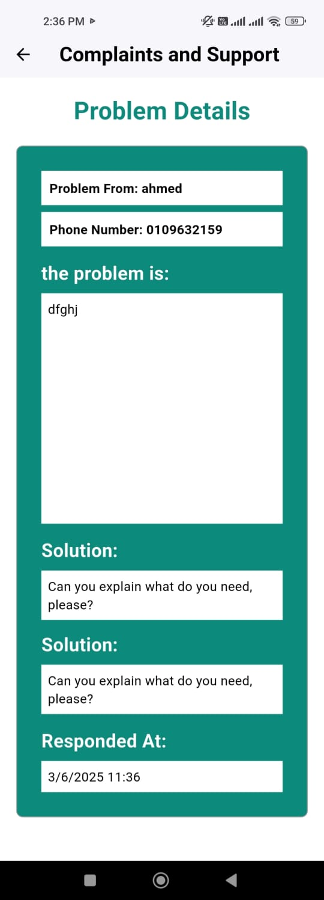

**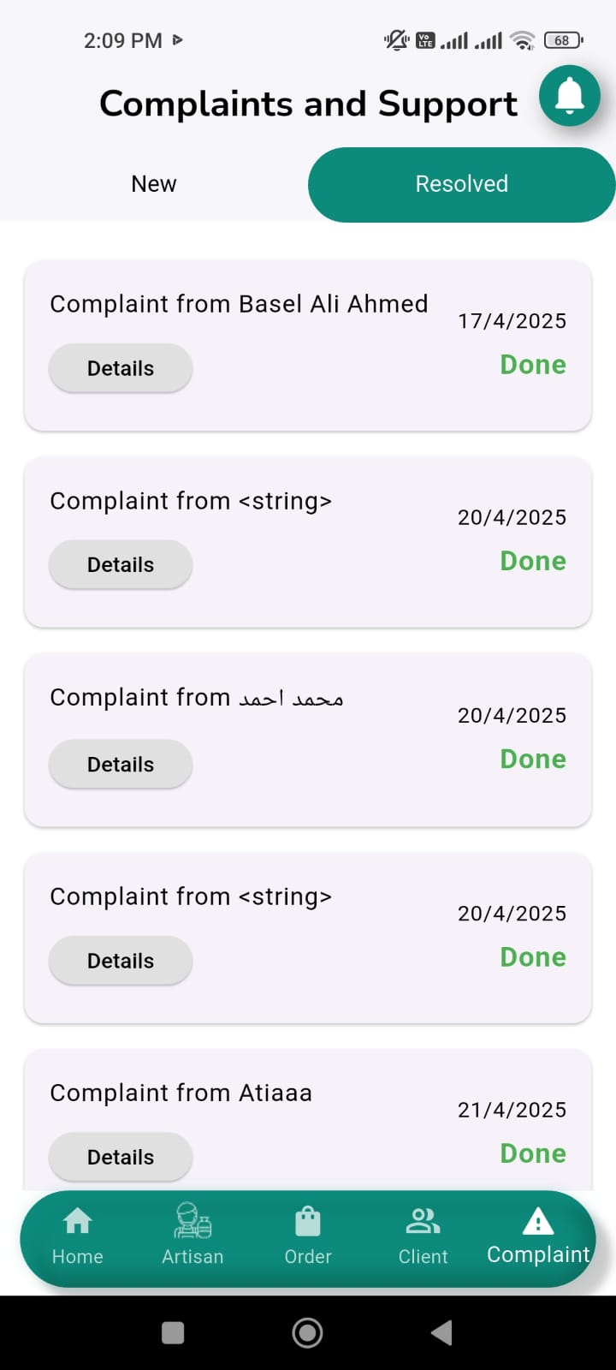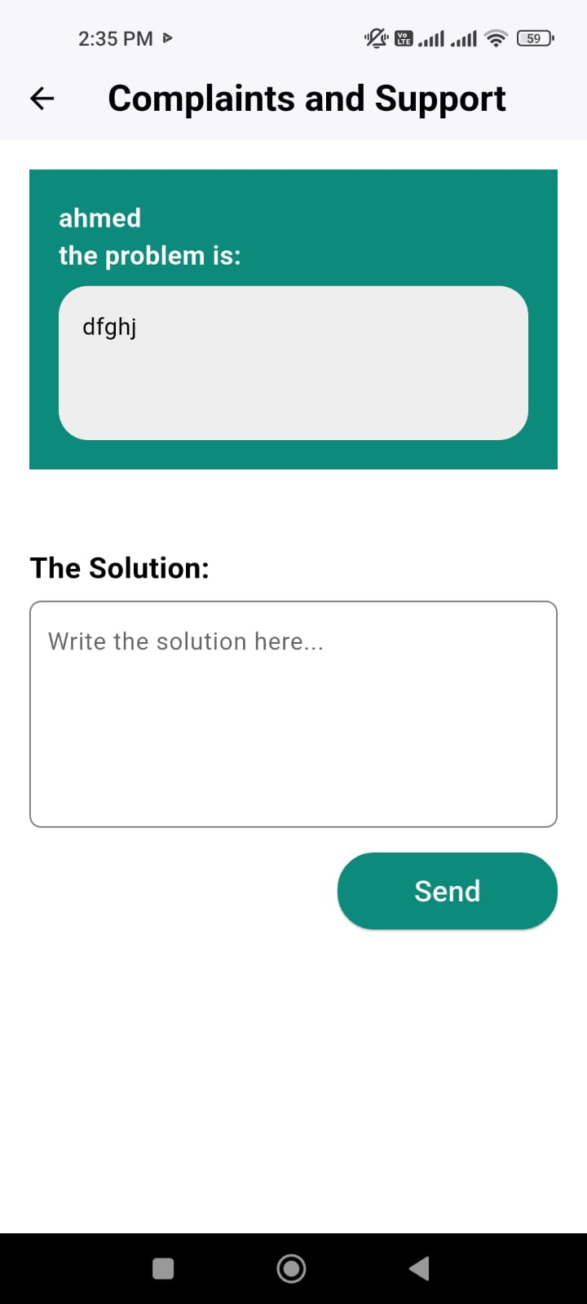**

##### 4.2.1.2.6.Notifications Screen

The Admin Notifications page in the Herfaapp serves as a central tool for monitoring new activities and actions within the system.  
Through this page, the admin receives real-time notifications about a variety of important events, including:

New registration requests from craftsmen or customers, with the ability to approve or reject them after review.

Alerts for new purchase orders from customers, allowing the admin to review and verify their accuracy.

Notifications regarding issues reported by users.

Updates on order status changes, such as approvals or status modifications.

This page helps the admin stay informed about all platform activities, enabling quick decision-making and

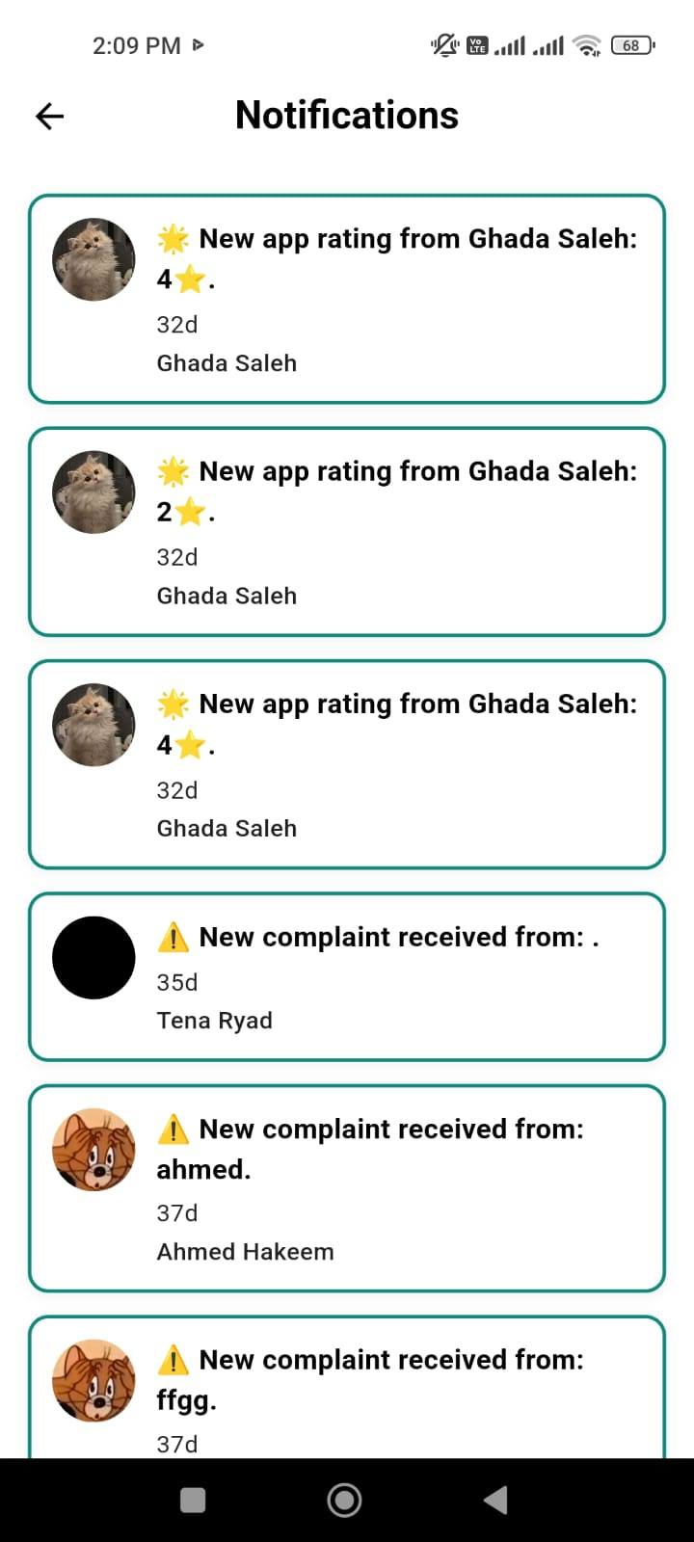ensuring a high-quality experience for us.

#### A screenshot of a phone AI-generated content may be incorrect.4.2.1.3. Artisan Interface

##### 4.2.1.3.1.Home Screen

The Artisan Home Page is thoughtfully designed to give the Artisan a clear and elegant overview of their business activity.

The page begins with key statistics, including the number of available and unavailable products, average pricing, product ratings, and the overall craftsman rating. It also displays the distribution of products by category, helping the Artisan understand which types of products they produce most often.

Monthly earnings are highlighted to help track income, along with the most popular products to guide the Artisan in focusing on what customers love most.

Toward the bottom, there’s a well-organized table that lists all products with their prices, quantities, and availability status—making inventory management easy and efficient.

Completing the layout is a simple bottom navigation bar that allows quick access to the Home, Orders, Add Product, Notifications, and Profile pages.

Overall, this page combines functionality and visual appeal to serve as a complete dashboard, empowering the Artisan to grow their business with confidence and ease.

##### A screenshot of a phone AI-generated content may be incorrect.A screenshot of a phone AI-generated content may be incorrect.4.2.1.3.2. Order Screen

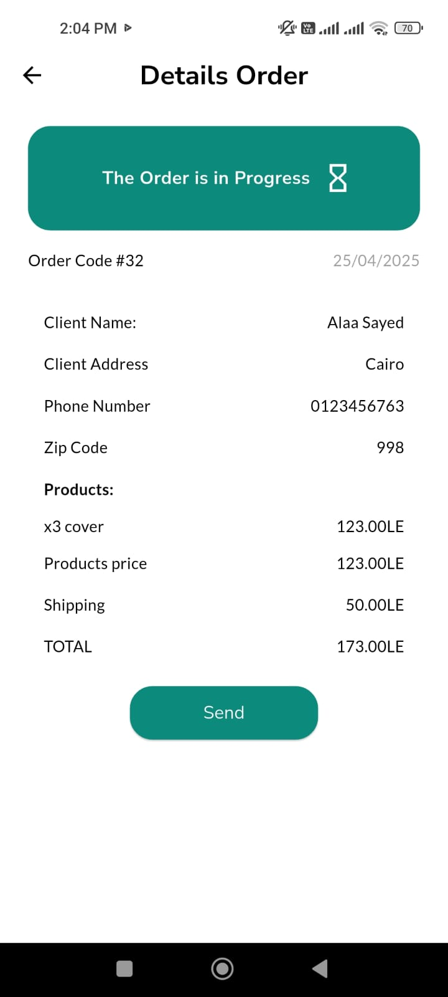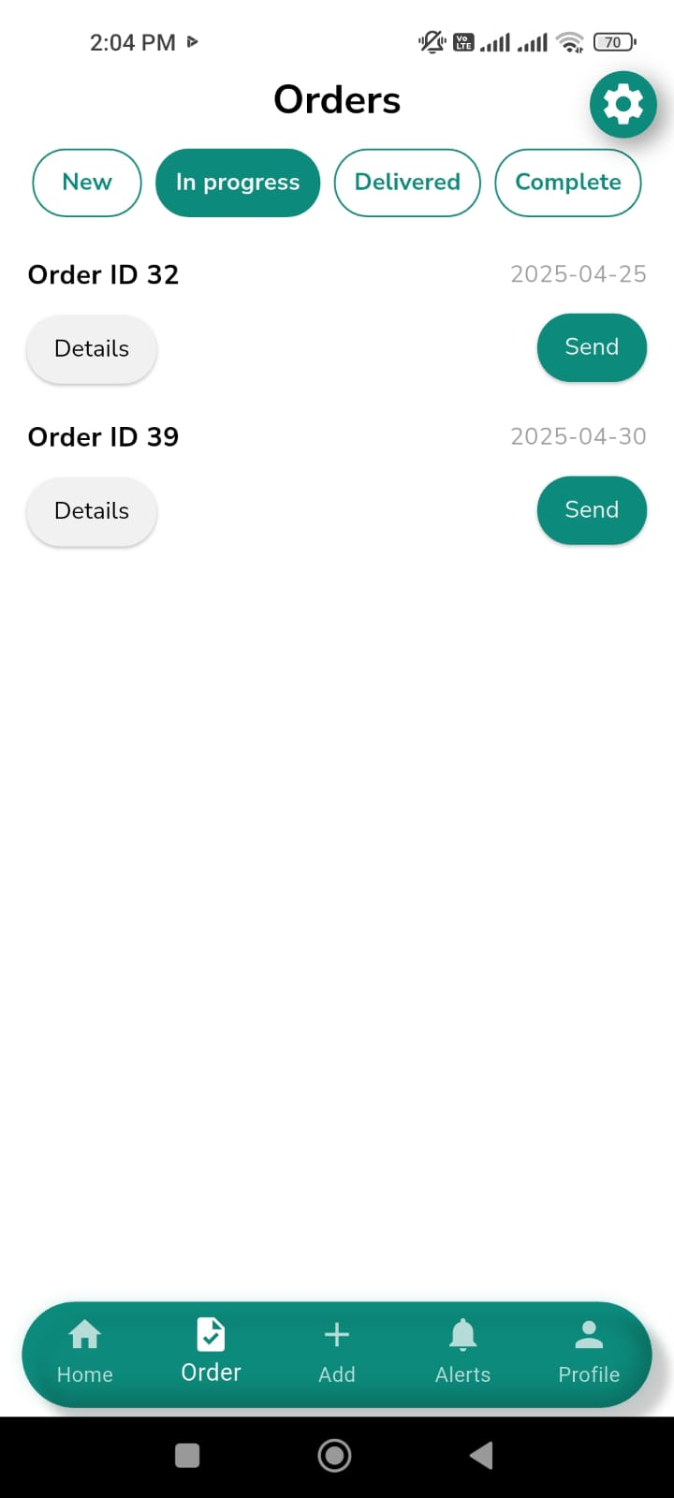

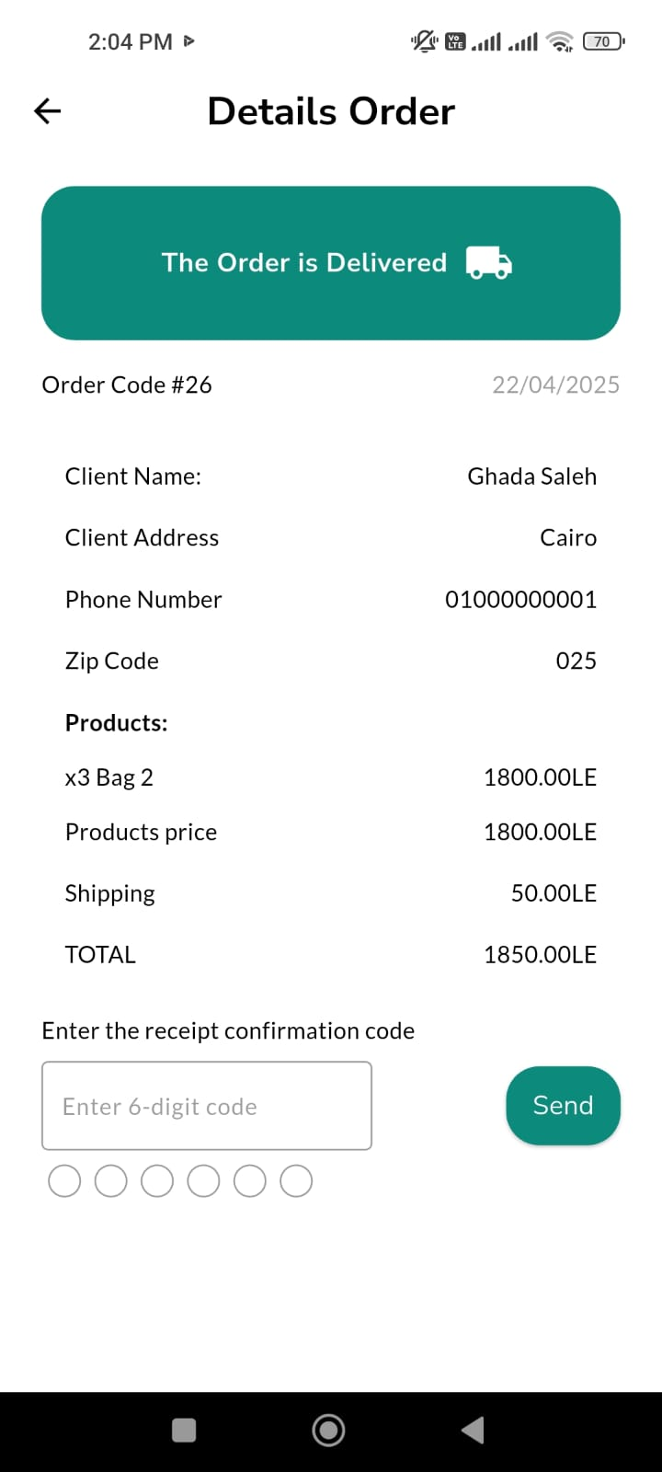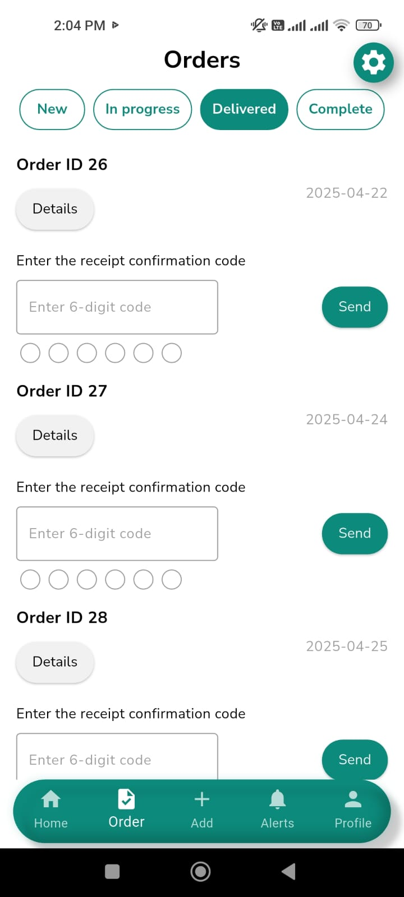

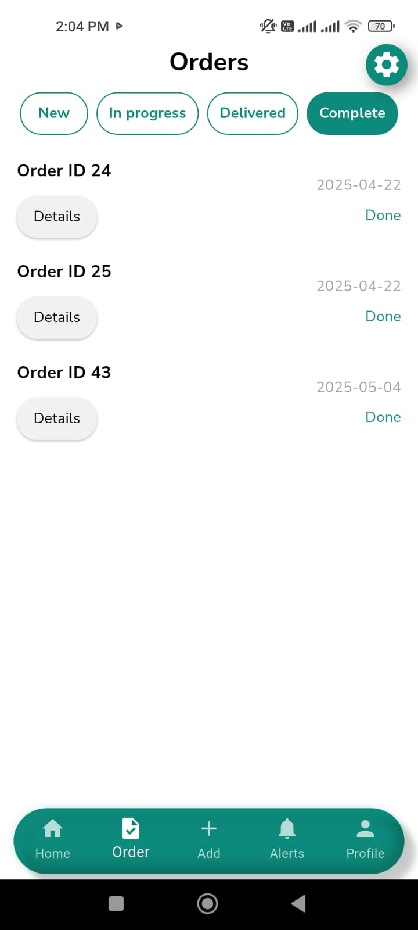

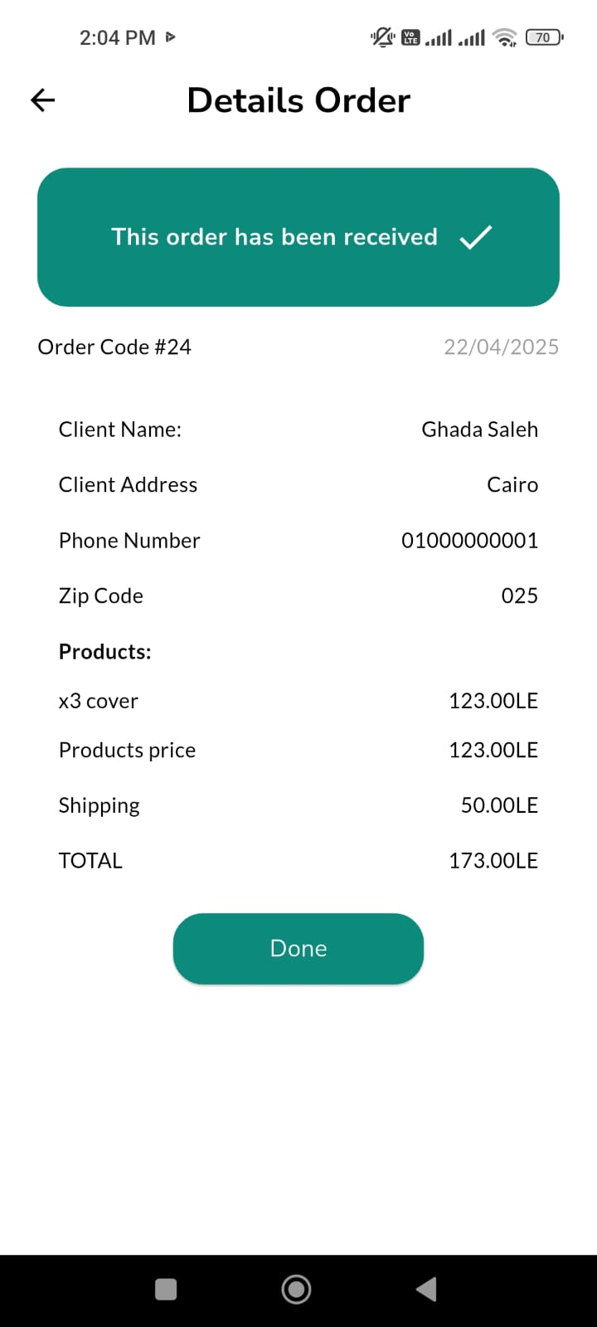

Customer orders sent to the Artisan are displayed on a dedicated page within the app, allowing them to track every order in detail. The steps are as follows:

Order Display:  
When the craftsman enters the "Orders" page, a list appears containing all received orders, sorted by arrival date or status.

Order Card Components:  
Each order is shown within a card that contains the following information:

* Product Name
* Customer Name
* Quantity Ordered
* Total Price
* Order Date
* Current Order Status (e.g., "In Progress", "Delivered", "Rejected")

Order Status Tracking:  
The craftsman can easily recognize the status of each order through the color or text shown on the card, making it easy to distinguish active orders from completed ones.

Order Management:  
Based on each order’s status, the craftsman can:

* Manually update the status (e.g., from "In Progress" to "Delivered").

Easy Tracking:  
The interface simplifies tracking all orders in one place, with the ability to revisit any previous order and view itsdetails**.**

**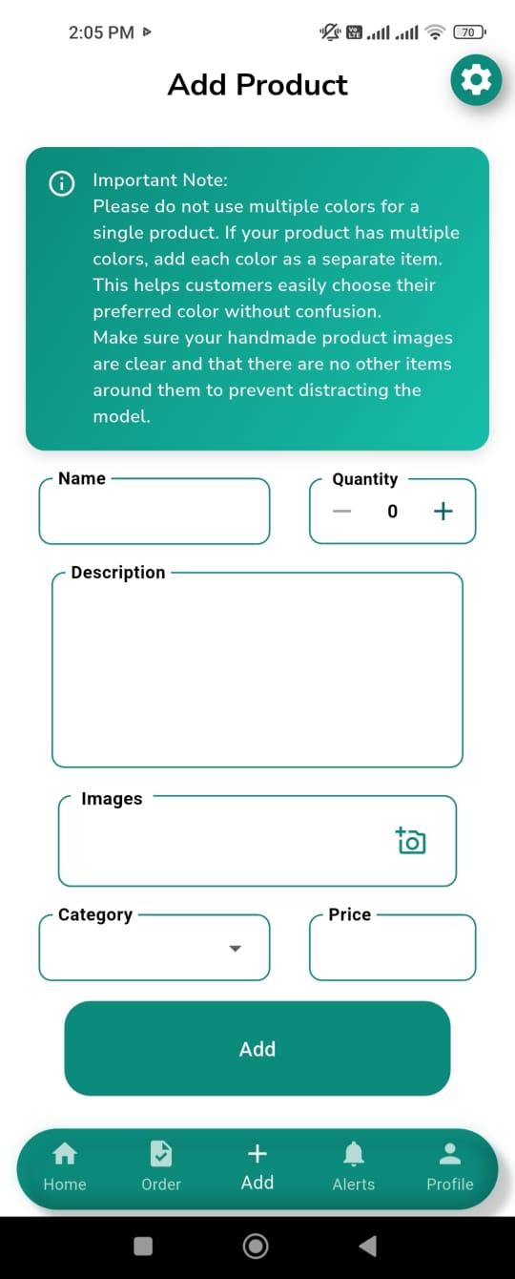**4.2.1.3.3 Add a Product Screen

The Artisan page allows users to add and manage

their products. It includes:

Adding a product with name, price, quantity,

category, and availability.

Uploading multiple product images.

AI-based product classification as

"Handmade" or "Factory-made".

The page offers a simple and efficient interface

for product management.

##### A screenshot of a phone AI-generated content may be incorrect.4.2.1.3.4. Profile Screen

###### 4.2.1.3.4.1. Show and Edit a Product Screen

The "My Profile" page allows the Artisan to

manage their products easily and clearly. It includes:

* A display of the craftsman’s current products
* in an organized card layout.

Each product card contains:

* Product image.
* Product name, category, and price.
* Product status (Available / Unavailable).
* An "Edit" button to modify the product details.

The Profile Settings page in the Herfa app allows users to fully manage their accounts with ease. Through this page, the artisan can update personal information, explore support options, and read the privacy policy to understand how their data is handled. They can also rate their experience with the app or securely log out at any time.

Each option on this page opens a dedicated section:

* **Profile:** Edit name, email address, and phone number.
* **Support:** Contact the support team.
* **Privacy Policy:** View data protection details.
* **Rate This App:** Rate and review the app.
* **Log Out:** Securely sign out of the account.

##### 4.2.1.3.5.Notifications Screen

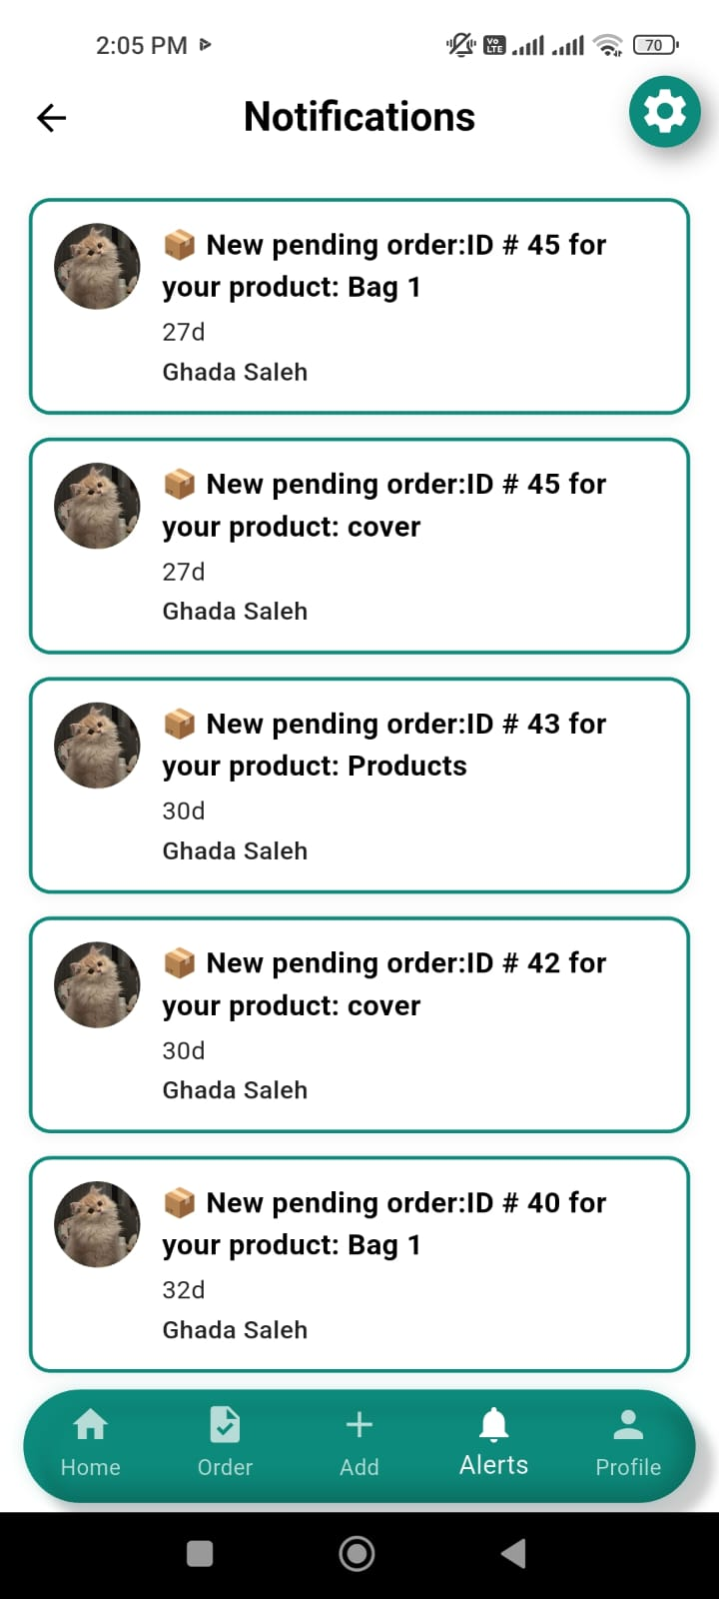The notifications page helps the Artisan stay updated on all important activities related to their products and orders. It includes:

* Real-time alerts when a customer places a new order.
* Clear messages showing the product name and order ID.
* The customer’s name and how long ago the order was placed.
* Easy access to recent order updates to take quick action.
* All notifications are displayed in a clean, organized list to help the Artisan manage their business smoothly.

This page ensures that the craftsman doesn’t miss any new activity and can respond quickly to customer requests or updates.

### 4.2.2 Mobile Application

**Mobile Application Implementation (Flutter)**

The mobile application was developed using Flutter, a modern open-source UI toolkit by Google, which allows building cross-platform applications from a single codebase. The purpose of the app is to enable users (Clients, Artisans, and Admins) to interact with the system based on their roles after authentication.

#### 4.2.2.1. Client Interface

**4.2.2.1.1.Login Screen

The Login Screen is the main entry point for authenticated access to the app. It provides a form that accepts:

Phone Number

Password

Upon submission, the app performs the following:

Form Validation: Ensures that both fields are not empty.

API Integration: Sends login credentials to the backend API using an asynchronous request.

Response Handling:

On success, it retrieves and stores the AccessToken, RefreshToken, and Role using SharedPreferences.

Based on the role returned (Admin, Client, or Artisan), the user is redirected to the appropriate dashboard.

On failure, specific error messages are shown using an AlertDialog, covering various scenarios like:

Account deactivated or deleted

Invalid credentials

Unexpected errors

Auto-login Feature: If the user had previously logged in, the app automatically checks stored tokens in initState() and redirects to the appropriate screen.

State Management

Basic local state management is handled using setState() for:

Loading indicators (isLoading)

Password visibility toggle (obscureText)

Input clearing on refresh

UI and UX Considerations

The UI is fully responsive and adapts to different screen sizes using MediaQuery.

It supports both light and dark themes dynamically.

Styling is enhanced using the GoogleFonts package for custom typography.

Navigation

Role-based navigation is implemented by checking the user’s role after login:

Admin: Redirected to CustomNavigatorAdmin.

Client: Redirected to CombinedNavigation.

Artisan: Redirected to CustomNavigator.

Security Considerations

Tokens are securely stored using SharedPreferences.

Only validated input is sent to the API.

Tokens are checked at startup to maintain session continuity securely.

##### 4.2.2.1.2.RegistrationScreen

**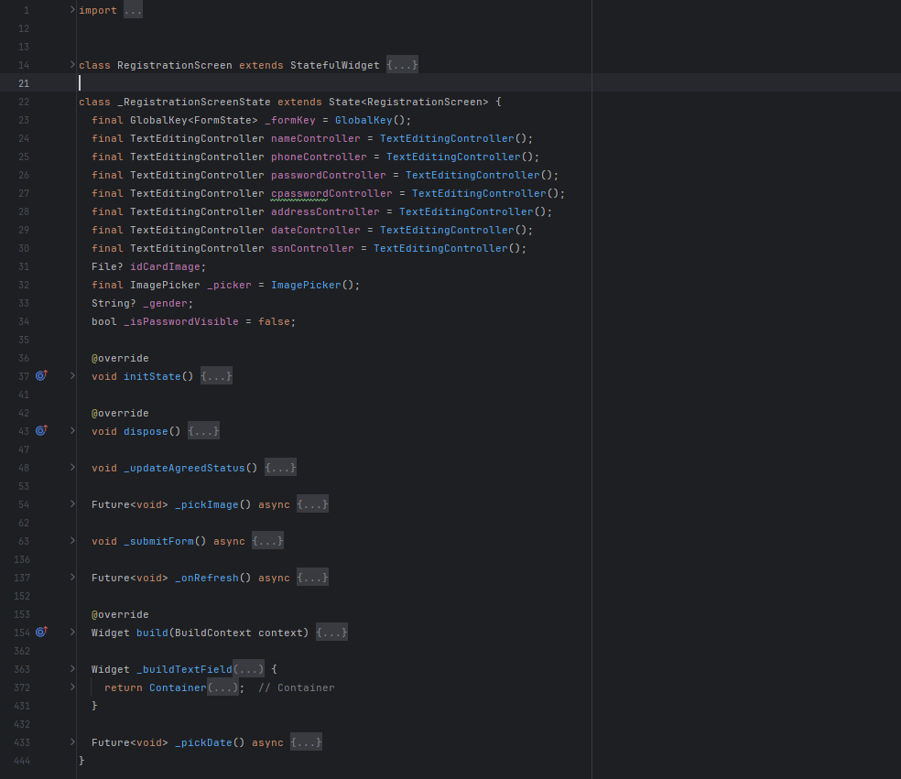**

This class defines a **user registration screen** in the **Herfa app**, allowing users to sign up as either **Artisan** or **Client** based on the role passed to the widget.

**Required Fields for Registration**

Full Name

Phone Number

Password + Confirm Password

Address

Birth Date (via DatePicker)

National ID (SSN)

Gender (Male/Female)

Upload ID Card Image

Agree to Terms and Conditions

**Validation Rules**

All fields must be filled.

Password and confirm password must match.

Gender must be selected.

ID card image must be uploaded.

Terms and conditions must be agreed to.

**Reset Functionality**

Pull-to-refresh resets all input fields and state using \_onRefresh().

**Form Submission: \_submitForm()**

Shows a loading spinner while submitting.

Sends data via ApiService.registerUser().

On success:

Navigates to the respective home screen:

CustomNavigator for artisans

CombinedNavigation for clients

On failure:

Displays an error message using SnackBar.

**UI Highlights**

Supports both light and dark modes.

Fully responsive layout based on screen dimensions.

Image picker integration for uploading the ID card.

Includes preview of the selected image.

Clean, modern UI using GoogleFonts and themed colors.

**Key Dependencies/Imports**

shared\_state.dart: Tracks terms agreement status.

terms\_screen.dart: Terms and conditions screen.

ApiService: Handles API calls for registration.

customNavigator.dart and customNavigatorClient.dart: Role-based navigation.

image\_picker: For selecting an ID image.

intl: For date formatting.

##### 4.2.2.1.3.Home

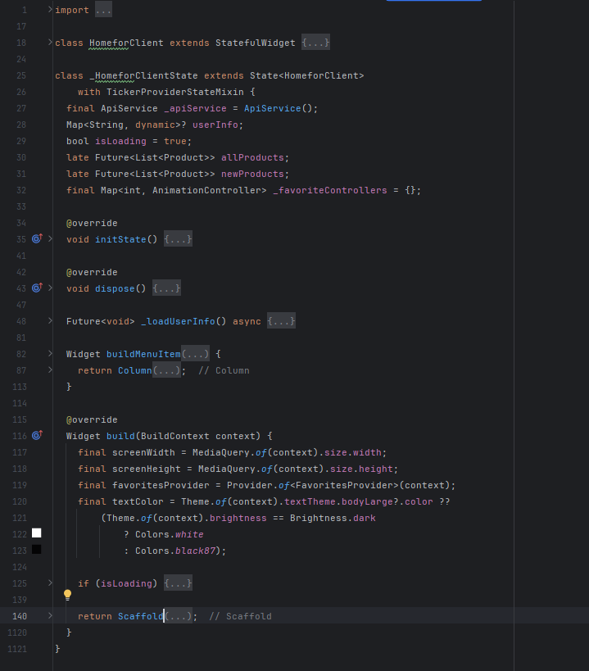

**Purpose:** The HomeforClient widget is the main client dashboard for an e-commerce app, showcasing user info, recommended and new products, and navigation to categories, artisan profiles, and settings.

**Key Features:**

Displays user profile (name, image), horizontal product lists (recommended/new, 10 items each), and a favorites system with animated toggling.

Includes a drawer menu for notifications, support, terms, privacy policy, and about us.

Supports pull-to-refresh for data updates.

State:

userInfo: Stores user data (e.g., image, name) from ApiService.

isLoading: Tracks user info loading.

allProducts, newProducts: Futures for product data.

\_favoriteControllers: Manages favorite icon animations.

**Functionality:**

Initialization: Fetches user info and products (fetchAllProductsFull2, fetchLatestProducts) on initState.

User Info: Shows name and image with error handling via SnackBar.

Product Lists: Displays sorted products (by ID) with images, names, prices, descriptions, and artisan avatars (links to ArtisanProfileforClient). Tapping navigates to ProductDetails.

Favorites: Toggles via FavoritesProvider with animated feedback and SnackBar notifications.

Navigation: AppBar links to CategoriesScreen; drawer navigates to settings pages.

Error Handling: Redirects to LoginScreen for unauthorized errors, shows retry options for product fetch failures, and handles image errors with fallback icons.

UI:

Responsive with GoogleFonts.lato, light/dark theme support, and CachedNetworkImage for efficient image loading.

Includes static banners (home1.png, home2.png).

Dependencies:

Packages: flutter/material, google\_fonts, cached\_network\_image, provider.

Internal: ApiService, FavoritesProvider, LoginScreen, CategoriesScreen, ArtisanProfileforClient, AllProductsScreen, ProductDetails, settings pages.

Usage:

Integrated via Navigator.push to HomeforClient.

Requires ApiService, FavoritesProvider, and asset images.

Customizable for product limits or UI styles.

Notes:

Performance: Optimized with cached images and limited product display.

Limitations: Fixed 10-product limit per section; no filtering/sorting.

Scalability: Can add personalized recommendations or more categories.

##### 4.2.2.1.4.Categories Screen

**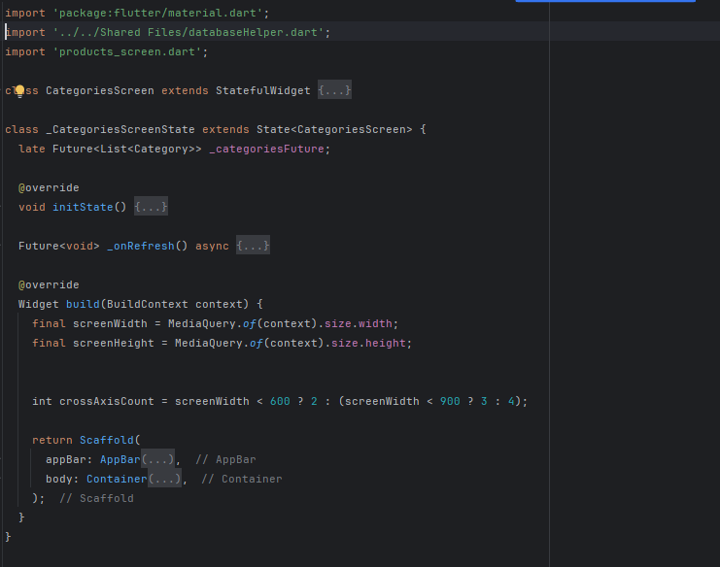**

This screen displays all available product categories in a grid layout, each showing:

* The category name
* The number of products
* An image representing the category (from the first product)

Key Features:

Data Fetching

* On initialization (initState), the app fetches categories using ApiService().fetchCategories().
* Uses FutureBuilder to manage loading, success, and error states.
* Pull-to-refresh is supported using RefreshIndicator to reload the category list.

Grid Display

* Responsive grid layout:
  + 2 columns on small screens,
  + 3 on medium,
  + 4 on large.
* Each card includes:
  + Background image (network image or fallback icon),
  + Category name,
  + Product count.

Navigation

* On tapping a category, navigates to ProductsScreen with the selected category name.

Theming

* Fully supports dark mode and light mode.
* Uses gradient background and adapts text/image colors based on the theme.

Error & Loading Handling

* While fetching: shows CircularProgressIndicator.
* On error: displays error message.
* If no categories: shows "No categories available" message.

Dependencies

* ApiService().fetchCategories() for API calls.
* databaseHelper.dart likely holds the Category model.
* products\_screen.dart for navigating to product listings by category.

##### 4.2.2.1.5. Cart Screen Implementation

**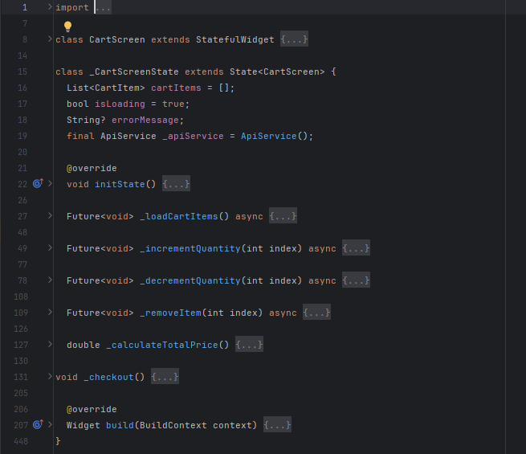**

**Purpose:** Cart Screen is a StatefulWidget that displays the user's cart items, allows them to modify quantities, remove items, and proceed to checkout. It communicates with an API to reflect these actions on the backend.

**Main Functionalities:**

* **Display Cart Items:**
  + Fetches cart items from API using \_apiService.getCartItems().
  + Displays product image, name, artisan, price, and quantity.
* **Update Item Quantity:**
  + Increments or decrements the quantity of a product in the cart.
  + Calls updateCartItemQuantity(cartId, newQuantity) on the API.
* **Remove Item:**
  + Deletes an item from the cart using deleteCartItem(cartId).
* **Checkout Process:**
  + Calculates the total price.
  + Opens a bottom sheet with a summary and navigates to the CheckoutScreen.
* **Error Handling:**
  + Catches and displays errors when loading, updating, or removing items.
  + Provides retry button when loading fails.

**Key Components:**

* **List<CartItem> cartItems**
  + Holds the current items in the cart.
* **bool isLoading / String? errorMessage**
  + Used to control UI states (loading, error, data).
* **ApiService \_apiService**
  + Handles network requests related to cart operations.
* **Widgets Used:**
  + ListView.builder: To display cart items.
  + CachedNetworkImage: For efficient product image loading.
  + RefreshIndicator: To allow pull-to-refresh.
  + SnackBar: To display messages to the user.
  + showModalBottomSheet: For displaying checkout confirmation.

**Navigation:**

* Navigates to CheckoutScreen on pressing "Go to Payment", passing:
  + totalPrice
  + cartItems

**Theming Support:**

* Adapts text and background colors based on Brightness.dark or Brightness.light.

**Lifecycle Methods:**

* initState():
  + Calls \_loadCartItems() to fetch data when the screen loads.

**Recommendations for Contributors:**

* Consider refactoring the cart item UI into a separate widget for maintainability.
* Add swipe-to-delete functionality for better UX.
* Add loading indicators inside buttons during network calls for visual feedback.

##### 4.2.2.1.6. My Order Screen

**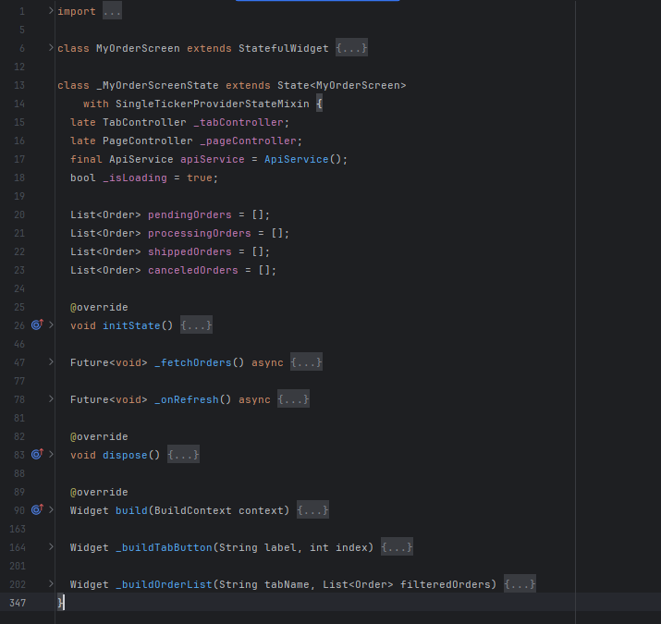**

**Purpose**:  
Displays and manages the user's orders, categorized by status (Pending, Processing, Shipped, Cancelled), with the ability to refresh, navigate to details, and cancel pending orders.

**Dependencies**

* flutter/material.dart
* google\_fonts/google\_fonts.dart
* databaseHelper.dart (custom API service)
* order\_details.dart (detailed order screen)

**State Variables**

* TabController \_tabController: Controls the tab selection.
* PageController \_pageController: Manages the swiping between pages.
* ApiService apiService: Handles API calls (fetching and canceling orders).
* \_isLoading: Controls loading spinner visibility.
* pendingOrders, processingOrders, shippedOrders, canceledOrders: Lists storing orders filtered by status.

**Lifecycle Methods**

* initState():
  + Initializes controllers.
  + Adds listeners to synchronize tab and page controllers.
  + Fetches orders from the API.
* dispose(): Disposes of controllers to free resources.

**Core Functionality**

* \_fetchOrders()  
  Fetches orders for each status category using the apiService, updates UI accordingly.
* \_onRefresh()  
  Triggers re-fetching of all order lists via pull-to-refresh.
* \_buildTabButton(label, index)  
  Custom tab button that changes style based on selection and updates the view.
* \_buildOrderList(tabName, filteredOrders)  
  Displays the order list for each status with "Details" and optional "Cancel" buttons.

**UI Overview**

* AppBar:
  + Custom-styled title using Google Fonts.
  + Horizontal scrollable tab buttons below title.
* Body:
  + Loading indicator shown when data is loading.
  + PageView shows four different pages for each status.
  + ListView.builder used to render each order in the list.

**Features**

* Synchronization between tab buttons and swiped pages.
* Fully responsive layout based on screen dimensions.
* Dark and light mode compatibility.
* Error and success messages via SnackBar.
* Cancel functionality only available for "Pending" orders.

##### 4.2.2.1.7.Search Screen

**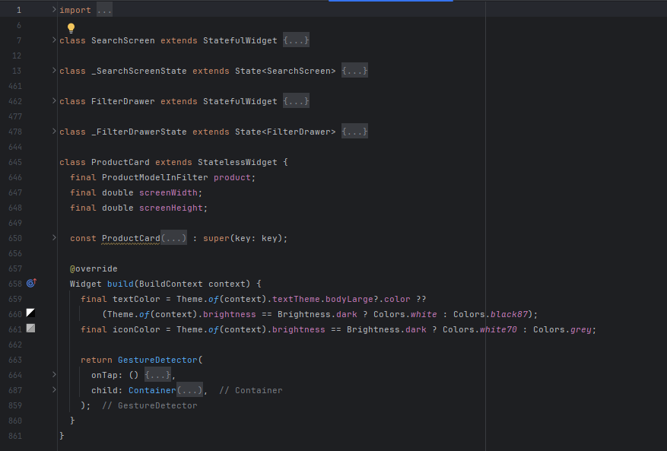**

**Purpose**: The SearchScreen is a Flutter widget for an e-commerce app, enabling users to search products by name, apply filters (category, price, rating), view recent searches, and browse products in a responsive grid.

**Key Components:**

SearchScreen (StatefulWidget):

Features: Search bar, recent searches, filter drawer, pull-to-refresh, and product grid.

State: Manages products (\_allProducts, \_filteredProducts), filters (currentFilters), loading/error states, and search input with 500ms debouncing.

Functionality: Performs local search (no filters) or server-side search (with filters), saves recent searches, and handles errors (e.g., login prompts, session expiry).

FilterDrawer (StatefulWidget):

Features: Category selection (single choice), price range (0–5000 LE), minimum rating (1–5 stars), reset/apply buttons.

Functionality: Updates filters via onFiltersChanged callback, displays active filters as removable chips.

ProductCard (StatelessWidget):

Features: Displays product image, name, price, rating, stock status, and badges ("Sale", "Out of Stock").

Functionality: Navigates to ProductDetails on tap, uses CachedNetworkImage for efficient image loading.

**Functionality:**

Search: Debounced input triggers local (name-based) or server-side (filtered) searches; recent searches are saved.

Filtering: Users apply category, price, and rating filters via FilterDrawer, with active filters shown as chips.

Product Display: Products shown in a two-column grid, with stock status (in/low/out) and sale indicators.

Error Handling: Handles API/auth errors with retry/login prompts.

Refresh: Pull-to-refresh reloads products.

Theme: Supports light/dark themes with dynamic colors.

**Dependencies:**

Packages: cached\_network\_image, flutter/material.

Internal: ApiService, ProductModelInFilter, AuthService, ProductDetails, navigation routes (/login).

**Usage:**

Integrate via Navigator.push to SearchScreen.

Requires ApiService for product fetching and ProductModelInFilter for data.

Customizable: Adjust categories, price ranges, or UI styles.

**Notes:**

Scalable but assumes single-category filtering and hardcoded price limits.

Efficient with debouncing and image caching.

Comprehensive error handling enhances UX.

#### 4.2.2.2.Artisan Interface

##### 4.2.2.2.1.home screen

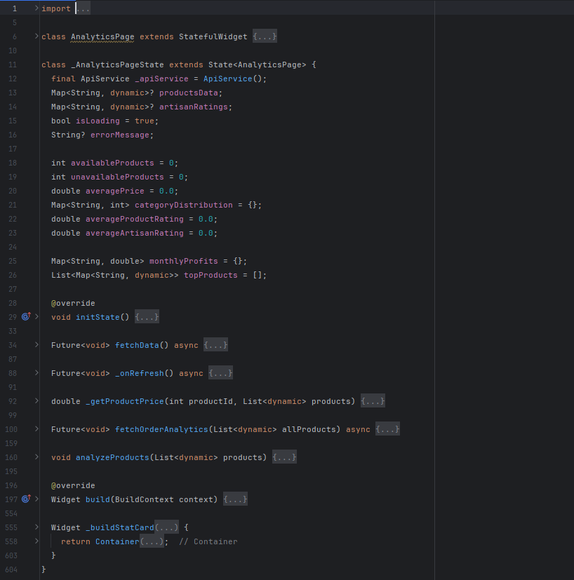

**Purpose**: The AnalyticsPage is a Flutter widget for an e-commerce app, providing artisans with a dashboard to view product and sales analytics, including product availability, ratings, category distribution, monthly profits, and top-selling products.

**Key Components**:

**AnalyticsPage (StatefulWidget)**:

**Features**: Displays stats (available/unavailable products, average price, ratings), category distribution, monthly profits, top products, and a product overview table.

**State**:

productsData, artisanRatings: Store API responses.

isLoading, errorMessage: Manage loading/error states.

Metrics: availableProducts,unavailableProducts,averagePrice, averageProductRating, averageArtisanRating, categoryDistribution, monthlyProfits, topProducts.

**Functionality**:

Fetches user info, products, and artisan ratings via ApiService.

Analyzes products for availability, price, ratings, and categories.

Computes monthly profits and top products from delivered orders.

Supports pull-to-refresh to reload data.

**Functionality**:

**Initialization**: On initState, fetches data (fetchData) for user info, products, and artisan ratings concurrently, then analyzes orders.

**Data Fetching**:

Uses ApiService methods: getMyInformation, getProducts, getArtisanRatings, getOrdersByStatus, getOrderDetails.

Handles errors by displaying messages.

**Product Analysis** (analyzeProducts):

Counts available/unavailable products based on quantity/status.

Calculates average price and product rating.

Maps category distribution.

**Order Analytics** (fetchOrderAnalytics):

Processes delivered orders to compute monthly profits (price × quantity).

Identifies top 5 products by sales volume.

**UI**:

**Stat Cards**: Show key metrics (e.g., available products, average price) with colored backgrounds.

**Lists**: Display category distribution, monthly profits, and top products.

**DataTable**: Shows product details (name, price, quantity, status, rating).

**Refresh**: Pull-to-refresh reloads all data.

**Theme**: Supports light/dark modes with GoogleFonts.nunitoSan.

**Dependencies**:

**Packages**: flutter/material, google\_fonts, intl (for date formatting).

**Internal**: ApiService, navigation routes.

**Usage**:

Integrate via Navigator.push to AnalyticsPage.

Requires ApiService implementation for API calls.

Customizable: Adjust UI styles or add metrics.

**Notes**:

**Performance**: Uses Future.wait for concurrent API calls.

**Error Handling**: Displays errors for failed API requests.

**Limitations**: Assumes single artisan (SSN-based); no filtering for time periods.

**Scalability**: Easily extendable for additional metrics or visualizations.

##### 4.2.2.2.2.Profile Artisan

**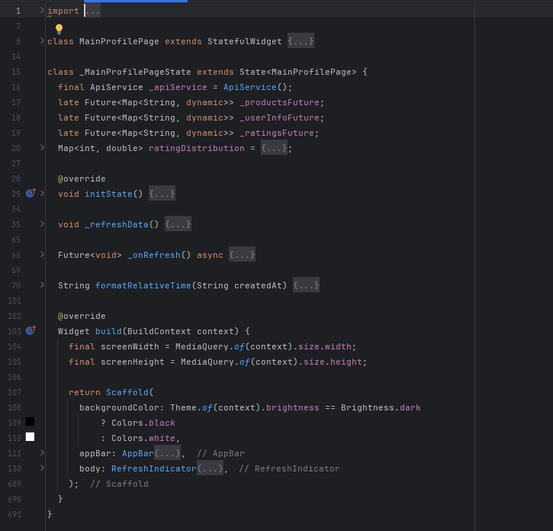**

**Purpose:** The MainProfilePage is a Flutter widget for an e-commerce app, serving as an artisan's profile dashboard. It displays the artisan’s profile information, their products, and customer reviews, with options to edit products and refresh data.

**Key Components:**

MainProfilePage (StatefulWidget):

Features: Shows artisan’s name and image, a grid of their products, and a list of reviews with ratings. Supports pull-to-refresh and navigation to profile and product editing pages.

Functionality:

Fetches artisan’s products, profile info, and ratings on initialization (initState).

Calculates rating distribution based on artisan ratings.

Supports refreshing data with \_onRefresh.

Formats review timestamps (e.g., "2h ago", "1mo ago") using formatRelativeTime.

**Functionality:**

Initialization: On initState, initializes futures for products, user info, and ratings, with \_refreshData to reload data.

Data Fetching:

Uses ApiService methods: getProducts, getMyInformation, getArtisanRatings.

Fetches artisan’s SSN from user info to retrieve ratings.

Handles errors by displaying messages (e.g., "Error loading products").

Profile Section:

Displays artisan’s name (clickable to ProfilePage) and image (with fallback icon if unavailable).

Uses FutureBuilder to handle asynchronous data loading.

Products Section:

Shows products in a two-column grid with images, names, prices, and statuses (e.g., Available, Not Available).

Each product card has an "EDIT" button navigating to Edit\_Product with product data.

Handles image loading errors with a fallback icon.

Reviews Section:

Lists reviews with client name, image, rating (1–5 stars), comment, and relative timestamp.

Displays "No reviews available" if none exist.

UI:

Responsive design with GoogleFonts.nunitoSans for consistent typography.

Supports light/dark themes with dynamic colors.

Uses RefreshIndicator for pull-to-refresh.

Error Handling: Shows error messages for failed API calls; handles invalid dates and image loading errors.

**Dependencies:**

Packages: flutter/material, google\_fonts.

Internal: ApiService, ProfilePage, Edit\_Product, ProductDetailsPage.

**Usage:**

Integrate via Navigator.push to MainProfilePage.

Requires ApiService implementation and navigation routes for ProfilePage, Edit\_Product, and ProductDetailsPage.

Customizable: Adjust grid layout, styling, or add more profile details.

**Notes:**

Performance: Uses Future.wait for concurrent API calls; handles image loading efficiently.

Error Handling: Robust handling for API, image, and date parsing errors.

Limitations: Assumes single artisan (SSN-based); no sorting/filtering for products or reviews.

Scalability: Can extend to include more profile metrics or sorting options.

##### 4.2.2.2.3. Orders Screen

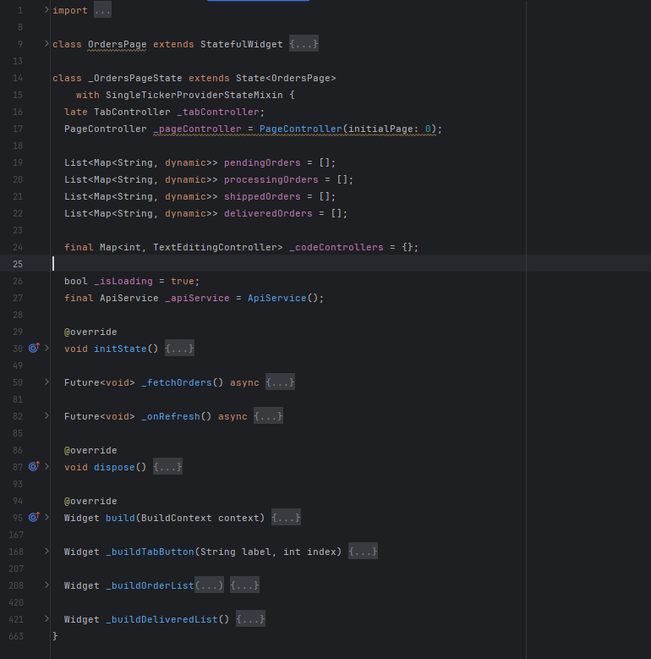

**Purpose**: The OrdersPage is a Flutter widget for an e-commerce app, providing artisans with a dashboard to manage orders across four statuses: New (Pending), In Progress (Processing), Delivered (Shipped), and Complete (Delivered). It allows viewing order details, accepting orders, shipping orders, and confirming delivery with a code.

**Key Components**:

**OrdersPage (StatefulWidget)**:

**Features**: Tabbed interface for order statuses, order lists with actions (accept, ship, confirm delivery), and navigation to detailed order pages. Supports pull-to-refresh.

**State**:

pendingOrders, processingOrders, shippedOrders, deliveredOrders: Lists of orders by status.

\_codeControllers: Manages text input for delivery confirmation codes.

\_isLoading: Tracks loading state.

\_tabController, \_pageController: Synchronize tab and page navigation.

**Functionality**:

Fetches orders by status (Pending, Processing, Shipped, Delivered) using ApiService.

Supports actions: accept orders (New), ship orders (In Progress), confirm delivery with a 6-digit code (Delivered).

Navigates to status-specific detail pages (OrderDetailsNew, OrderDetailsInProgress, OrderDetailsDelivered, OrderDetailsComplete).

Refreshes data with pull-to-refresh.

**Functionality**:

**Initialization**: On initState, fetches orders (\_fetchOrders) and sets up TabController and PageController for synchronized navigation.

**Data Fetching**:

Uses ApiService.getOrdersByStatus to retrieve orders for each status.

Filters out erroneous orders and initializes text controllers for delivery codes.

**Tabs and Navigation**:

Four tabs: New, In Progress, Delivered, Complete, implemented as buttons with ElevatedButton.

PageView displays order lists, synced with tabs via \_tabController and \_pageController.

**Order Lists**:

**New**: Shows order ID, date, and "Accept" button to move to Processing.

**In Progress**: Shows order ID, date, and "Send" button to move to Shipped.

**Delivered**: Shows order ID, date, and a 6-digit code input for delivery confirmation, with visual code entry indicators.

**Complete**: Shows order ID, date, and "Done" status.

Each order has a "Details" button linking to a status-specific details page.

**Actions**:

**Accept**: Calls ApiService.acceptOrder to update order status.

**Ship**: Calls ApiService.shipOrder to update order status.

**Confirm Delivery**: Validates 6-digit code via ApiService.confirmDelivery, updates status on success.

Shows success/error SnackBar messages for actions.

**UI**:

Responsive design with GoogleFonts.nunitoSans for typography.

Supports light/dark themes with dynamic colors.

Displays loading indicator or "No orders" message when applicable.

**Error Handling**: Filters out erroneous API responses; shows SnackBar for action failures.

**Dependencies**:

**Packages**: flutter/material, google\_fonts.

**Internal**: ApiService, OrderDetailsNew, OrderDetailsInProgress, OrderDetailsDelivered, OrderDetailsComplete.

**Usage**:

Integrate via Navigator.push to OrdersPage.

Requires ApiService implementation for order fetching and status updates.

Customizable: Adjust tab styles, add sorting, or modify order actions.

**Notes**:

**Performance**: Efficiently manages controllers and API calls; synchronizes tab/page navigation.

**Error Handling**: Robust handling for API errors and invalid inputs (e.g., code length).

**Limitations**: No sorting/filtering for orders; assumes fixed status flow.

**Scalability**: Can extend to include more statuses or order metrics.

##### 4.2.2.2.4. Add product screen

**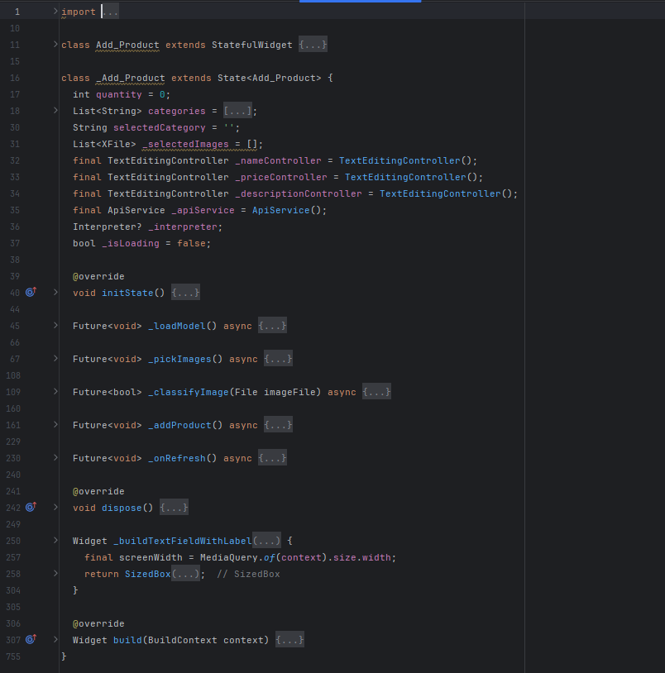**

**Purpose**: The Add\_Product Flutter widget enables artisans in an e-commerce app to add handmade products, featuring a form for product details, image uploads validated by a TensorFlow Lite model, and category selection.

**Key Components:**

Add\_Product (StatefulWidget):

Features: Form for product name, price, quantity, description, category, and images. Uses ML to ensure images are handmade. Supports pull-to-refresh and navigates to MainProfilePage on success.

State:

quantity, selectedCategory, \_selectedImages: Track form inputs.

\_nameController, \_priceController, \_descriptionController: Manage text fields.

\_isLoading: Tracks loading state.

\_interpreter: TensorFlow Lite model for image classification.

Functionality:

Loads TensorFlow Lite model (model\_no\_quant.tflite) to classify images.

Validates inputs and images before submission via ApiService.addProduct.

Resets form on refresh or successful submission.

**Functionality:**

Image Validation: Uses ImagePicker for multi-image selection; resizes images to 224x224, classifies them as handmade or machine-made. Rejects machine-made images (≥40% confidence).

Form:

Name, price (numeric), quantity (increment/decrement), description (multi-line), category (dropdown), images (upload/delete).

Warns against multi-color products or unclear images.

Submission: Validates inputs (non-empty, valid price, quantity > 0, etc.), submits via API, shows success/error SnackBar, and redirects to MainProfilePage.

Refresh: Clears form fields.

UI: Responsive, light/dark theme support, GoogleFonts.nunitoSans typography.

Error Handling: Alerts for model loading issues, SnackBar for invalid inputs or API errors.

**Dependencies:**

Packages: flutter/material, google\_fonts, image\_picker, tflite\_flutter, image.

Internal: ApiService, MainProfilePage.

**Usage:**

Integrate via Navigator.push to Add\_Product.

Requires ApiService.addProduct and TensorFlow Lite model in assets.

**Notes:**

Performance: Efficient image processing and API calls.

Limitations: Fixed 40% machine-made threshold; single-color product assumption.

Scalability: Extendable for more fields or validation rules.

#### 4.2.2.3.Admin Interface

##### 4.2.2.3.1.Artisans Management Screen

**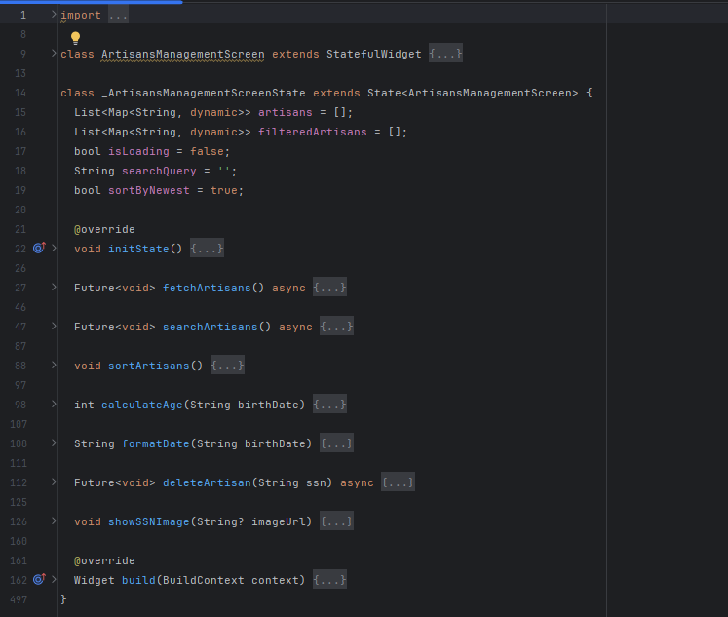**

**Purpose:** The ArtisansManagementScreen widget is an administrative dashboard for managing artisans in an e-commerce app, allowing admins to view, search, and sort artisans, edit their profiles, delete accounts, and inspect SSN images.

Key Features:

Displays a list of artisans with details like name, phone, SSN, age, gender, status (active/inactive), and address.

Supports searching by phone or SSN, sorting by newest/oldest ID, and refreshing data via ApiService.

Provides actions to edit artisan profiles, delete artisans, and view SSN images in a dialog.

State:

artisans: Stores all artisans data fetched from ApiService.

filteredArtisans: Stores filtered artisans and sorted artisans list for display.

isLoading: Tracks loading state for data fetching.

searchQuery: Holds the current search input.

sortByNewest: Toggles sorting order (newest/oldest).

Functionality:

Initialization: Fetches all artisans (fetchArtisans) on initState.

Data Fetching: Uses ApiService.getAllArtisans to retrieve artisan data; shows error SnackBar if failed.

Search (searchArtisans): Filters artisans by phone or SSN (case-insensitive, space-removed); resets to full list if query is empty.

Sort (sortArtisans): Sorts artisans by SSN substring (first 3 digits) in newest/oldest order.

Age Calculation (calculateAge): Computes age from birth date.

Date Formatting (formatDate): Formats birth date to dd/MM/yyyy.

Delete Artisan (deleteArtisan): Deletes artisan via ApiService.deleteArtisan, refreshes list on success, shows SnackBar for success/error.

SSN Image (showSSNImage): Displays SSN image in a dialog; shows error if unavailable.

Navigation: Tapping an artisan card navigates to ArtisanProfile; edit button navigates to EditArtisanScreen, refreshing data on return if edited.

UI:

Responsive with GoogleFonts.nunitoSans typography, light/dark theme support.

Features a search bar, sort dropdown, and refreshable ListView of artisan cards.

Each card shows name, gender, phone, SSN, address, age, status, SSN image, and edit/delete buttons.

Uses Card with RoundedRectangleBorder and teal border for styling.

Dependencies:

Packages: flutter/material, google\_fonts, intl.

Internal: ApiService, ArtisanProfile, EditArtisanScreen.

Usage:

Integrated via Navigator.push to ArtisansManagementScreen.

Requires ApiService implementation for artisan data and actions.

Customizable for additional filters or UI styles.

**Notes:**

**Performance:** Efficient with filtered list management and lazy loading.

**Error Handling:** Robust for API errors, invalid data, and image loading failures.

**Limitations:** Sorting based on SSN substring; search limited to phone/SSN.

**Scalability:** Can add more filters (e.g., name, status) or advanced sorting.

##### 4.2.2.3.2. Clients Management Screen

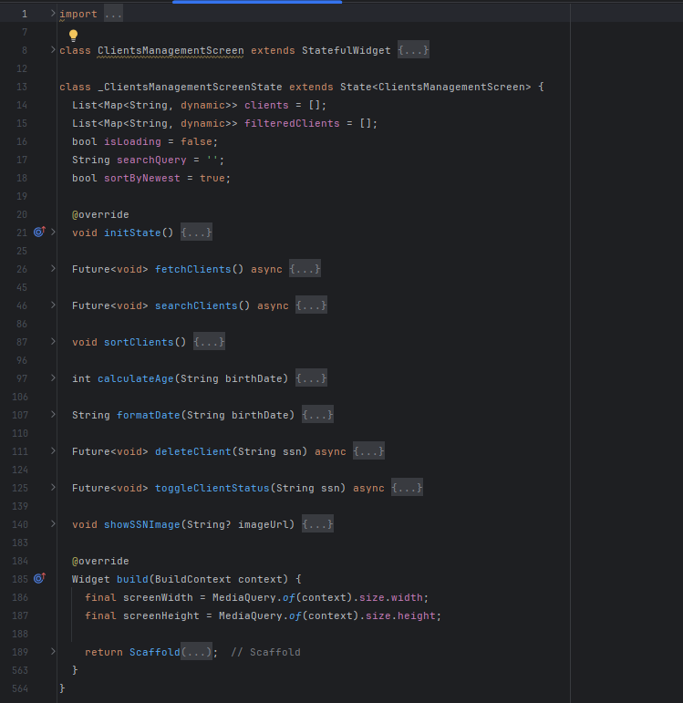

**Purpose**: The ClientsManagementScreen widget is an administrative dashboard for managing clients in an e-commerce app, enabling admins to view, search, sort, edit, delete, toggle account status, and inspect SSN images of clients.

**Key Features**:

Displays a list of clients with details like name, phone, SSN, age, gender, status (active/inactive), and address.

Supports searching by phone or SSN, sorting by newest/oldest ID, and refreshing data via ApiService.

Allows editing client profiles, deleting clients, toggling account status (active/inactive), and viewing SSN images in a dialog.

**State**:

clients: Stores all client data fetched from ApiService.

filteredClients: Stores filtered and sorted client list for display.

isLoading: Tracks loading state for data fetching.

searchQuery: Holds current search input.

sortByNewest: Toggles sorting order (newest/oldest).

**Functionality**:

**Initialization**: Fetches all clients (fetchClients) on initState.

**Data Fetching**: Uses ApiService.getAllClients to retrieve client data; shows error SnackBar if failed.

**Search** (searchClients): Filters clients by phone or SSN (case-insensitive, space-removed); resets to full list if query is empty.

**Sort** (sortClients): Sorts clients by SSN substring (first 3 digits) in newest/oldest order.

**Age Calculation** (calculateAge): Computes age from birth date.

**Date Formatting** (formatDate): Formats birth date to dd/MM/yyyy.

**Delete Client** (deleteClient): Deletes client via ApiService.deleteClient, refreshes list on success, shows SnackBar for success/error.

**Toggle Status** (toggleClientStatus): Toggles client status via ApiService.toggleClient, refreshes list, shows SnackBar.

**SSN Image** (showSSNImage): Displays SSN image in a dialog; shows error if unavailable.

**Navigation**: Edit button navigates to EditClientScreen, refreshing data on return if edited.

**UI**:

Responsive with GoogleFonts.nunitoSans typography, light/dark theme support.

Features a search bar, sort dropdown, and refreshable ListView of client cards.

Each card shows name, gender, phone, SSN, address, age, status, SSN image, and edit/delete/toggle buttons.

Uses Card with RoundedRectangleBorder and teal border for styling.

**Dependencies**:

**Packages**: flutter/material, google\_fonts, intl.

**Internal**: ApiService, EditClientScreen.

**Usage**:

Integrated via Navigator.push to ClientsManagementScreen.

Requires ApiService implementation for client data and actions.

Customizable for additional filters or UI styles.

**Notes**:

**Performance**: Efficient with filtered list management and lazy loading.

**Error Handling**: Robust for API errors, invalid data, and image loading failures.

**Limitations**: Sorting based on SSN substring; search limited to phone/SSN.

**Scalability**: Can add more filters (e.g., name, status) or advanced sorting.

##### A screenshot of a computer program AI-generated content may be incorrect.4.2.2.3.3.Complaints and Supports Screen

**Purpose**: The ComplaintsScreen widget is an administrative interface for managing complaints in an e-commerce app, allowing admins to view and handle new and resolved complaints with details navigation.

**Key Features**:

Displays complaints in two tabs: "New" and "Resolved," fetched via ApiService.

Supports pull-to-refresh for updating complaint lists.

Allows navigation to ComplaintDetailsScreen for detailed complaint information.

Handles loading states and errors with appropriate UI feedback.

**State**:

\_tabController: Manages tab navigation (New/Resolved).

newComplaints, resolvedComplaints: Lists of Complaint objects for each status.

isLoading: Tracks data fetching state.

errorMessage: Stores error messages for display.

\_apiService: Instance of ApiService for API calls.

**Functionality**:

**Initialization**:

Sets up TabController and fetches complaints (\_loadComplaintsFromApi) on initState.

**Data Fetching**: Uses ApiService.fetchComplaintsByStatus to retrieve complaints by status ("New" or "Resolved"); maps JSON to Complaint objects.

**Tabs**:

**New Complaints**: Lists unresolved complaints with user name, date, and "Details" button.

**Resolved Complaints**: Lists resolved complaints with user name, date, "Done" status, and "Details" button.

**Navigation**: "Details" button navigates to ComplaintDetailsScreen; refreshes complaints if changes are made.

**Refresh**: Pull-to-refresh reloads complaints for both tabs.

**Error Handling**:

Displays error messages (e.g., "Unauthorized" for 401 errors) with a "Retry" button.

Shows "No complaints" message for empty lists.

**Disposal**: Properly disposes of TabController.

**UI**:

Responsive with GoogleFonts.nunitoSans typography, light/dark theme support.

Features a TabBar with custom indicator and refreshable ListView of complaint cards.

Cards display user name, date, and action buttons; resolved cards show "Done" in green.

Uses Card and ElevatedButton for consistent styling.

**Dependencies**:

**Packages**: flutter/material, google\_fonts.

**Internal**: ApiService, Complaint model, ComplaintDetailsScreen.

**Usage**:

Integrated via Navigator.push to ComplaintsScreen.

Requires ApiService implementation for complaint data and Complaint model for data mapping.

Customizable for additional complaint statuses or UI enhancements.

**Notes**:

**Performance**: Efficient with lazy loading and minimal state updates.

**Error Handling**: Robust for API errors, including unauthorized access.

**Limitations**: Only supports "New" and "Resolved" statuses; no sorting/filtering.

**Scalability**: Can add more tabs (e.g., "In Progress") or advanced filtering.

##### 4.2.2.3.4. Custom Navigator Screen

**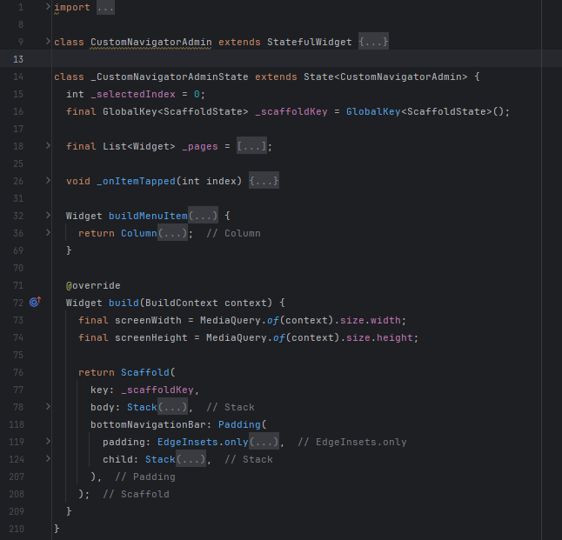**

**Purpose**: The CustomNavigatorAdmin widget serves as the main navigation hub for admins in an e-commerce app, providing access to key administrative screens via a bottom navigation bar and a notification button.

**Key Features**:

Navigates between five admin screens: Dashboard, Artisans Management, Orders Management, Clients Management, and Complaints.

Features a bottom navigation bar with icons and labels for each screen.

Includes a floating notification button to access NotificationsScreen.

Supports responsive design with light/dark theme compatibility.

**State**:

\_selectedIndex: Tracks the currently selected navigation item (default: 0).

\_scaffoldKey: Manages the Scaffold for potential drawer or snackbar interactions.

\_pages: List of widgets for each navigation screen (DashboardPage, ArtisansManagementScreen,OrdersManagementScreen, ClientsManagementScreen, ComplaintsScreen).

**Functionality**:

**Navigation**: Updates \_selectedIndex on bottom navigation bar tap, displaying the corresponding screen from \_pages.

**Notification Button**: Positioned at top-right, navigates to NotificationsScreen on tap.

**Bottom Navigation Bar**:

Displays five items: Home (Dashboard), Artisan, Order, Client, and Complaint.

Uses icons (including a custom asset for Artisan) and labels; supports selected/unselected states with color changes.

Styled with a custom Container for rounded corners, shadow, and teal background (Color(0xFF0C8A7B)).

**Menu Item Builder** (buildMenuItem): Utility for creating drawer-like list items with icons, text, and dividers (not used in current UI but available).

**UI**:

Responsive with dynamic sizing based on screenWidth and screenHeight.

Bottom navigation bar has a teal background, rounded corners, and shadow effects.

Notification button is a circular teal icon with shadow and white notification icon.

Supports light/dark themes via Theme.of(context) for colors.

**Dependencies**:

**Packages**: flutter/material, google\_fonts (imported but unused in this file).

**Internal**: NotificationsScreen, DashboardPage, ArtisansManagementScreen, OrdersManagementScreen, ClientsManagementScreen, ComplaintsScreen.

**Usage**:

Integrated via Navigator.push to CustomNavigatorAdmin.

Requires implementation of ApiService for data in child screens and asset image (potter 1.png).

Customizable for additional navigation items or UI styling.

**Notes**:

**Performance**: Lightweight with static page list and minimal state management.

**Error Handling**: Relies on child screens for error handling.

**Limitations**: No drawer implementation despite buildMenuItem; fixed to five screens.

**Scalability**: Can add more navigation items or integrate a drawer for additional options.

**4.2.2.3.5.Dashboard Screen

**Purpose:** The DashboardPage widget is the central admin dashboard for an e-commerce app, providing an overview of key metrics (artisans, clients, orders, complaints, categories) and app ratings, with navigation to ratings and categories management.

**Key Features:**

Displays counts for artisans, clients, orders, complaints, and categories fetched via ApiService.

Shows app ratings (average and total) with navigation to RatingsPage.

Includes a logout button and pull-to-refresh for data updates.

Features a button to navigate to CategoriesPage for category management.

**State:**

artisansCount, clientsCount, ordersCount, complaintsCount, categoriesCount: Store metric counts as strings.

\_isLoading: Tracks data fetching state.

\_errorMessage: Stores error messages for display.

\_ratingsFuture: Future for fetching app ratings.

\_apiService, \_authService: Instances for API and authentication operations.

**Functionality:**

Initialization: Fetches dashboard data (\_fetchDashboardData) and app ratings (\_apiService.getAppRatings) on initState.

Data Fetching: Uses ApiService.getDashboardData to retrieve metric counts; updates state with counts or error message.

Refresh: Pull-to-refresh (\_refreshAllData) reloads dashboard data and ratings.

Logout: Calls AuthService.logout, clears SharedPreferences role, and navigates to LoginScreen.

**Navigation:**

Tapping app ratings navigates to RatingsPage.

Categories card button navigates to CategoriesPage.

Error Handling: Displays error messages with a centered text; handles API and network errors.

**UI:**

Responsive with GoogleFonts.nunitoSans typography, light/dark theme support.

Features a card-based layout with:

App ratings card (gradient background, shows average rating).

Metric cards for artisans, clients, orders, complaints, and categories (with images and counts).

Categories card includes a floating + button for adding categories.

Uses CardTheme for consistent white/light cards, teal borders, and shadows.

AppBar includes a logout button.

**Dependencies:**

Packages: flutter/material, google\_fonts, shared\_preferences.

Internal: ApiService, AuthService, LoginScreen, RatingsPage, CategoriesPage.

**Usage:**

Integrated via Navigator.push to DashboardPage (typically within CustomNavigatorAdmin).

Requires ApiService for data, AuthService for logout, and asset images (artisan.png, clients.png, order.png, problem.png, category.png).

Customizable for additional metrics or UI styling.

**Notes:**

**Performance:** Efficient with asynchronous data fetching and minimal state updates.

**Error Handling:** Robust for API errors and network issues.

**Limitations:** No interactive metric details beyond categories; fixed card layout.

**Scalability:** Can add more metrics or interactive elements (e.g., charts).

##### 4.2.2.3.6. Orders Management Screen

**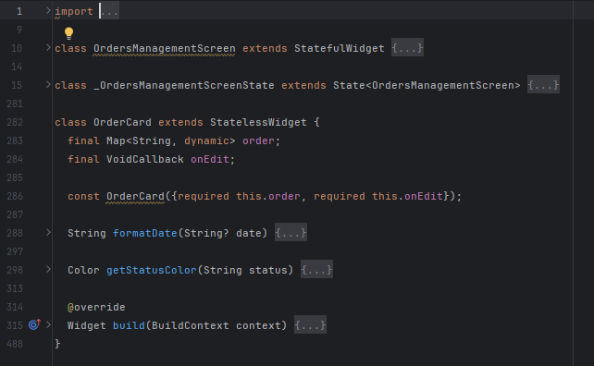**

**Purpose:** The OrdersManagementScreen widget is an administrative interface for managing orders in an e-commerce app, allowing admins to view, search, sort, edit, and view details of orders.

**Key Features:**

Displays a list of orders with details like order ID, client name, artisan name, order date, arrived date, and status.

Supports searching by order ID, code, or status, and sorting by newest/oldest order ID.

Includes pull-to-refresh for updating orders and handles token refresh for authentication.

Provides actions to edit orders (EditOrderScreen) and view details (OrderDetailsScreen).

State:

orders: Stores all orders fetched from ApiService.

filteredOrders: Stores filtered and sorted orders for display.

isLoading: Tracks data fetching state.

isAscending: Toggles sort order (true for oldest, false for newest).

\_searchController: Manages search input.

\_authService: Instance for authentication and token management.

**Functionality:**

Initialization: Fetches orders (fetchOrders) on initState and sets up search listener.

Data Fetching: Uses HTTP GET to /api/Admin/all-orders with bearer token; supports token refresh on 401 errors via refreshToken.

Search (\_filterOrders): Filters orders by ID, code, or status (case-insensitive).

Sort (sortOrders): Sorts orders by Order\_ID in ascending (oldest) or descending (newest) order.

Refresh (\_onRefresh): Reloads orders with pull-to-refresh.

Token Refresh (refreshToken): Refreshes access token using refresh token; retries fetch on success.

Navigation: Edit button navigates to EditOrderScreen; "Details" link navigates to OrderDetailsScreen.

Error Handling:

Shows SnackBar for login issues, session expiry, or fetch errors.

Handles invalid order IDs and network errors.

UI:

Responsive with GoogleFonts.nunitoSans typography, light/dark theme support.

Features a search bar, sort dropdown, and refreshable ListView of order cards (OrderCard).

OrderCard:

Displays order ID, client/artisan names, order/arrived dates, and status (color-coded: green for Delivered/Complete, blue for Processing, etc.).

Includes edit button and "Details" link.

Formats dates to dd/MM/yyyy with fallback for invalid dates.

Uses Card with teal border and rounded corners.

Dependencies:

Packages: flutter/material, google\_fonts, http, intl.

Internal: AuthService, ApiService, EditOrderScreen, OrderDetailsScreen.

Usage:

Integrated via Navigator.push to OrdersManagementScreen (typically within CustomNavigatorAdmin).

Requires AuthService for token management and API endpoint for order data.

Customizable for additional filters or UI styling.

Notes:

Performance: Efficient with filtered list and lazy loading.

Error Handling: Robust for authentication, API, and network issues.

Limitations: Search limited to ID, code, status; sorting only by ID.

Scalability: Can add more filters (e.g., date, client) or status-based tabs.

### 4.2.3 Deep Learning

#### 4.2.3.1.Yolov8 Model

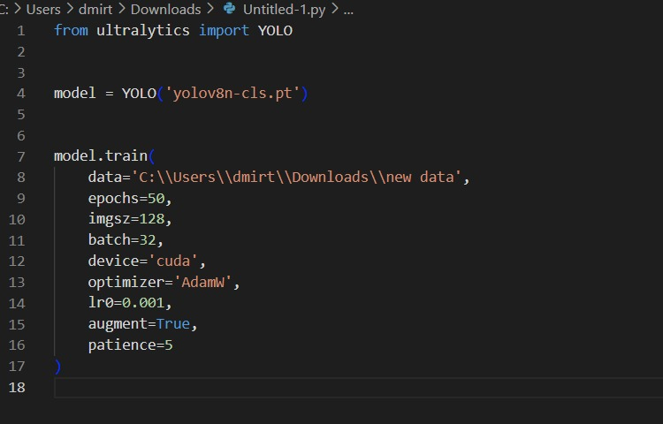

Model Architecture and Training

In this project, we used YOLOv8n-cls, a lightweight image classification model provided by Ultralytics. The goal was to classify product images into two categories: handmade and factory-made.

Model Configuration:

* Base Model: yolov8n-cls.pt (YOLOv8 Nano for Classification)
* Training Epochs: 50
* Image Size: 128 × 128 pixels
* Batch Size: 32
* Training Device: GPU (CUDA)
* Optimizer: AdamW
* Learning Rate: 0.001
* Data Augmentation: Enabled
* Early Stopping: Enabled with a patience of 5 epochs

The model was trained using Ultralytics' high-level training interface, which simplifies the training and fine-tuning process.

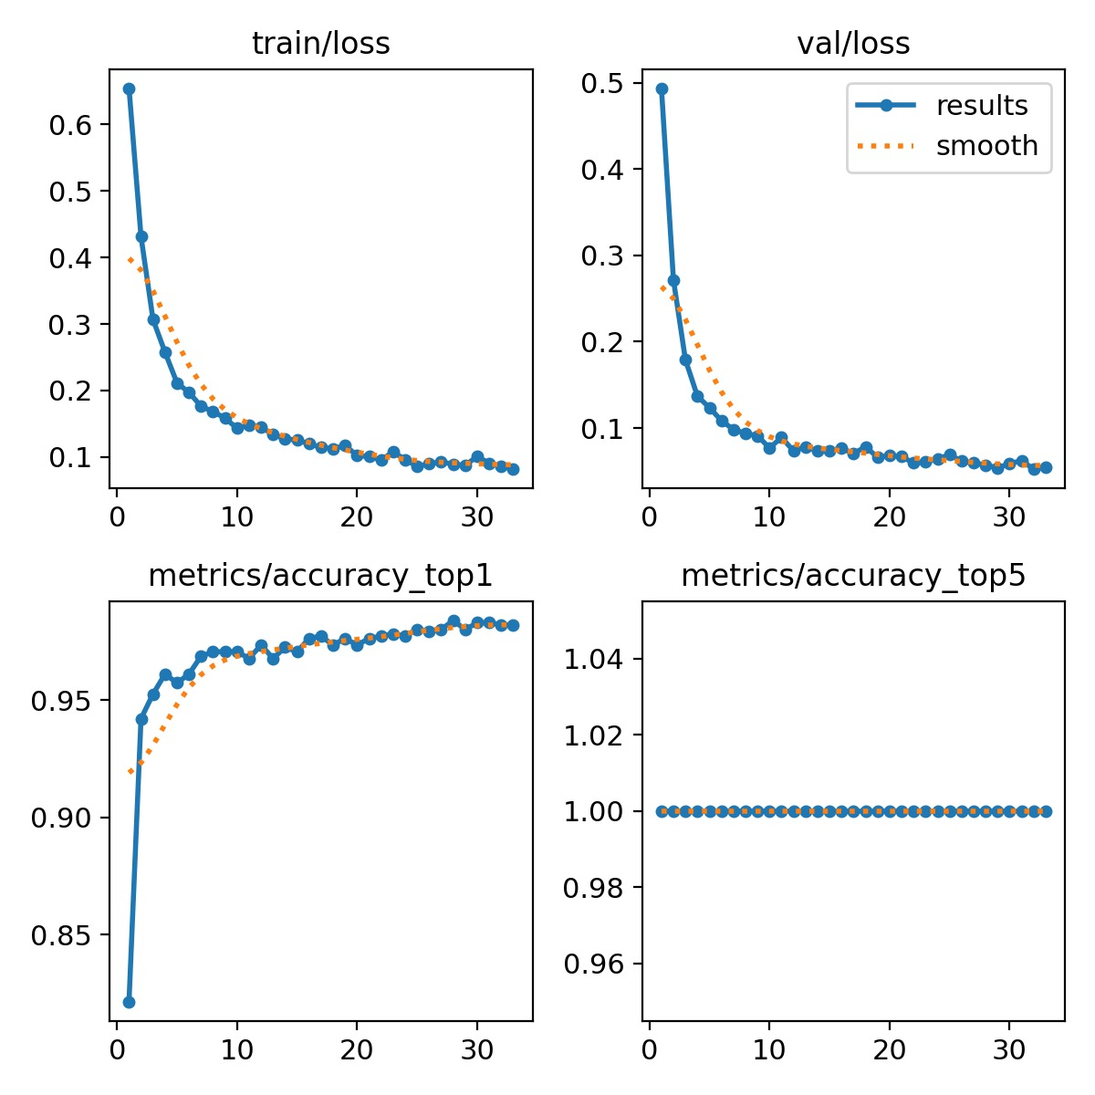

After training the YOLOv8 classification model, the results showed high performance in both training and validation:

* **Training Loss** steadily decreased from 0.65 to 0.09, showing effective learning.
* **Validation Loss** decreased from 0.5 to 0.07, indicating good generalization and no overfitting.
* **Top-1 Accuracy** reached over **97%**, confirming the model's strong ability to distinguish between handmade and factory-made products.
* **Top-5 Accuracy** remained at **100%**, which is expected due to the binary nature of the task.

These results confirm that the model is **well-trained**, **robust**, and ready for deployment into the mobile application.

**Confusion Matrix and Classification Metrics**

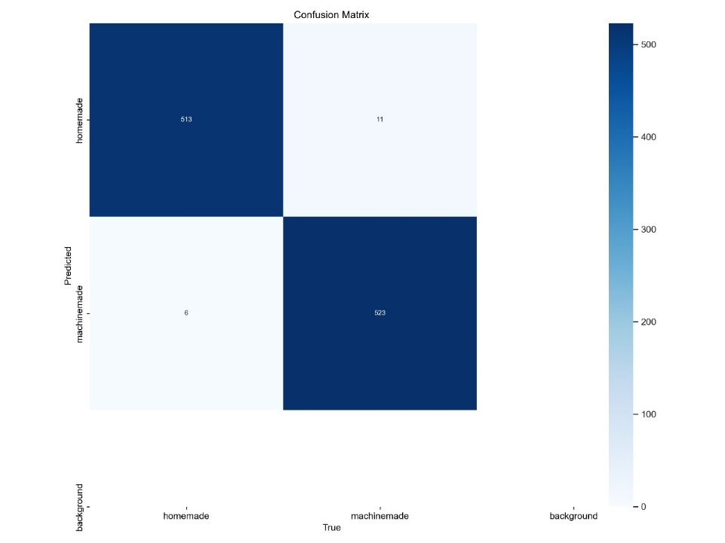

**Interpretation:**

* **True Positives (TP = 513)**: Correctly predicted handmade items.
* **True Negatives (TN = 523)**: Correctly predicted machine made items.
* **False Positives (FP = 6)**: Machine made items wrongly predicted as handmade.
* **False Negatives (FN = 11)**: Handmade items wrongly predicted as machine made.

After training the model, a confusion matrix was generated to evaluate how well the model distinguishes between **handmade** and **machine made** products. The matrix reveals:

* **513** correctly classified handmade items.
* **523** correctly classified machine-made items.
* Only **6 false positives** (machine made predicted as handmade).
* Only **11 false negatives** (handmade predicted as machine made).

**Final Performance:**

* Accuracy: 98.48%
* Precision: 98.84%
* Recall: 97.90%
* F1 Score: 98.37%

These metrics confirm that the model is highly accurate and reliable for real-world use.

#### 4.2.3.2.Mobile NetV2 Model

*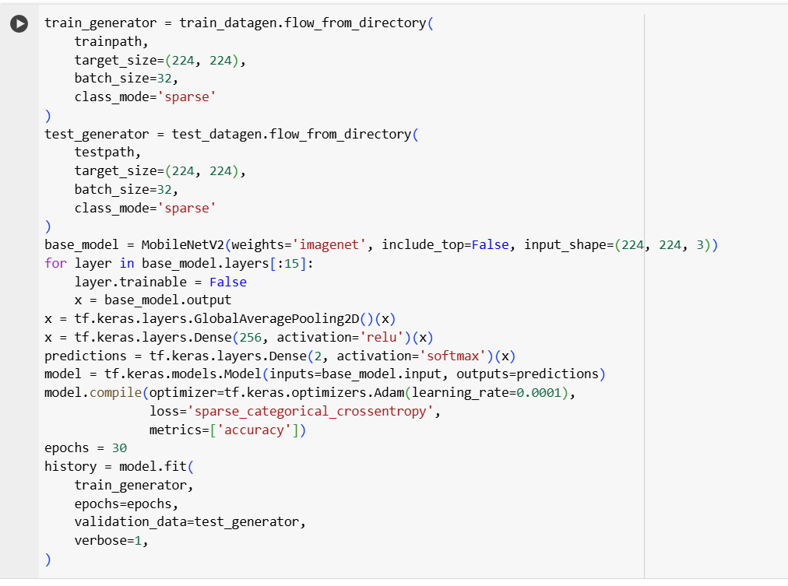*

**1.General Idea of the Model**

In this project, Transfer Learning was used through the well-known model MobileNetV2, which is a lightweight and efficient model pre-trained on the ImageNet dataset containing over 14 million labeled images across 1000 categories. This model was selected because it is optimized for resource-constrained devices such as smartphones, offering an excellent balance between accuracy and speed.

**2.Data Preparation and Loading**

ImageDataGenerator was used to load images from training and testing directories.

Images were resized to 224x224 pixels to match the model's input requirements.

Batch size was set to 32 images per batch.

The classification mode used was sparse, representing classes as integer labels.

**3.Loading the Base MobileNetV2 Model**

The pre-trained MobileNetV2 model with ImageNet weights was loaded.

include\_top=False indicates that the original top classification layer was excluded.

The input shape was set to (224, 224, 3) for colored image input.

**4.Freezing Some Layers**

The first 15 layers of the model were frozen to prevent their weights from being updated during training.

This helps preserve the general features learned from the ImageNet dataset.

**5.Building Custom Classification Layers**

GlobalAveragePooling2D: Converts spatial features into a single feature vector.

Dense (256): A hidden layer with 256 units and ReLU activation function.

Dense (2): The output layer with 2 units for the two classes using Softmax activation.

**6.Model Compilation for Training:**

Optimizer: Adam was used.

Learning Rate: Set to 0.0001 for controlled learning speed.

Loss Function: sparse\_categorical\_crossentropy was used.

Metrics: Model accuracy was evaluated using accuracy.

**7.Training the Model**

The model was trained for 30 epochs.

After each epoch, performance was validated using test data.

The goal was to ensure performance improvement and reduce prediction errors.

#### 4.2.3.3.ResNet Model

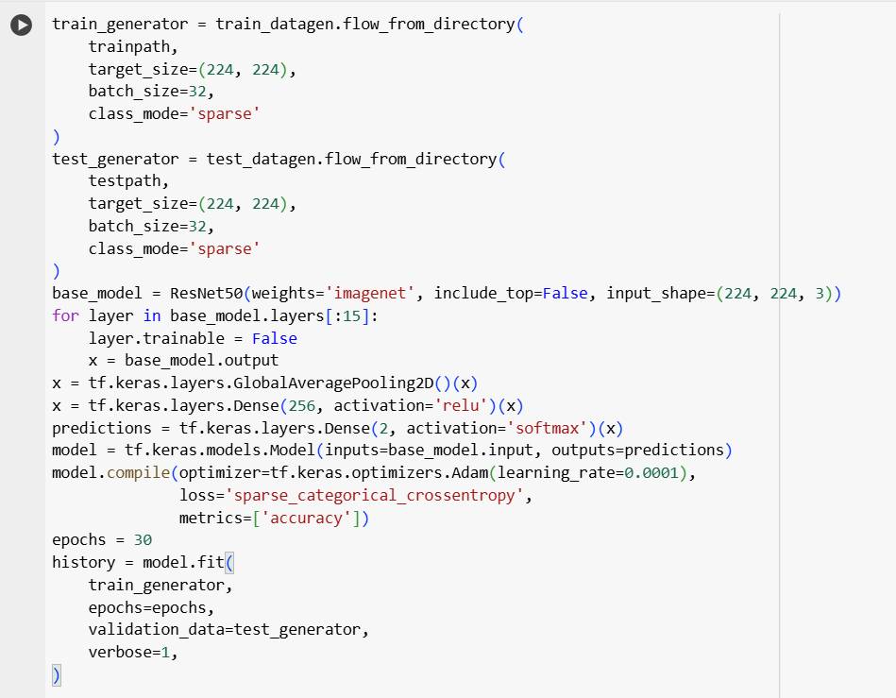

**1.General Idea of the Model**

In this project, Transfer Learning was applied using the well-known ResNet50 model. This is a deep and powerful convolutional neural network pre-trained on the ImageNet dataset, which contains over 14 million labeled images across 1,000 categories. ResNet50 was chosen for its high ability to extract deep features, thanks to its use of skip connections, which help solve the vanishing gradient problem—making it very effective for complex classification tasks.

**2.Data Preparation and Loading**

ImageDataGenerator was used to load images from the training and test directories.

Images were resized to **224x224 pixels** to match the model’s input requirements.

The batch size was set to **32** images.

The classification mode was set to sparse, where class labels are represented as integers.

**3.Loading the Pre-trained ResNet50 Model:**

* The **ResNet50** model was loaded with pre-trained weights from ImageNet.
* include\_top=False indicates that we are not using the model's original final layer.
* The input shape was defined as **(224, 224, 3)** to support colored images.

4.**Freezing Some Layers:**

* The **first 15 layers** of the model were frozen to prevent their weights from being updated during training.
* The goal is to **preserve the general features** learned from the ImageNet dataset, while allowing the remaining layers to adapt to the new data.

**5. Building Custom Classification Layers**

* GlobalAveragePooling2D: Used to convert the spatial feature maps into a single feature vector.
* Dense(256) with ReLU: A hidden dense layer with 256 units and the ReLU activation function.
* Dense(2) with Softmax: The output layer with 2 units for the two classes, using Softmax activation to output class probabilities.

**6. Model Compilation:**

* **Optimizer**: The **Adam** optimizer was used.
* **Learning Rate**: Set to **0.0001** to control how quickly the model learns.
* **Loss Function**: sparse\_categorical\_crossentropy was used because the class labels are in integer format.
* **Metrics**: The model’s performance was evaluated using **accuracy**.

**7. Training the Model**

* The model was trained for **30 epochs**.
* At the end of each epoch, the model's performance was evaluated using the **test data**.
* The objective was to **improve model accuracy** and reduce prediction errors over time.

#### 4.2.3.4.VGG16 Model

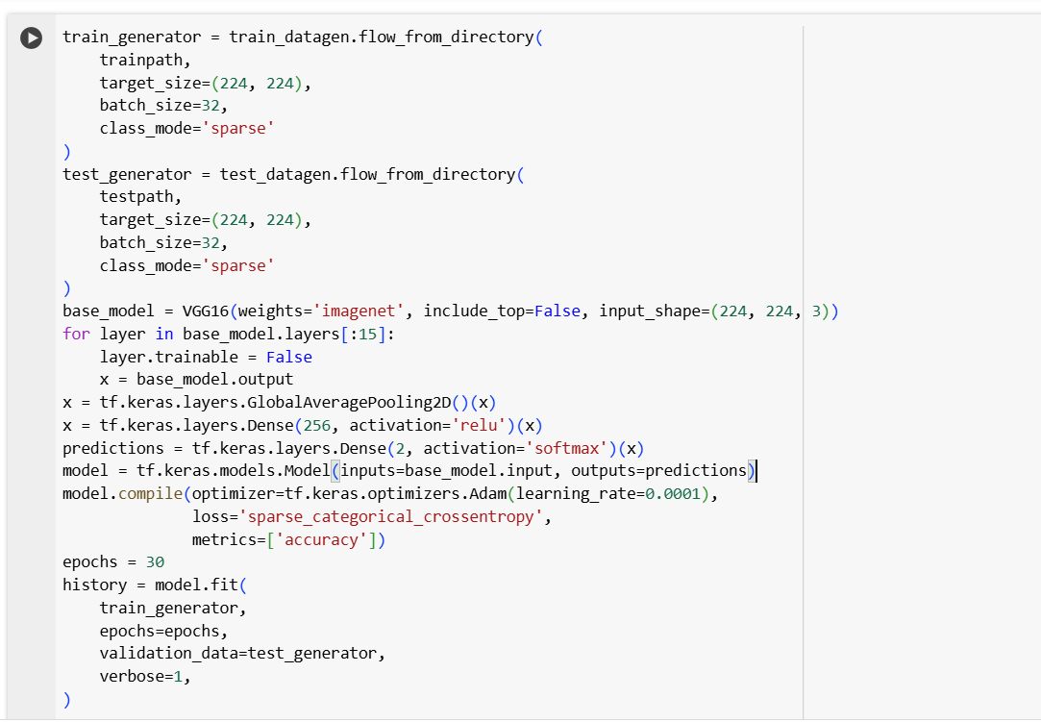

**1. General Overview of the Model**

In this project, **Transfer Learning** was applied using the well-known **VGG16** model, which is one of the classical and effective models in image classification. The model was pre-trained on the **ImageNet** dataset, which contains over 14 million labeled images. VGG16 is known for its simple architecture based on repeated **convolutional layers** with small filters (3x3), making it suitable for extracting important features from images.

**2. Data Preparation and Loading**

* ImageDataGenerator was used to load images from the training and testing directories.
* Image size was resized to **224x224 pixels** to match the model input requirements.
* The **batch size** was set to **32**.
* The classification mode was set to **sparse**, where classes are represented as integer labels.

**3. Loading the Base VGG16 Model**

* The pre-trained **VGG16** model was loaded with **ImageNet weights**.
* include\_top=False was used to exclude the original top (fully connected) layers.
* The input shape was set to **(224, 224, 3)** to support colored images.

**4. Freezing Some Layers**

* The first **15 layers** of the base model were **frozen**, preventing them from being updated during training.
* This helps retain the general knowledge the model learned from ImageNet, while the top layers adapt to the new data.

**5. Building Custom Classification Layers**

* GlobalAveragePooling2D: Converts spatial feature maps into a single feature vector.
* Dense(256) with **ReLU activation**: A hidden layer with 256 units to learn complex representations.
* Dense(2) with **Softmax activation**: The output layer contains 2 units for binary classification.

**6. Compiling the Model for Training**

* **Optimizer**: Adam was used as the optimizer.
* **Learning Rate**: Set to **0.0001**.
* **Loss Function**: sparse\_categorical\_crossentropy was used since the classes are integers.
* **Metrics**: The model’s performance was evaluated using **accuracy**.

**7. Training the Model**

* The model was trained for **30 epochs**.
* After each epoch, the model's performance was validated using the test data.
* The goal was to **gradually improve accuracy** and **reduce errors** over time.

#### 4.2.3.5.VGG19 Model

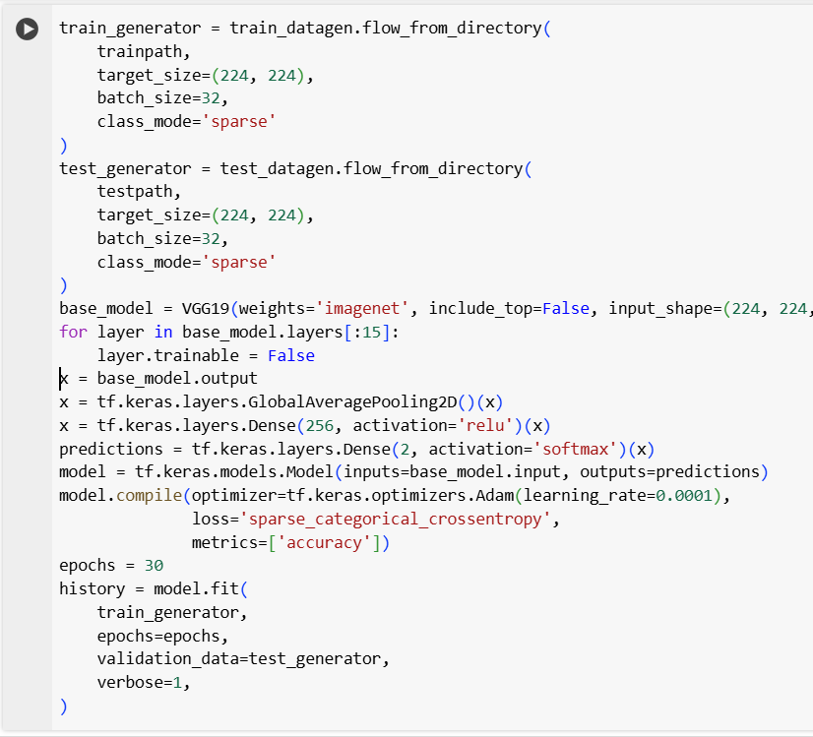

**1. General Overview of the Model**

In this project, **Transfer Learning** was applied using the well-known **VGG19** model, which is an extended version of **VGG16** and features a deeper architecture with 19 layers. The model was pre-trained on the **ImageNet** dataset, which contains millions of labeled images. VGG19 was chosen due to its simple yet powerful structure and its excellent ability to extract image features—especially useful for applications that demand high accuracy.

**2. Data Preparation and Loading:**

* ImageDataGenerator was used to load images from the training and testing directories.
* The images were resized to **224x224 pixels** to match the model's input requirements.
* The **batch size** was set to **32**.
* The classification mode used was **sparse**, where classes are represented as integer labels.

**3. Loading the Base VGG19 Model:**

* The pre-trained **VGG19** model was loaded with **ImageNet weights**.
* include\_top=False was used to remove the original top layers, which are specific to the 1000 ImageNet classes.
* The input shape was set to **(224, 224, 3)** to support colored images.

**4. Freezing Some Layers:**

* The first **15 layers** of the model were **frozen**, meaning their weights were not updated during training.
* This preserves the general knowledge learned from ImageNet and allows the top layers to adapt to the new dataset.

**5. Building Custom Classification Layers:**

* GlobalAveragePooling2D: Converts the output to a single feature vector for easy input to the dense layers.
* Dense(256) with **ReLU activation**: A powerful hidden layer with 256 units to learn complex representations.
* Dense(2) with **Softmax activation**: The output layer has 2 units, one for each class.

**6. Compiling the Model for Training:**

* **Optimizer**: Adam was used to update weights efficiently.
* **Learning Rate**: Set to **0.0001** to control the learning speed.
* **Loss Function**: sparse\_categorical\_crossentropy was used, which is suitable for integer-labeled classes.
* **Metrics**: Model performance was evaluated using **accuracy**.

**7. Training the Model:**

* The model was trained for **30 epochs**.
* After each epoch, the model's performance was validated using test data.
* The goal was to improve model accuracy and ensure that **overfitting** or **underfitting** does not occur.

#### A screenshot of a computer code AI-generated content may be incorrect.4.2.3.6.CNN Model

**1. General Idea of the Model**

In this project, an image classification model was built using Convolutional Neural Networks (CNN) from scratch, without relying on any pre-trained models. The model aims to classify images into two categories (Binary Classification). It was implemented using the **Keras** library within the **TensorFlow** environment. The model relies on multiple convolutional layers to extract essential features from the images, followed by fully connected layers to make the final decision.

**2. Data Preparation and Loading**

* **ImageDataGenerator** was used to load images from the training and testing directories.
* All images were resized to **224x224 pixels** to match the model’s input shape.
* The **batch size** was set to **32**.
* The classification mode used was **sparse**, where categories are represented as integer labels (0 and 1).

**3. Building the CNN Model**

The model was constructed using the **Sequential API** to build the architecture step by step.

**Convolutional Layers:**

These layers extract features from the images. The following pattern was repeated **5 times** with increasing filter sizes:

* **Conv2D**
  + First layer: Conv2D(32, (3,3), activation='relu', input\_shape=(224, 224, 3))
  + It contains 32 filters of size 3×3.
  + Uses the **ReLU** activation function to speed up training and avoid the vanishing gradient problem.
* **BatchNormalization**
  + Normalizes the output values.
  + Speeds up the training process and reduces the risk of overfitting.
* **MaxPooling2D(2,2)**
  + Reduces spatial dimensions while preserving important features.
  + Helps reduce the number of parameters and speeds up the model.
* **Filter Sizes Progression:**
  + Filters increased as follows: **64 → 128 → 256 → 512**
  + Increasing the number of filters allows the model to learn more complex features.

**Fully Connected Layers:**

* **Flatten()**
  + Converts the 2D output of the previous layers into a 1D vector for dense layers.
* **Dense(512, activation='relu') + Dropout(0.5)**
  + A dense layer with 512 units for deep learning.
  + **Dropout (50%)** is used to reduce overfitting.
* **Dense(256, activation='relu') + Dropout(0.3)**
  + Another dense layer with 256 units.
  + **Dropout (30%)** improves generalization and prevents memorization.
* **Dense(2, activation='softmax')**
  + The output layer contains two units representing the two classes.
  + **Softmax** converts the output into probabilities that sum up to 1.

**4. Model Compilation**

* **Optimizer**: Adam
* **Learning Rate**: 0.0001
* **Loss Function**: sparse\_categorical\_crossentropy (suitable for integer-encoded class labels)
* **Evaluation Metric**: accuracy

**5. Training the Model**

* The model was trained on the dataset for **30 epochs**.
* After each epoch, the model's performance was evaluated on the test dataset.
* The goal was to gradually improve the model’s accuracy while avoiding both **overfitting** and **underfitting**.

# Chapter 5

**Testing & Evaluation**

## 5.1.Testing strategies (unit testing, integration testing, user testing).

**Testing Strategies**

In order to ensure the reliability and functionality of the Craft Management System mobile application, several testing strategies were employed across its three main components: Client, Craft, and Admin.

### 5.1.1. Unit Testing

Each individual feature was tested in isolation to verify its correctness. Examples include:

* **Client Side**: registration, browsing products, adding to cart.
* **Craft Side**: adding/editing products, viewing orders.
* **Admin Side**: managing users, approving products.

### 5.1.2. Integration Testing

We tested the interaction between modules to ensure smooth data flow. Examples include:

* A user registers, adds a product to the cart, and completes an order.
* A craftsman receives a new order and responds to client messages.
* Admin removes a banned user and the system updates client views accordingly.

### 5.1.3. User Testing

Although formal user testing with external users has not yet been conducted, internal testing was carried out by the development team using Flutter. The developers simulated typical user interactions to ensure the core functionality, navigation, and workflow were operating correctly. This internal evaluation helped identify and resolve major issues before planning future testing with real users.

## 5.2.Performance metrics (Accuracy, Speed, Scalability, etc.).

### 5.2.1.Accuracy

**Introduction**

In our quest to develop an accurate and reliable homemade products detection system, we conducted a comprehensive evaluation of four distinct deep learning models: CNN, VGG16, VGG19, resnet 50,mobilenet and Yolov8ncl. Each model was trained on our carefully curated dataset, which included images of various products categories.

The evaluation process was crucial to determine which model would provide the best performance for our application.

To begin, we trained each model on the dataset, fine-tuning their parameters and architectures to optimize their learning capabilities. Each model utilized different techniques and architectures, contributing unique strengths to the task of homemade product detection.

After training, we evaluated each model using several key metrics, including accuracy. These metrics provided a comprehensive understanding of how well each model performed in detecting and classifying homemade products.

#### 5.2.1.1.CNN (Convolutional Neural Network):

Evaluation: The CNN model demonstrated strong performance in feature

extraction and classification due to its convolutional layers, which are effective in identifying patterns in images. We evaluated its accuracy, precision, and recall, noting its ability to generalize well across different types of categories.

**Progress of Model Training: Accuracy and Loss Over Epochs**

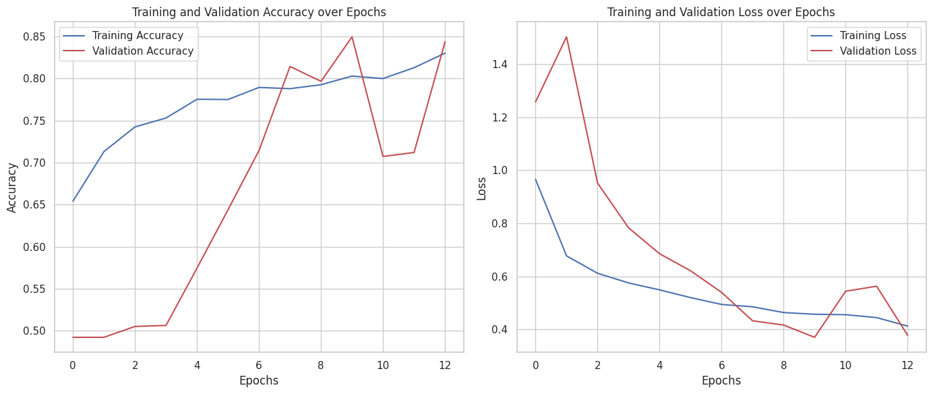

This table provides a summary of a CNN model’s training process. It includes the following details:

|  |  |
| --- | --- |
| Attribute | Value |
| Number of Classes | 2 |
| Batch Size | 32 |
| Number of Epochs | 30 |
| Final Train Accuracy | 0.8305 |
| Final Validation Accuracy | 0.8437 |
| Final Train Loss | 0.4098 |
| Final Val Loss | 0.3781 |
| Final test accuracy | 0.60 |

**Classification Report:**

|  |  |  |  |  |
| --- | --- | --- | --- | --- |
|  | **precision** | **recall** | **f1-score** | **support** |
| **homemade** | 0.91 | 0.21 | 0.35 | 517 |
| **machinemade** | 0.56 | 0.98 | 0.71 | 534 |
| **accuracy** |  |  | 0.60 | 1051 |
| **macro avg** | 0.74 | 0.60 | 0.53 | 1051 |
| **weighted avg** | 0.73 | 0.60 | 0.53 | 1051 |

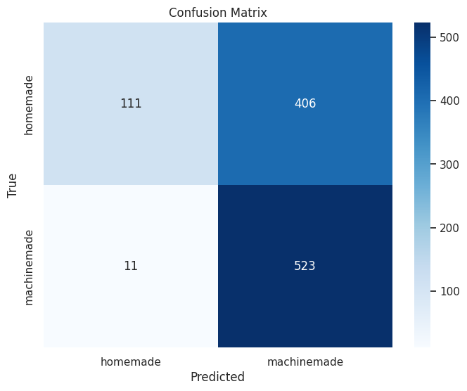**Confusion Matrix**

#### 5.2.1.2. Visual Geometry Group )VGG16) model:

Evaluation: VGG16, known for its deep architecture with 16 layers, showed impressive accuracy in detecting homemade products. We assessed its performance by examining the detailed feature maps it generated, which helped in identifying subtle differences between various categories. The model’s ability to maintain high accuracy and precision was a key focus during evaluation.

Progress of Model Training: Accuracy and Loss Over Epochs

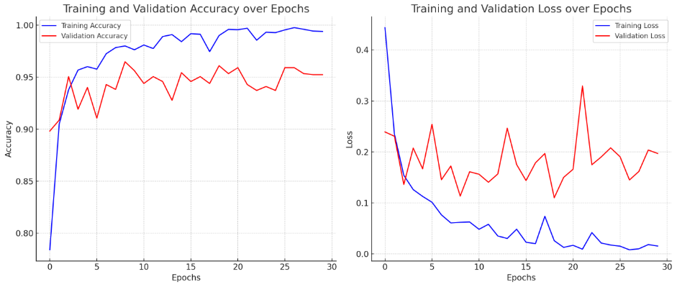

### 

**This table provides a summary of a VGG16 model’s training process. It includes the following details:**

|  |  |
| --- | --- |
| Attribute | Value |
| Number of Classes | 2 |
| Data Split | 80% Train - 20% Test |
| Batch Size | **32** |
| Number of Epochs | **30** |
| Final Train Accuracy | 0,9939 |
| Final Validation Accuracy | 0.9524 |
| Final Train Loss | 0.0155 |
| Final Validation Loss | |  |  | | --- | --- | |  | 0.1969 | |
| Final test accuracy | 0.93 |

**Classification Report:**

|  |  |  |  |  |
| --- | --- | --- | --- | --- |
|  | **precision** | **recall** | **f1-score** | **support** |
| **homemade** | 0.97 | 0.89 | 0.93 | 517 |
| **machinemade** | 0.90 | 0.97 | 0.94 | 534 |
| **accuracy** |  |  | 0.93 | 1051 |
| **macro avg** | 0.94 | 0.93 | 0.93 | 1051 |
| **weighted avg** | 0.93 | 0.93 | 0.93 | 1051 |

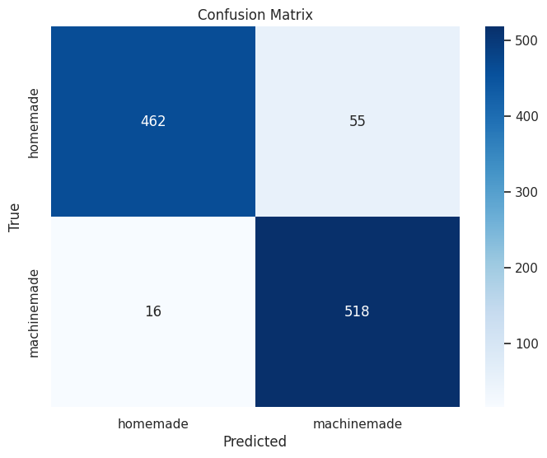**Confusion Matrix**

#### 5.2.1.3. Visual Geometry Group )VGG19( model:

Evaluation: Similar to VGG16 but with an even deeper architecture (19 layers), VGG19 provided slightly better feature extraction capabilities. We evaluated its performance by comparing its metrics to those of VGG16, paying close attention to improvements in precision and recall, which are critical for reducing false positives and false negatives.

Progress of Model Training: Accuracy and Loss Over Epochs



This table provides a summary of a VGG19 model’s training process. It includes the following details:

|  |  |
| --- | --- |
| Attribute | Value |
| Number of Classes | 2 |
| Data Split | 80% Train - 20% Test |
| Batch Size | **32** |
| Number of Epochs | **30** |
| Final Train Accuracy | 0.9929 |
| Final Validation Accuracy | 0.9258 |
| Final Train Loss | 0.0230 |
| Final Validation Loss | |  |  | | --- | --- | |  | 0.2391 | |
| Final test accuracy | 0.91 |

**Classification Report:**

|  |  |  |  |  |
| --- | --- | --- | --- | --- |
|  | **precision** | **recall** | **f1-score** | **support** |
| **homemade** | 0.96 | 0.85 | 0.90 | 517 |
| **machinemade** | 0.87 | 0.97 | 0.92 | 534 |
| **accuracy** |  |  | 0.91 | 1051 |
| **macro avg** | 0.92 | 0.91 | 0.91 | 1051 |
| **weighted avg** | 0.92 | 0.91 | 0.91 | 1051 |

**Confusion Matrix**

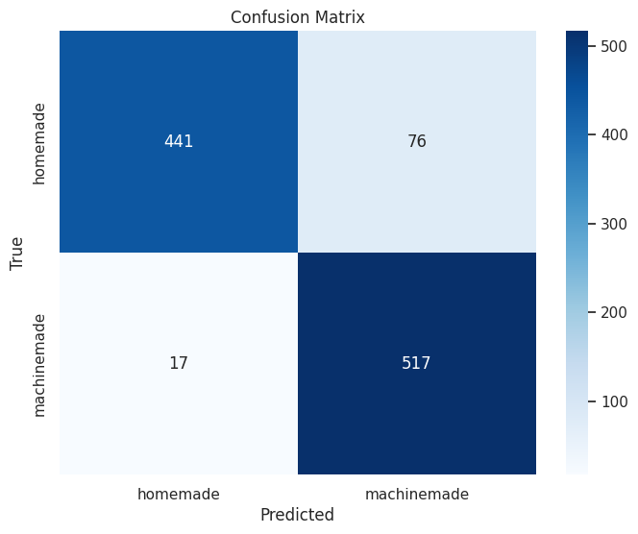

#### **5.2.1.4. Residual Network (ResNet50) Model:**

**Evaluation:** ResNet50, a deep residual network composed of 50 layers, demonstrated strong performance in classifying homemade products. Its architecture, which includes skip connections, helped mitigate vanishing gradient issues and allowed deeper feature extraction. During evaluation, we focused on the model’s ability to learn complex patterns through residual learning. The model produced detailed activation maps that effectively captured distinguishing features across different product categories. Emphasis was placed on maintaining high accuracy, precision, and robustness throughout the classification process.

Progress of Model Training: Accuracy and Loss Over Epochs

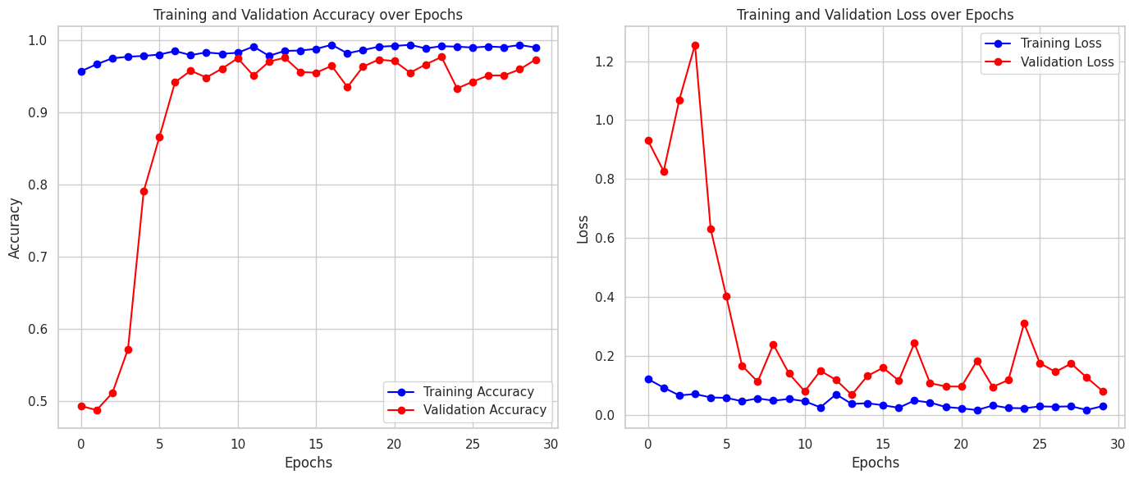

This table provides a summary of a ResNet model’s training process. It includes the following details:

|  |  |
| --- | --- |
| Attribute | Value |
| Number of Classes | 2 |
| Data Split | 80% Train - 20% Test |
| Batch Size | **32** |
| Number of Epochs | **30** |
| Final Train Accuracy | 0.9903 |
| Final Validation Accuracy | 0.9734 |
| Final Train Loss | 0.0299 |
| Final Validation Loss | |  |  | | --- | --- | |  | 0.0811 | |
| Final Test accuracy | 0.76 |

**Classification Report:**

|  |  |  |  |  |
| --- | --- | --- | --- | --- |
|  | **precision** | **recall** | **f1-score** | **support** |
| **homemade** | 0.94 | 0.55 | 0.69 | 517 |
| **machinemade** | 0.69 | 0.97 | 0.80 | 534 |
| **accuracy** |  |  | 0.76 | 1051 |
| **macro avg** | 0.82 | 0.76 | 0.75 | 1051 |
| **weighted avg** | 0.81 | 0.76 | 0.75 | 1051 |

**Confusion Matrix**

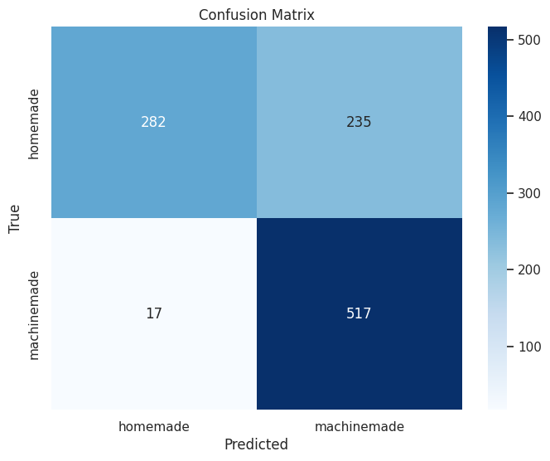

#### **5.2.1.5. MobileNetV2 Model:**

**Evaluation:** MobileNetV2, a lightweight and efficient convolutional neural network, was employed for classifying homemade products with a focus on speed and resource optimization. Its use of depthwise separable convolutions significantly reduced computational cost without compromising performance. The evaluation emphasized the model’s ability to generalize well on small datasets while maintaining competitive accuracy. Through feature analysis, MobileNetV2 demonstrated strong capacity in capturing fine-grained visual details, making it suitable for deployment in real-time or mobile applications. The model's balance between accuracy and efficiency was a key factor in its assessment.

Progress of Model Training: Accuracy and Loss Over Epochs

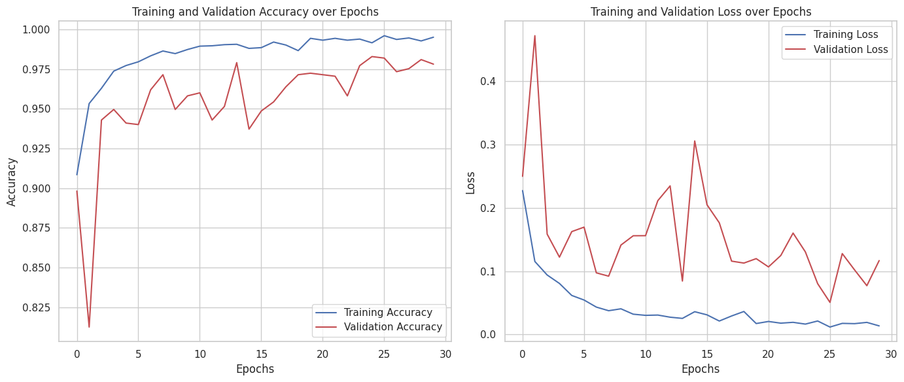

This table provides a summary of a mobile net model’s training process. It includes the following details:

|  |  |
| --- | --- |
| Attribute | Value |
| Number of Classes | 2 |
| Data Split | 80% Train - 20% Test |
| Batch Size | **32** |
| Number of Epochs | **30** |
| Final Train Accuracy | 0.9972 |
| Final Validation Accuracy | 0.9781 |
| Final Train Loss | 0.0100 |
| Final Validation Loss | |  |  | | --- | --- | |  | 0.1168 | |
| Final test accuracy | 0.89 |

**Classification Report:**

|  |  |  |  |  |
| --- | --- | --- | --- | --- |
|  | **precision** | **recall** | **f1-score** | **support** |
| **homemade** | 0.93 | 0.83 | 0.88 | 517 |
| **machinemade** | 0.85 | 0.94 | 0.89 | 534 |
| **accuracy** |  |  | 0.60 | 1051 |
| **macro avg** | 0.89 | 0.88 | 0.89 | 1051 |
| **weighted avg** | 0.89 | 0.89 | 0.89 | 1051 |

**Confusion Matrix**

**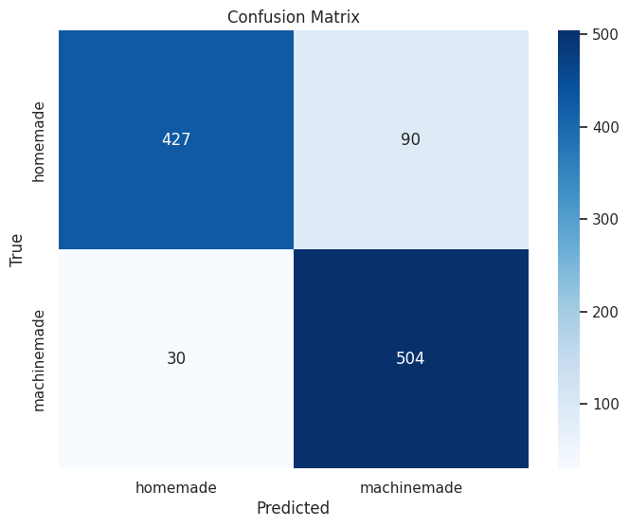**

#### 5.2.1.6.You Only Look Once (YOLOv8l-cls) model:

Evaluation: Yolov8l, designed for object detection, was evaluated for its speed and accuracy in detecting the homemade products over the machine-made ones. We measured its performance in terms of detection speed and the accuracy of identifying and classifying porducts . The model’s robustness in handling real-time detection scenarios was also a significant part of the evaluation.

Through this rigorous evaluation process, we compared the results from each model, identifying the one that provided the best overall performance. The Yolov8l model exhibited the highest accuracy and reliability about 98%, ensuring that our homemade products detection system delivers precise and trustworthy classification. This thorough evaluation process is essential in our mission to enhance the trustfulness of the app to deliver a homemade products .

Progress of Model Training: Accuracy and Loss Over Epochs

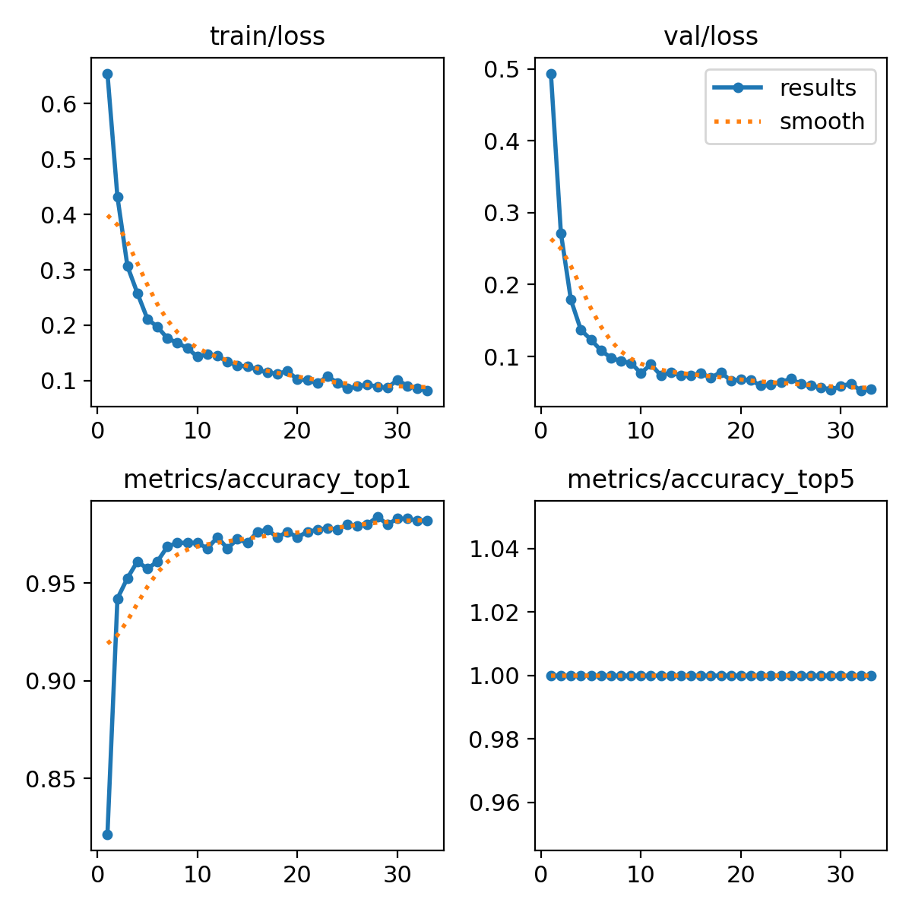

This table provides a summary of a Yolov8l model’s training process. It includes the following details:

|  |  |
| --- | --- |
| Attribute | Value |
| Num of Classes | 2 |
| Batch Size | 32 |
| Num of Epochs | 30 |
| Final Train Accuracy | 0.9891 |
| Final Validation Accuracy | 0.98196 |
| Final Train Loss | 0.08167 |
| Final Val Loss | 0.05497 |
| Final test accuracy | 0.98 |

**Classification Report:**

|  |  |  |  |  |
| --- | --- | --- | --- | --- |
|  | **precision** | **recall** | **f1-score** | **support** |
| **homemade** | 0.99 | 0.98 | 0.98 | 524 |
| **machinemade** | 0.98 | 0.99 | 0.98 | 529 |
| **accuracy** |  |  | 0.98 | 1053 |
| **macro avg** | 0.98 | 0.98 | 0.98 | 1053 |
| **weighted avg** | 0.98 | 0.98 | 0.98 | 1053 |

Confusion matrix :

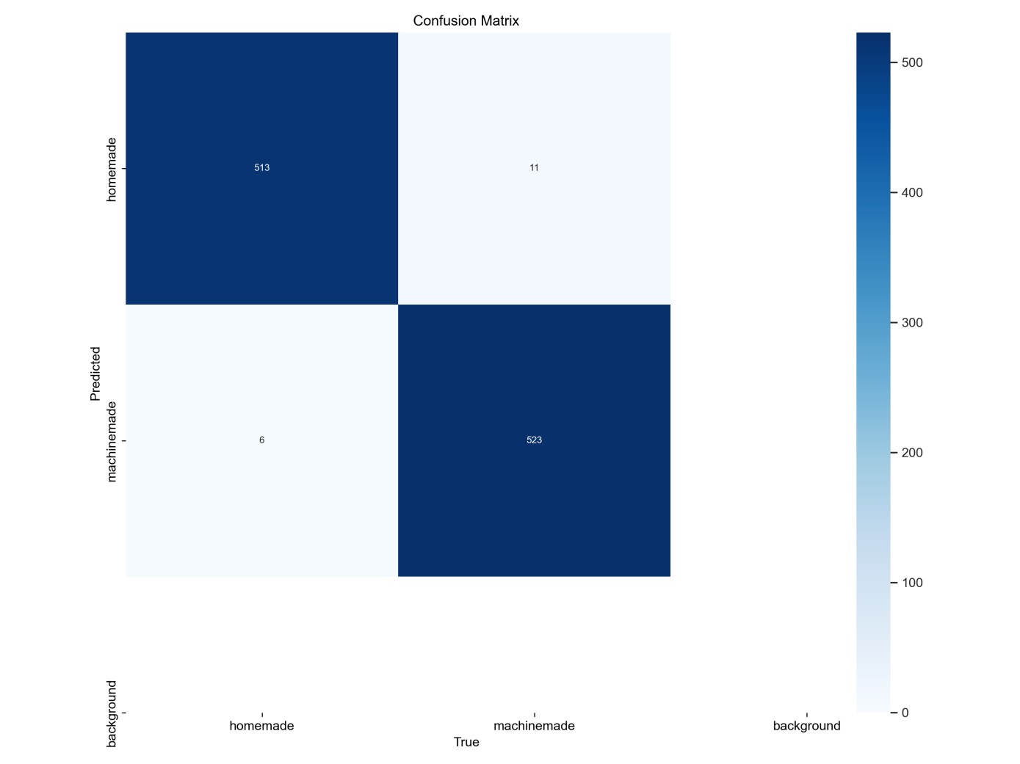

### 5.2.2. Speed

The application’s speed was evaluated during navigation between pages using an internal testing environment, and the results were as follows:

* Maximum Load Time (Max): The Artisan Home page took approximately 2.4 seconds to load, due to the large amount of displayed data such as products, orders, and reports.
* Minimum Load Time (Min): The Login page loaded in about 0.7 seconds, owing to its simple content.
* Average Load Time: Across the main pages of the application, the average response time was approximately 1.3 seconds.

These results indicate generally good performance, with room for improving the load speed of data-heavy pages like the Artisan Home page in future versions.

### 5.2.3. Scalability

Since the application is still under development and has not been released for public use yet, scalability has not been evaluated through actual users.  
However, the development team conducted internal simulation tests to ensure system stability when handling large volumes of data and users.  
The backend of the system is built using .NET C#, a robust technology that enables the creation of scalable applications by supporting concurrent requests, enhancing performance, and seamless integration with databases.  
Therefore, the system is expected to adapt to future growth and an increased number of users without impacting overall efficiency.

# Chapter 6

**Results & Discussion**

## 6.1.Introduction

This chapter aims to present and analyze the results achieved during the development and implementation of the "Craft Management System" project, a mobile application built using Flutter and partially relying on artificial intelligence to enhance the user experience.  
The chapter discusses the progress made in the project, the extent to which the predefined objectives were achieved, the challenges encountered, as well as the technical and implementation constraints.  
It also explores how the adopted technologies contributed to improving the system’s efficiency and sets the stage for the next chapter focused on future work.

## 6.2.Summary of findings.

After working on the project, the initial version of the Craft Management System application was successfully developed, covering the core functionalities for all three main user interfaces:Artisan, Client, and Admin.  
An AI-based classification model was also integrated to accurately classify products, and it was successfully tested.

**Achieved Results:**

* **Artisan Interface:**
  + Craftsmen can log in or create a new account.
  + They can add new products with images, descriptions, and prices.
  + They are able to edit or delete their products
  + They can monitor sales reports and the number of orders.
* **Client Interface:**
  + Clients can browse products based on categories.
  + They can add products to the shopping cart and complete their orders.
  + They can rate products and leave comments.
* **Admin Interface:**
  + The admin manages user accounts and platform content.
  + They can review, delete, or edit any inappropriate content.
  + They handle user complaints.
* **Smart Product Classification System:**
  + A deep learning model was implemented to determine whether a product is handmade or machine-made.
  + After testing multiple models ,the YOLOv8 model was selected as it achieved 98% accuracy on the test dataset, which enhances user trust in the authenticity of displayed products.

## 6.3.Interpretation of results.

Based on the initial project plan, the application has successfully achieved its main objectives, which were:

* **Supporting and Empowering Craftsmen Digitally:**
  + This was accomplished through a user-friendly interface that allows craftsmen to showcase their products, monitor sales, and interact with clients.
* **Enhancing User Trust:**
  + The use of a smart classification model to distinguish between handmade and machine-made products helped reduce doubts and increase transparency.
  + Simplifying Purchase and Management Processes:
    - The three interfaces were designed to make it easy for all users to perform their tasks efficiently.
  + However, some future objectives have not yet been fully implemented, such as:
    - Integrating multiple payment methods (currently, the app supports only cash on delivery).
    - Implementing a recommendation system to analyze top-selling products.
    - Developing a smart ID verification system based on OCR technology.

## 6.4.Limitations of the proposed solution.

Despite significant progress in developing the application and achieving most of the project objectives, we faced some challenges that impacted certain technical and operational aspects:

* **Running AI Models Within the App:**

Due to limited support in some Flutter tools for directly running complex AI models, we adopted the use of external services to process images and classify products, adding an extra technical layer.

* **Data Availability*:***

Collecting diverse and sufficient data to accurately train the model was challenging, but this was overcome by utilizing various sources and improving training techniques.

* **Payment Options:**

Currently, the app supports cash on delivery only, which is a practical option for many users, with plans to develop multiple electronic payment methods in the future.

* **User Interface Design:**

The interfaces were designed to be functional and user-friendly, with future plans to enhance the design and visual experience to better meet user expectations.

* **User Identity Verification:**

At present, craftsman data is manually reviewed to ensure quality, while the implementation of an automated verification system is under consideration for upcoming versions to enhance security and trust.

# Chapter 7

**Conclusion & Future Work**

## 7.1.Summary of contributions.

Our project focused on developing a mobile application using Flutter, aimed at managing and marketing handcrafted products through a comprehensive system with three main interfaces: Artisan, Client, and Admin. The application seeks to support and empower artisans, facilitate the marketing and sale of their products, and ensure the quality of operations through admin supervision.To enhance user experience and improve system reliability, deep learning technologies were integrated into the app. Several models were trained to automatically classify products as either “handmade” or “factory-made” based on product images and entered information. After careful evaluation of model performance, Several deep learning models were trained and evaluated to classify products based on their images. Among these, YOLOv8 outperformed the others, achieving the highest accuracy rate of 98%. As a result, it was selected as the core of the classification system, significantly improving precision and building trust in the platform.

This project highlights the importance of integrating artificial intelligence technologies with e-commerce solutions tailored for artisans. By customizing and evaluating several deep learning models, we successfully developed an intelligent system that helps users distinguish between handmade and factory-made products, thereby enhancing the platform’s credibility and supporting informed purchasing decisions.

Looking forward, we aim to further develop intelligent features within the app and enhance the performance of the adopted models to keep up with technological advancements and maximize benefits for both artisans and customers.

## 7.2.Possible improvements or extensions for future work.

As part of our future development plans for the Craft Management System, we aim to implement several advanced features to improve user experience, system intelligence, and operational efficiency:

1. **Chat System**:

We plan to integrate a real-time chat feature that allows direct communication between clients and artisans. This will help in answering inquiries, customizing orders, and building trust between users.

1. **Multiple Payment Methods**:

Currently, the system only supports "Cash on Delivery." In future updates, we aim to include various payment gateways such as credit/debit card payments, mobile wallets, and secure online transactions to make the purchasing process more flexible and convenient.

1. **Recommendation Model**:
2. We aim to develop a smart recommendation system that not only supports artisans but also enhances the client experience. For Clients, the system will track and analyze their browsing and search behavior to display the products they interact with the most. This personalized approach helps customers easily revisit items of interest.

1. **ID Image Verification Model**:

We plan to implement a machine learning model that verifies whether an uploaded image is indeed a national ID. This will add a layer of security and trust, especially for artisan verification during registration.

**These improvements will significantly boost the functionality, trustworthiness, and smart capabilities of the application, ensuring it continues to evolve to meet user needs and market demands.**

# References

https://[en.wikipedia.org/wiki/Etsy](https://en.wikipedia.org/wiki/Etsy)

https://[press.aboutamazon.com/2015/10/debuting-the-home-for-artisans-handmade-at-amazon](https://press.aboutamazon.com/2015/10/debuting-the-home-for-artisans-handmade-at-amazon)

https://[ayadymisr.com/index.php?route=information/information&information\_id=4](https://ayadymisr.com/index.php?route=information/information&information_id=4)

<https://herafy.net/%d8%b4%d8%b1%d9%88%d8%b7-%d8%a7%d9%84%d8%a8%d9%8a%d8%b9-%d9%88%d8%a7%d9%84%d8%aa%d8%ba%d9%84%d9%8a%d9%81/>

<https://oriental-o.com/%D9%85%D9%86-%D9%86%D8%AD%D9%86>

<https://www.creativeegypt.org/ar/about>

<https://api.flutter.dev/flutter/material/MaterialApp-class.html>

<https://dart.dev/language/modifier-reference>

<https://developers.googleblog.com/en/ready-for-production-apps-flutter-beta-3/>

<https://drive.google.com/drive/u/1/folders/1vtP7qFiO1S1xvEdnDJNgVGmmCSZy-Lag>

<https://keras.io/api/models/>

<https://keras.io/api/layers/activations/>

<https://keras.io/api/metrics/accuracy_metrics/>

<https://www.tensorflow.org/learn>

<https://keras.io/getting_started/>

<https://www.datacamp.com/tutorial/introduction-to-convolutional-neural-networks-cnns>

<https://keras.io/api/applications/vgg/>

[https://docs.ultralytics.com/ar/models/yolov8/#key-features](https://docs.ultralytics.com/ar/models/yolov8/" \l "key-features)

<https://github.com/ultralytics/ultralytics/issues/189>

<https://keras.io/api/applications/mobilenet>

<https://keras.io/api/applications/resnet/>